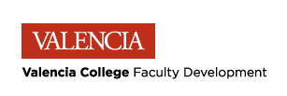

My Development Plan

valenciacollege.edu/facultydevelopment
Rev 5/16
Curriculum for Learning Leaders: Essential Competencies of a Valencia Educator
At Valencia, we have defined seven Essential Competencies that were developed by our academic community of deans and faculty. These competencies serve as the foundation of our ongoing development as teachers, counselors and librarians. Over the course of an entire career, faculty members continually develop their expertise in these essential competencies. As such, these seven Essential Competencies of a Valencia Educator form the foundation of all of our faculty development opportunities.

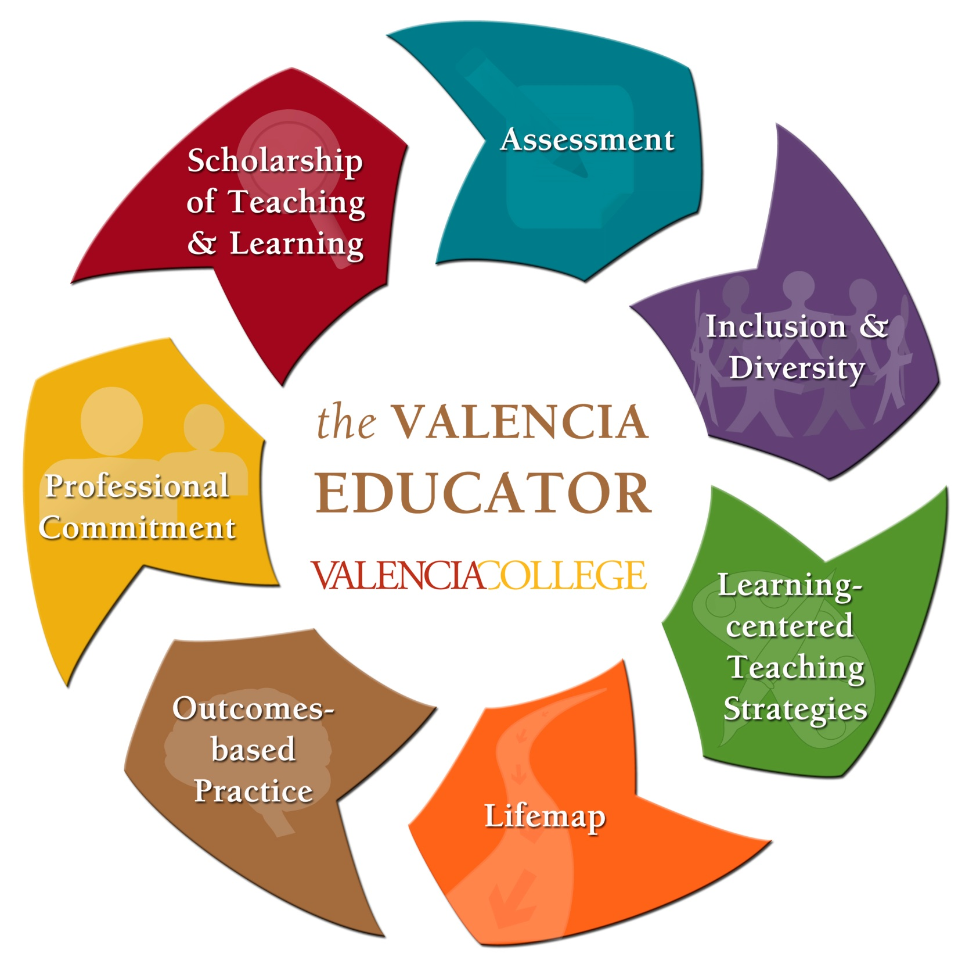

My Development Plan
The My Development Plan is a tool for faculty members to reflect on his or her knowledge of the Essential Competencies of a Valencia Educator and identify aspects of each competency that he or she would like to develop this year.

For the purposes of the My Development Plan, you will reflect on the five of the seven Essential Competencies that are the most classroom-based. Then you will select the faculty development opportunities you plan to participate in this year to enhance your professional practice of each competency.

How to Begin
To begin developing your individualized plan, you should do some homework first.
- Learn more about the Essential Competencies of a Valencia Educator.
  - Enroll in Teaching in Our Learning College (LCTS 1110, 30 PD hours) course. This scenario-based course introduces the Essential Competencies of a Valencia Educator and provides faculty with tools and resources to become more effective, learning-centered instructors. Participants will develop a "My Development Plan" and learning-centered syllabus.
  - If you would like more information on the Essential Competencies outside of a course, narrated presentations and resources are available for your review at http://valenciacollege.edu/faculty/development/coursesResources/

- Using the My Development Plan form, critically reflect on your practice in terms of the Essential Competencies taking into account your professional needs and student learning. Critically reflect from five perspectives: student, colleague, expert, supervisor (your Dean or Department/Program Chair, Discipline Coordinator) and self.

- Using your reflections, create a plan for your development in conjunction with your Dean (or Department/Program Chair, Discipline Coordinator) and register for selected faculty development courses and/or programs.
  - To register: http://valenciacollege.edu/faculty/development/howToRegisterForCourses.cfm
  - To access your Faculty Development transcript:: http://valenciacollege.edu/faculty/development/howToPrintFDTranscripts.cfm

For Questions or Support
Contact a member of our Faculty and Instructional Development Team by visiting the Center for Teaching/Learning Innovation on your campus.

East Campus Jyoti Pande (407) 582-2425
Building 4, Room 133 jpande@valenciacollege.edu

Lake Nona Campus Shara Lee (407) 582-7128
Building 1, Room 344 slee84@valenciacollege.edu

West Campus Dori Haggerty (407) 582-5826
Building 6, Room 326A dhaggerty@valenciacollege.edu

Winter Park Campus Jyoti Pande (407) 582-6919
Room 126 jpande@valenciacollege.edu

Osceola Campus Shara Lee (407) 582-4918
Building 4, Room 124 slee84@valenciacollege.edu

_______________________________________________________________________________________
Essential Competency | EXAMPLE - Mathematics Instructor Example  Review and Reflection (type your answers in the spaces provided)
Assessment  Valencia educators will develop student growth through consistent, timely formative and summative measures, and promote students’ abilities to self-assess.  Assessment practices will invite student feedback on the teaching and learning process as well as on student achievement.  - Authentic Assessment  - Classroom Assessment Techniques  - Formative Assessment  - Rubrics  - Summative Assessment | Review the Essential Competency-Assessment. If needed, a narrated presentation is available for your review. Then reflect from the five perspectives on the following questions.
- Describe your personal strengths in Assessment in terms of knowledge, skills, abilities, experiences and student learning.
I have taught part-time at Valencia for a few years and have learned a
lot about summative assessment from fellow teachers.

- Identify what you would like to learn about Assessment in terms of your own development and what you want to learn to improve student learning.
I would like to learn more about assessment, specifically formative assessment for math classes. In my student assessment of instruction feedback, students have told me they would like more feedback all throughout the term. I am not familiar with assessments other than tests and quizzes and would like to learn more about my students’ learning.

- Write your learning outcomes in terms of what you want to learn or be able to do in order to improve student learning or the student experience. It may be helpful to complete the following sentence-
I will _____________ in order to improve students’ abilities to __________________.
I will learn more about formative assessment techniques to improve students’ abilities to apply theorems to solve problems in Calculus I (MAC2311).

- Review the related courses and indicate at least one course/program that you plan to take to enhance your professional practice of this competency.
I plan to take ASMT 2122 Classroom Assessment Techniques

Learning-centered Teaching Strategies:

Valencia educators will implement diverse teaching and learning strategies that accommodate the learning styles of students and that promote both acquisition and applications of knowledge and understanding.

- Active Learning
- Collaborative and Cooperative Learning
- Critical Thinking
- Motivation
 | Review the Essential Competency- Learning-centered Teaching Strategies. If needed, a narrated presentation is available for your review. Then reflect from the five perspectives on the following questions.
 | - Describe your personal strengths in Learning-centered Teaching Strategies in terms of skills, abilities and experiences.
 | - Identify what you would like to learn about Learning-centered Teaching Strategies in terms of your own development and what you will be able to do to improve student learning.
- Write your learning outcomes in terms of what you want to learn or be able to do in order to improve student learning or the student experience. It may be helpful to complete the following sentence-
I will _____________ in order to improve students’ abilities to __________________.

- Review the related courses and indicate at least one course/program that you plan to take to enhance your professional practice of this competency.

Inclusion & Diversity:

Valencia educators will design learning opportunities that acknowledge, draw upon and are enriched by student diversity. An atmosphere of inclusion and understanding will be promoted in all learning environments.

- Diversity
- Learning Communities
- Learning Styles & Personality Types
- Universal Design for Learning

Review the Essential Competency- Inclusion & Diversity. If needed, a narrated presentation is available for your review. Then reflect from the five perspectives on the following questions.

- Describe your personal strengths in Inclusion & Diversity in terms of knowledge, skills, abilities, experiences and student learning.

- Identify what you would like to learn about Inclusion & Diversity in terms of your own development and what you want to learn to improve student learning.

- Write your learning outcomes in terms of what you want to learn or be able to do in order to improve student learning or the student experience. It may be helpful to complete the following sentence-
I will _____________ in order to improve students’ abilities to __________________.

- Review the related courses and indicate at least one course/program that you plan to take to enhance your professional practice of this competency.

Outcomes-based Practice  Valencia educators will design curriculum that aligns elements of student learning toward growth in the Student Core Competencies and progression through course sequences, by the demonstration of Program Learning Outcomes.  - Constructing Measureable Learning Outcomes  - Course and Program Outcomes  - Sequencing  - TVCA | Review the Essential Competency - Outcomes-based Practice. If needed, a narrated presentation is available for your review. Then reflect from the five perspectives on the following questions.
 | - Describe your personal strengths in Outcomes-based Practice in terms of skills, abilities and experiences.
 | - Identify what you would like to learn about Outcomes-based Practice in terms of your own development and what you will be able to do to improve student learning.
- Write your learning outcomes in terms of what you want to learn or be able to do in order to improve student learning or the student experience. It may be helpful to complete the following sentence-
I will _____________ in order to improve students’ abilities to __________________.

 | - Review the related courses and indicate at least one course/program that you plan to take to enhance your professional practice of this competency.

LifeMap  Valencia educators will design learning opportunities that promote student life skills development while enhancing discipline learning. Through intentional inclusion of growth-promoting strategies, instructors, counselors and librarians will facilitate the students’ reflection, knowledge, and appreciation for self and others; gradual assumption of responsibility for making informed decisions; and formulation and execution of their educational, career, and life plans. As a result, students can transfer those life skills to continued learning and planning in their academic, personal, and professional endeavors. | Review the Essential Competency- LifeMap. If needed, a narrated presentation is available for your review. Then reflect from the five perspectives on the following questions.
 | - Describe your personal strengths in LifeMap in terms of skills, abilities and experiences.
 | - Identify what you would like to learn about LifeMap in terms of your own development and what you will be able to do to improve student learning.
- Write your learning outcomes in terms of what you want to learn or be able to do in order to improve student learning or the student experience. It may be helpful to complete the following sentence-
I will _____________ in order to improve students’ abilities to __________________.

- Review the related courses and indicate at least one course/program that you plan to take to enhance your professional practice of this competency.

Assessment

Valencia educators will develop student growth through consistent, timely formative and summative measures, and promote students’ abilities to self-assess.

Assessment practices will invite student feedback on the teaching and learning process as well as on student achievement.

- Authentic Assessment
- Classroom Assessment Techniques
- Formative Assessment
- Rubrics
- Summative Assessment

Review the Essential Competency-Assessment. If needed, a narrated presentation is available for your review. Then reflect from the five perspectives on the following questions.

- Describe your personal strengths in Assessment in terms of knowledge, skills, abilities, experiences and student learning.

- Identify what you would like to learn about Assessment in terms of your own development and what you want to learn to improve student learning.

- Write your learning outcomes in terms of what you want to learn or be able to do in order to improve student learning or the student experience. It may be helpful to complete the following sentence-
I will _____________ in order to improve students’ abilities to __________________.

- Review the related courses and indicate at least one course/program that you plan to take to enhance your professional practice of this competency.

*To earn the Associate Faculty Certificate, you will need to complete 60 hours of faculty development courses, including the required Teaching in our Learning College course (LCTS1110, 30 PD hours). Renewal of the Associate Faculty Program is annual. Faculty members must complete 20 hours of qualifying faculty development activities each year and apply for Associate Faculty renewal.

Name _________________________________________________________________

Completed in consultation with Dean
_______________________________________________________________________

Department _____________________________________________________________

Primary Campus _________________________________________________________

Email _____________________________ Phone Number _______________________

My Development Planning Tool
Course Prefix | Course Title | Date(s) | Completed (Y/N) | PD Hours

