Re-activating the SAS Add-in:

Open Microsoft Excel and single-click the “Office” button, then single click the “Excel Options” button.

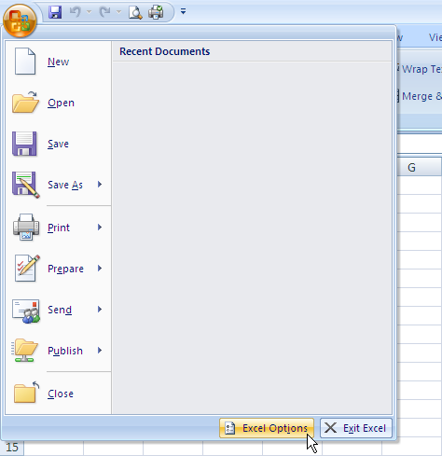

Click on the “Add-Ins” on the left of the window the pops up.

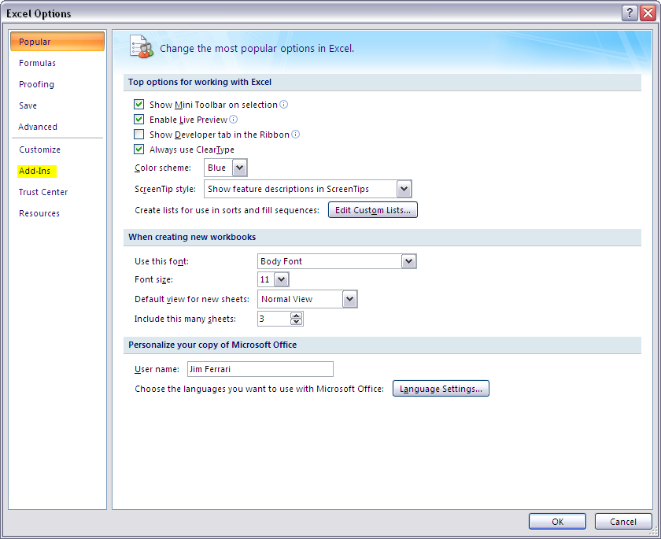

Select the pull down menu next to “Manage:” at the bottom of the window and select “Disabled Items”.

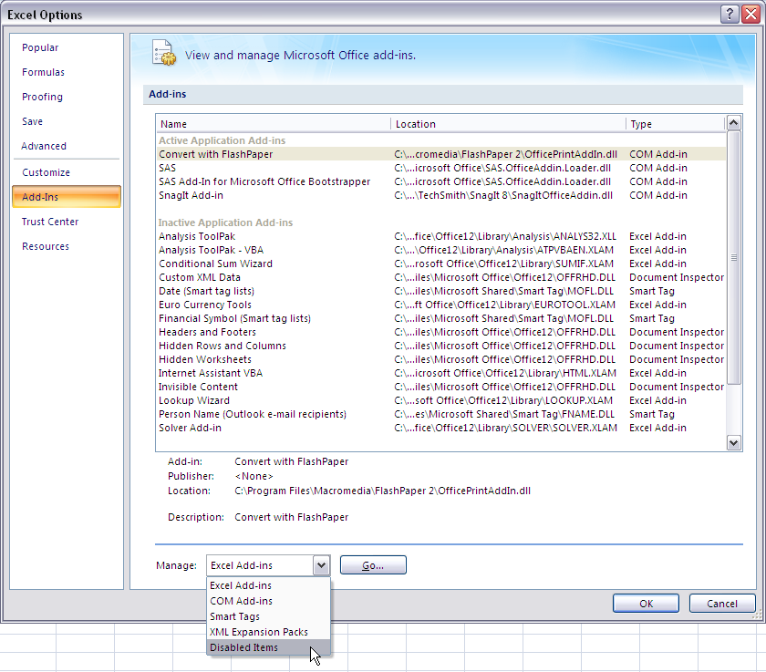

SAS Add-in should be in the window that pops up, select it (by clicking on it) and click “Enable”.

