Accessing the new environment on March 12th:

- From a PC running Windows XP:

Two versions of the SAS Add-in for Microsoft Office should be installed on your PC, but only one of them can be used at a time. A utility exists to switch between the two versions and to make either one or the other the active version.

When you return from Spring Break and need to switch to the new version of the Add-in (V 4.3) click the following link:

\\tech\OIT-Apps\SASInstallScript\switch4_3.bat (New add-in version)

If you cannot click on the link above, from the Start menu click on “Run…” and either copy/past or type “\\tech\OIT-Apps\SASInstallScript\switch4_3.bat” in the window that pops up and click “OK”.

Once the new environment is “live” you shouldn’t need to go back to the older version of the Add-in (V 2.1) but here is the link just in case:

\\tech\OIT-Apps\SASInstallScript\switch2_1.bat (Current add-in version)

After Spring Break you should switch to the 4.3 version of the SAS Add-in and leave it. The SAS tab in Excel should look slightly different, but familiar.

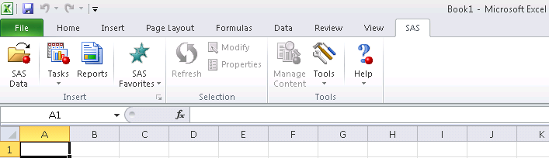

- From a PC running Windows 7:

Prior to the upgrade, access to the SAS Add-in for Excel was done through a virtual Windows XP environment that was running inside of Windows 7. This was necessary because the Add-in was not compatible with Windows 7 but running in the virtual XP environment had an impact on performance.

The new version of the SAS Add-in for Excel is installed directly in the Windows 7 environment and you will not need to access the virtual Windows XP environment to utilize it. To access the new version of the SAS Add-in, simply access the version of Excel that is available from the Start menu or desktop.

A link to Excel in the virtual Windows XP environment may have been created for you and placed on your desktop. DO NOT use this link to access the Data Warehouse after Spring Break.

The SAS tab in Excel should look slightly different, but familiar.

Prior to Spring Break you should have accessed the new version of the SAS Add-in and tested your access to the new Data Warehouse environment. If you do not have a SAS tab in Excel or you are having issues accessing the Data Warehouse, please contact the OIT Service Desk (oithelp@valenciacollege.edu).

