Getting to the Data Warehouse Portal:

The SAS Information Delivery Portal website is located at:
http://valenciacc.edu/DW

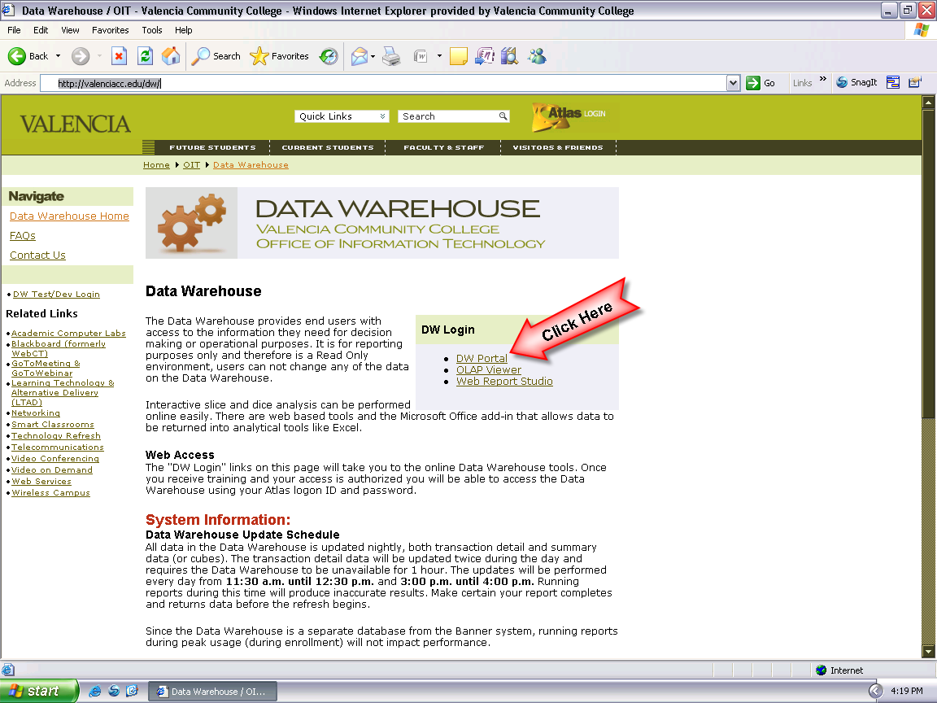

How to log onto the SAS Information Delivery Portal:

Type in your ATLAS User ID and Password, then click the “Log On” button. If you are having problems with your User ID or password, please send an email to DWHELP@valenciacc.edu.

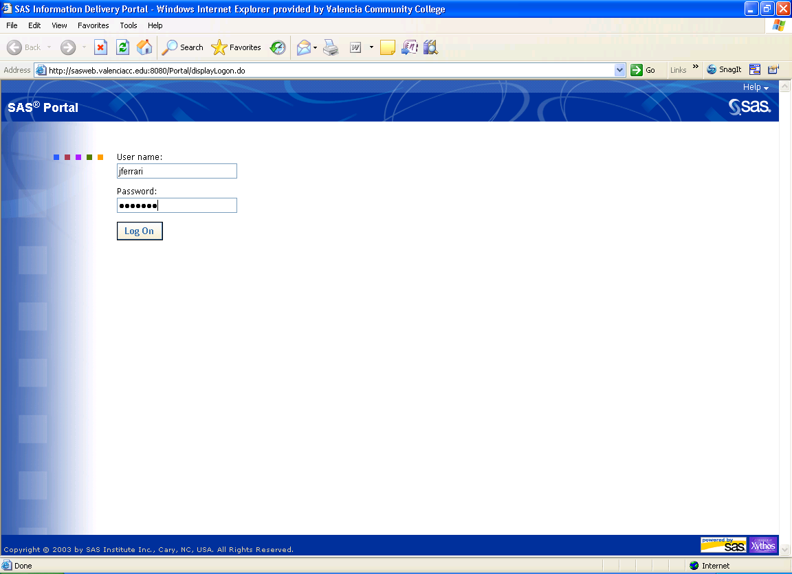

Running Class Scheduling reports

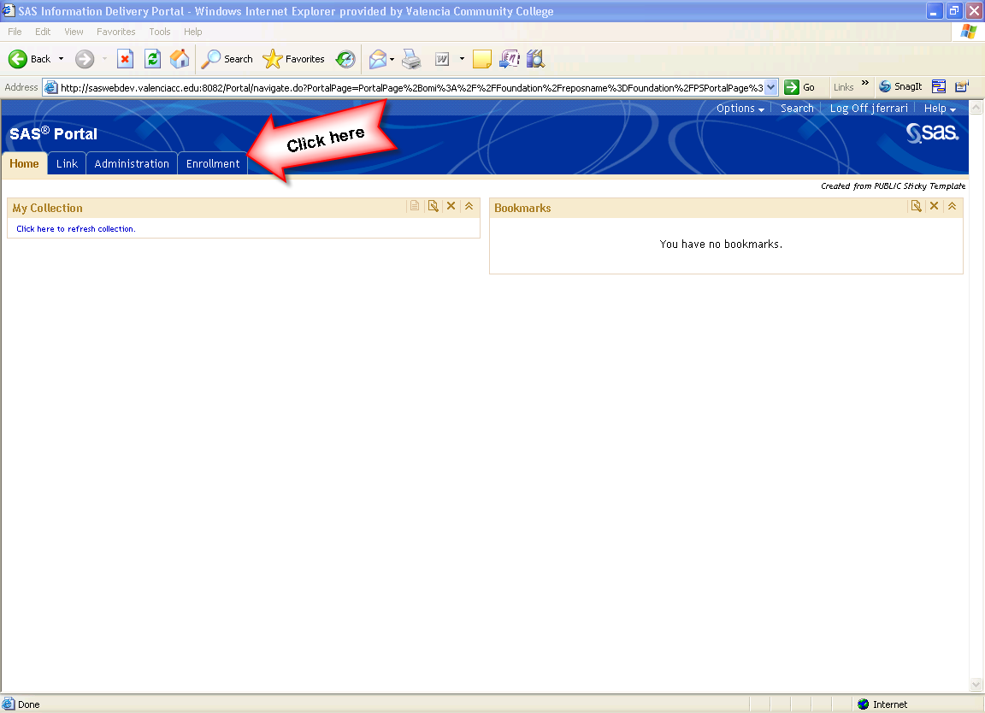

Click the blue lettering of the technical report name to run the report.
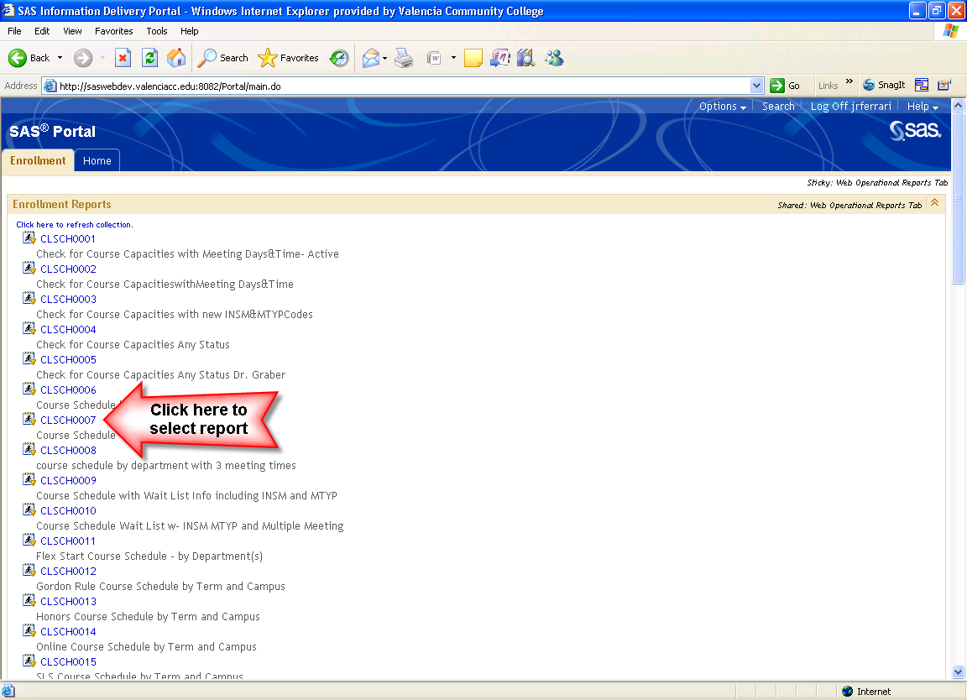
Running Class Scheduling reports (continued)

Populate parameters and click “Execute”.
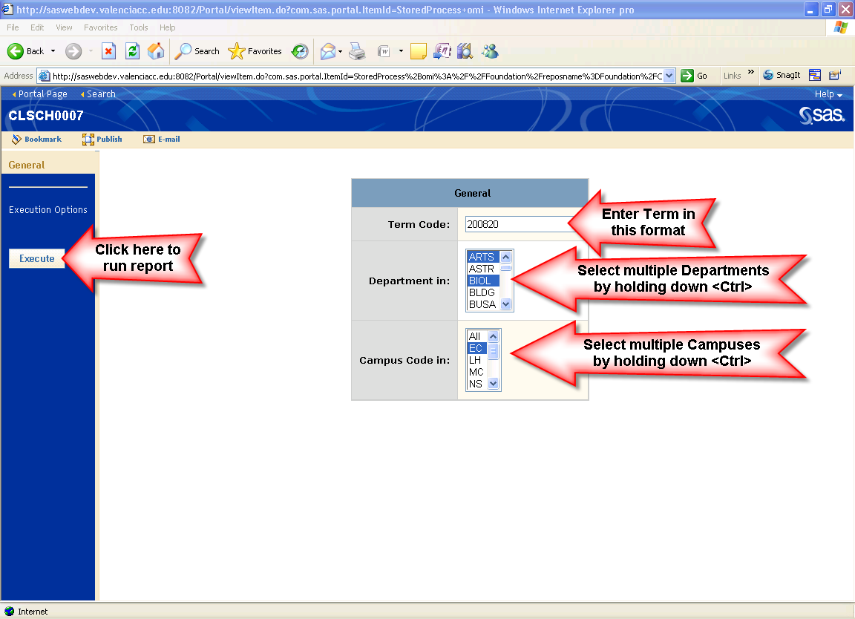

The output of the report is returned for viewing in your web browser.
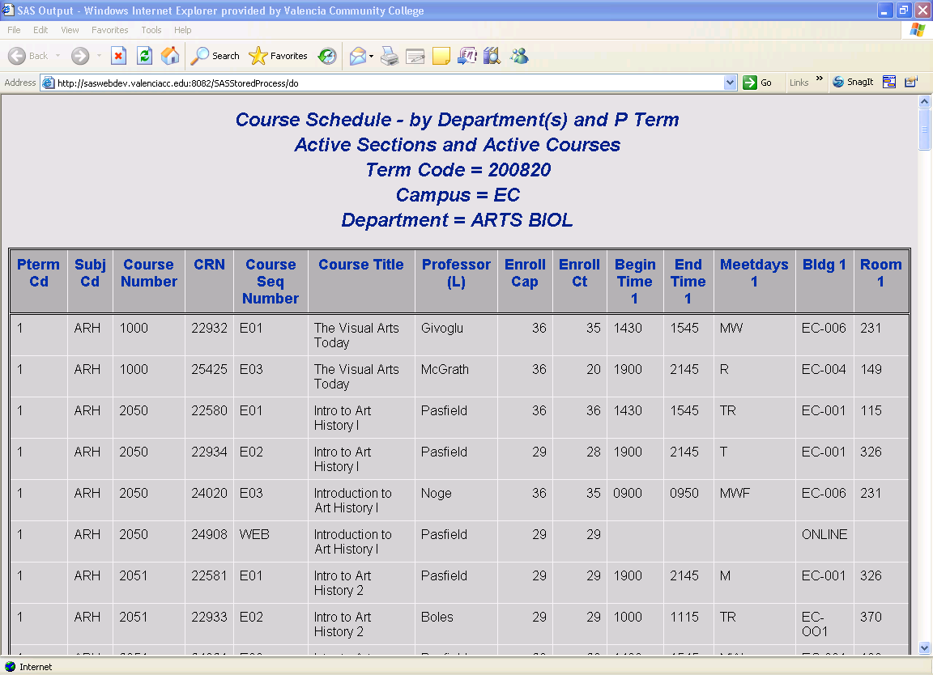
How to save report and access it in Excel:

- The report can be viewed online or saved as an HTML file that can be opened in Excel. Click File -> Save As… to save the report as an HTML file.

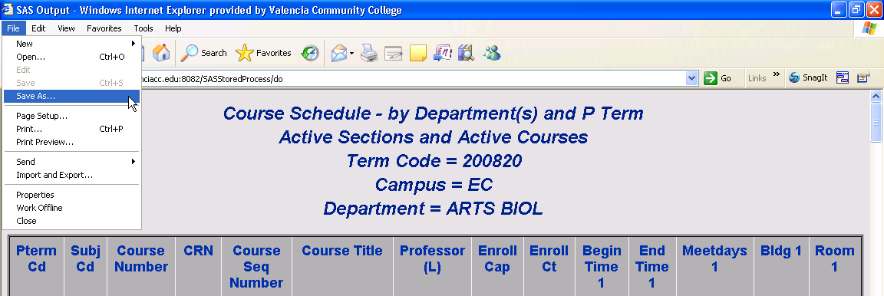

- If you get the following window, click on Yes. (You can also click the box next to “Never ask me again” so it doesn’t appear again.)

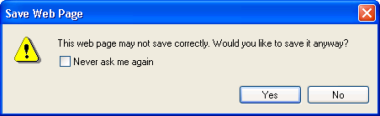

- Save the HTML file in a folder on your hard drive, you can give it a more appropriate name if you like.

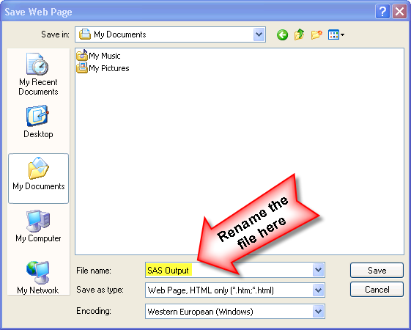

- Open Excel and select File -> Open.

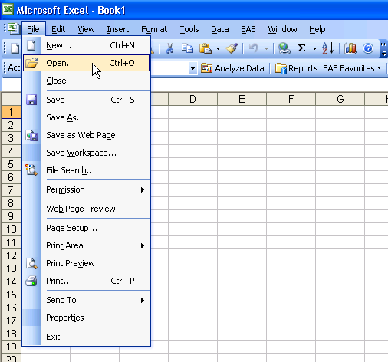

- Select the file you saved previously in step 3.

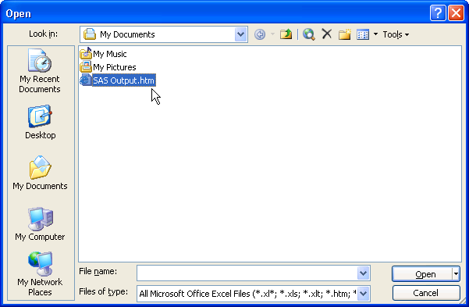

- The report data is available in Excel and needs to be saved in Excel format by selecting File -> Save As…

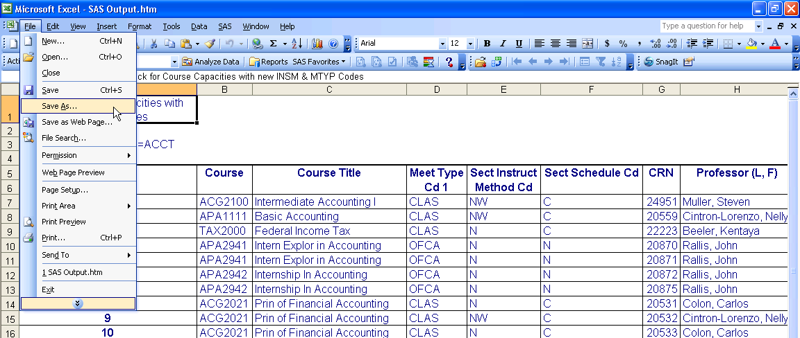

- Select “Microsoft Office Excel Workbook” for the “Save as type:” and give the file a more appropriate name.

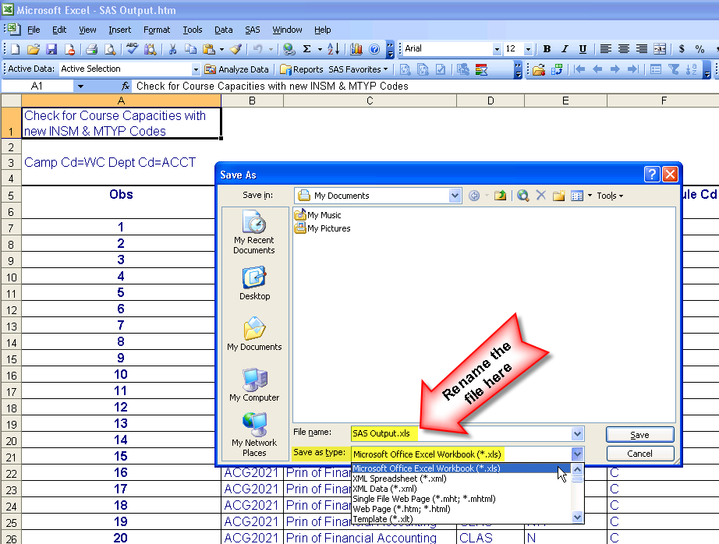

How to search for reports and add them as bookmarks to your portlet:

- Single click the word Search.

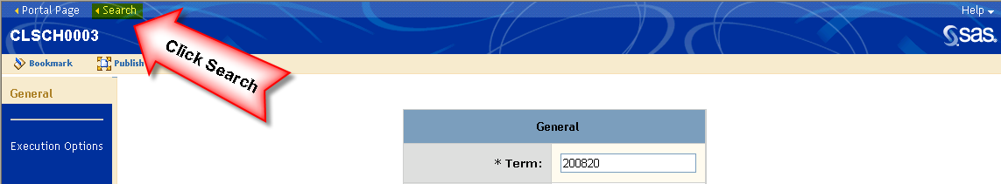

You can also get to the Search page from the Portal Page.

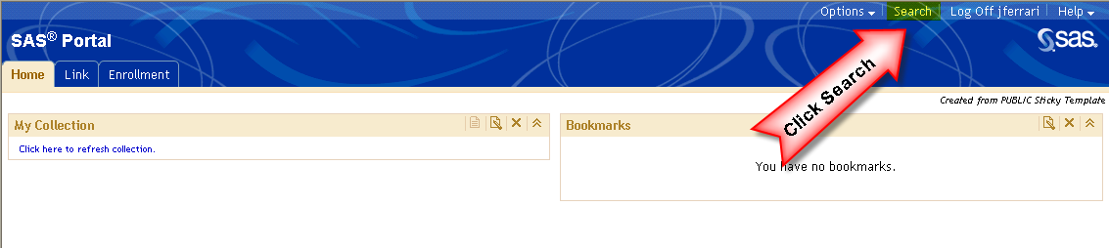

- Type the search criteria (Course Capacities, or any words from the Cognos report title) in the keywords box and put a check in the Select All box.
- Single click the Search button.

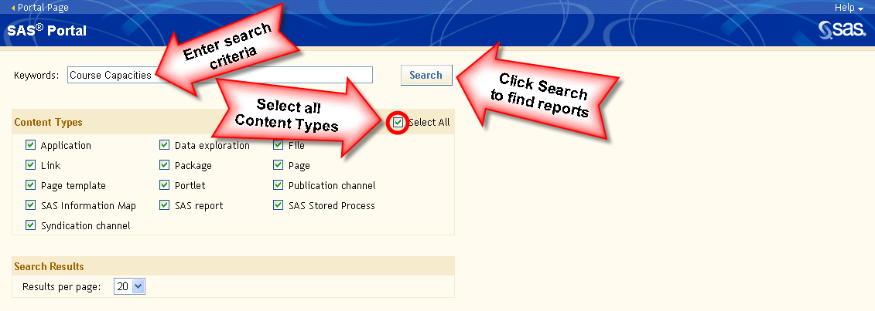

How to search for reports and add them as bookmarks to your portlet: (continued)

- The results of the search will appear on the screen as seen below:
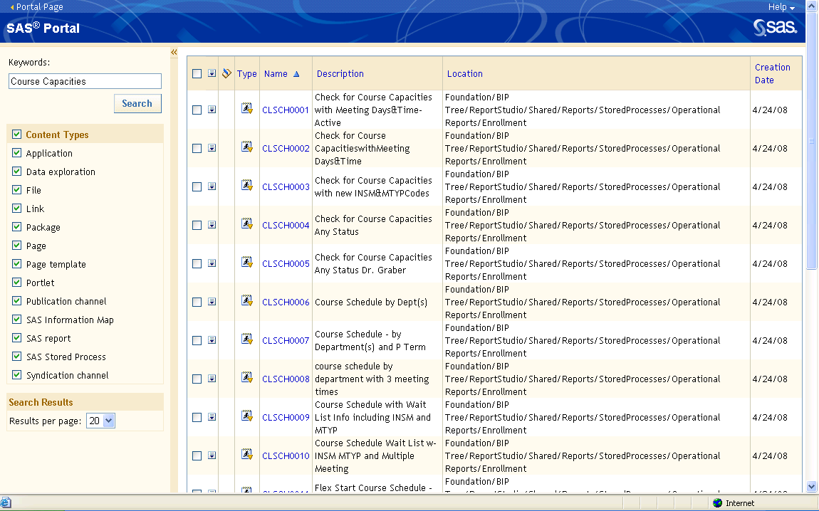

- Reports are returned with either “Course” or “Capacities” in the description. Using quotes “Course Capacities” will reduce the results to only descriptions that contain what is in quotes.
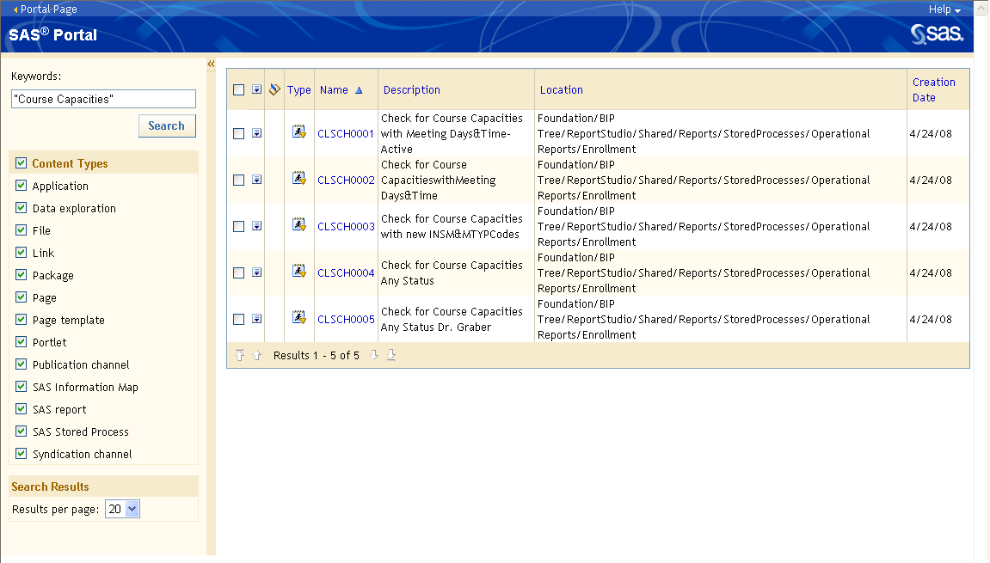

How to search for reports and add them as bookmarks to your portlet: (continued)

- Choose which reports you would like to bookmark by placing a check in the box to the left of the name or put a check in the top box to select all reports.

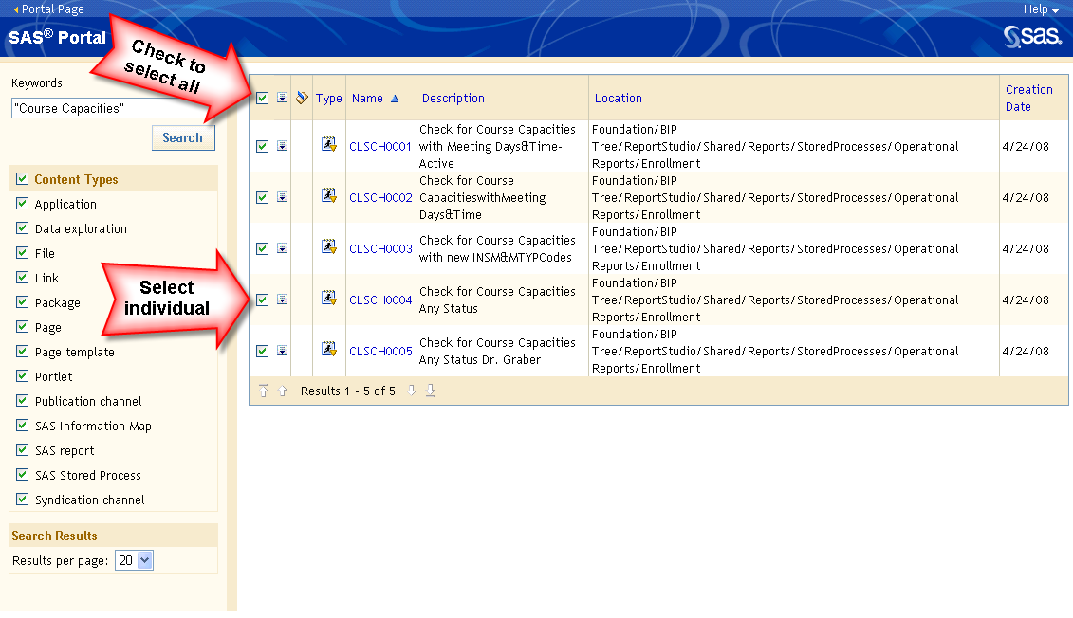

- Next, single click the icon to the right of the check box.
- Select bookmark.

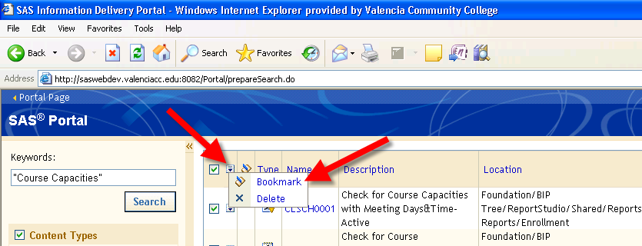

How to search for reports and add them as bookmarks to your portlet: (continued)

- The following message will appear if you chose select all:

- Next, single click the words Portal Page at the top left-hand corner of the website to return to the Home page.

- Click on the “Home” tab to get to your Portal Home Page.

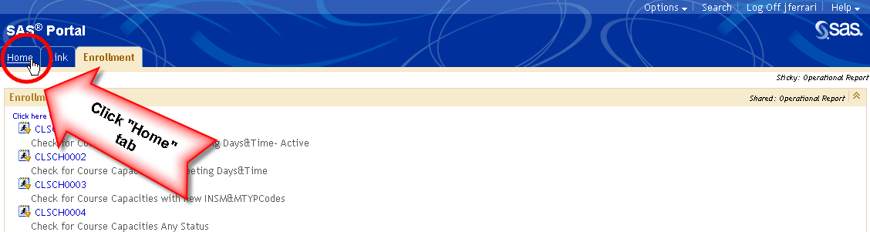

- Your bookmarks appear on your home page.

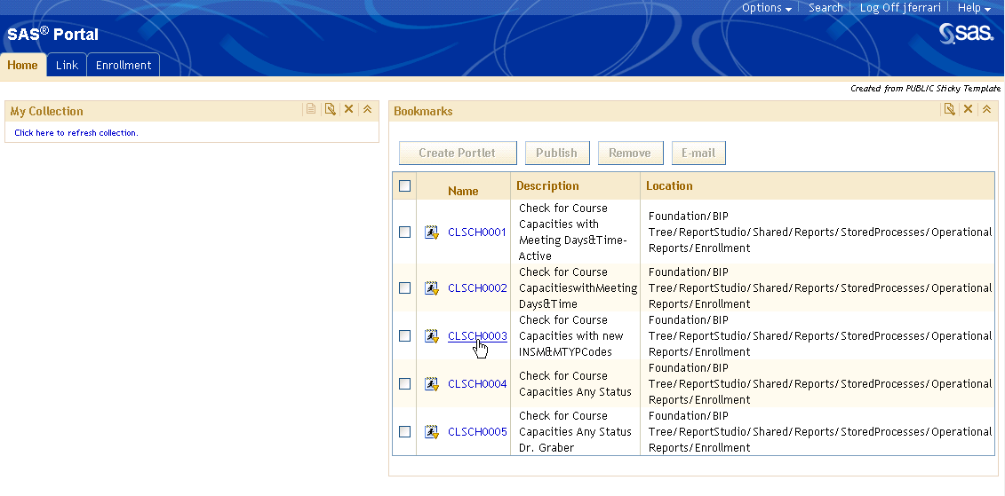

How to run reports:

- Single click the name of the report to run the report.

- Populate parameters and click “Execute” to run report.

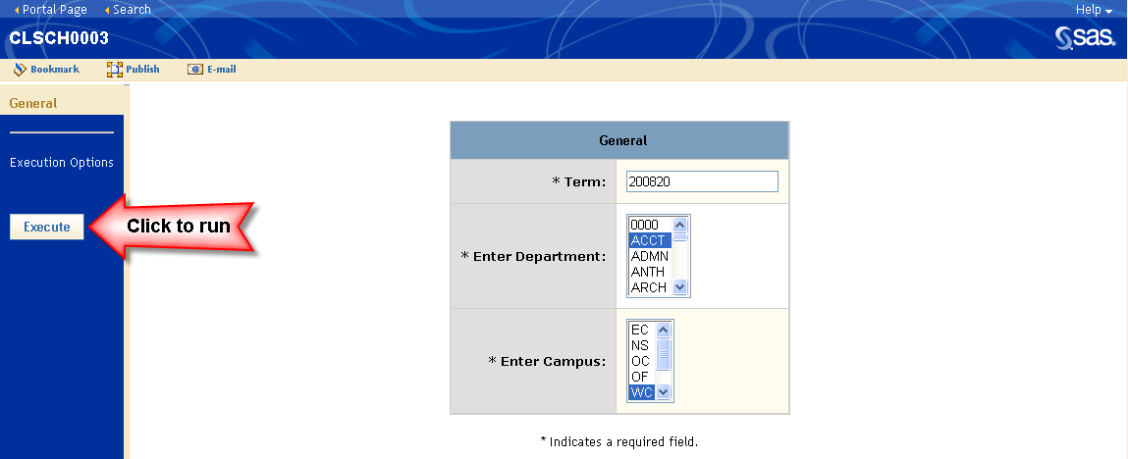

- To return to the Home page, single click the words Portal Page at the top left-hand corner of the website.

- If you are finished running reports and you wish to leave the SAS Portal page, please single click Log Off at the top right-hand corner of the website.

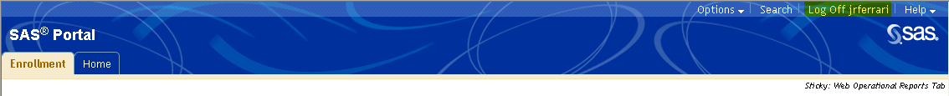

- You will now be back at the SAS Portal Log on page.
- Single click the red X to exit Internet Explorer.

