SAS ATD TRAINING MANUAL

FEATURING THE SAS ADD-IN FOR MICROSOFT EXCEL
- Double click your Microsoft Excel icon to launch Microsoft Excel.
- Click SAS from the Microsoft Excel menu.
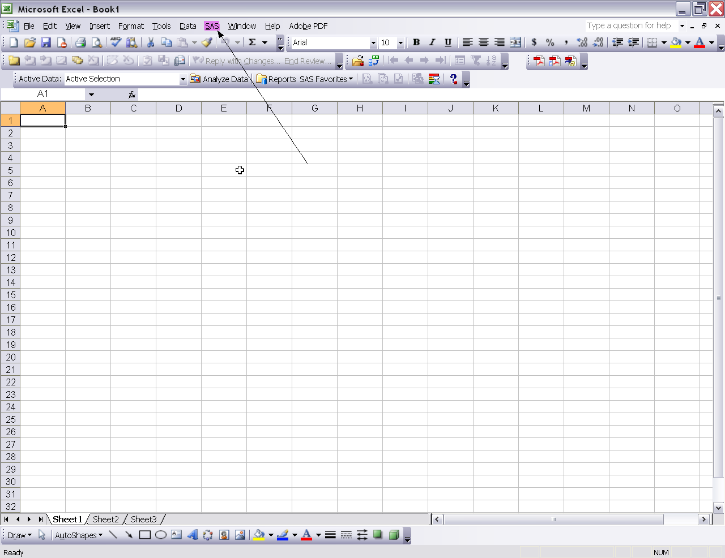
- Select Open Data Source, then click Into PivotTable.
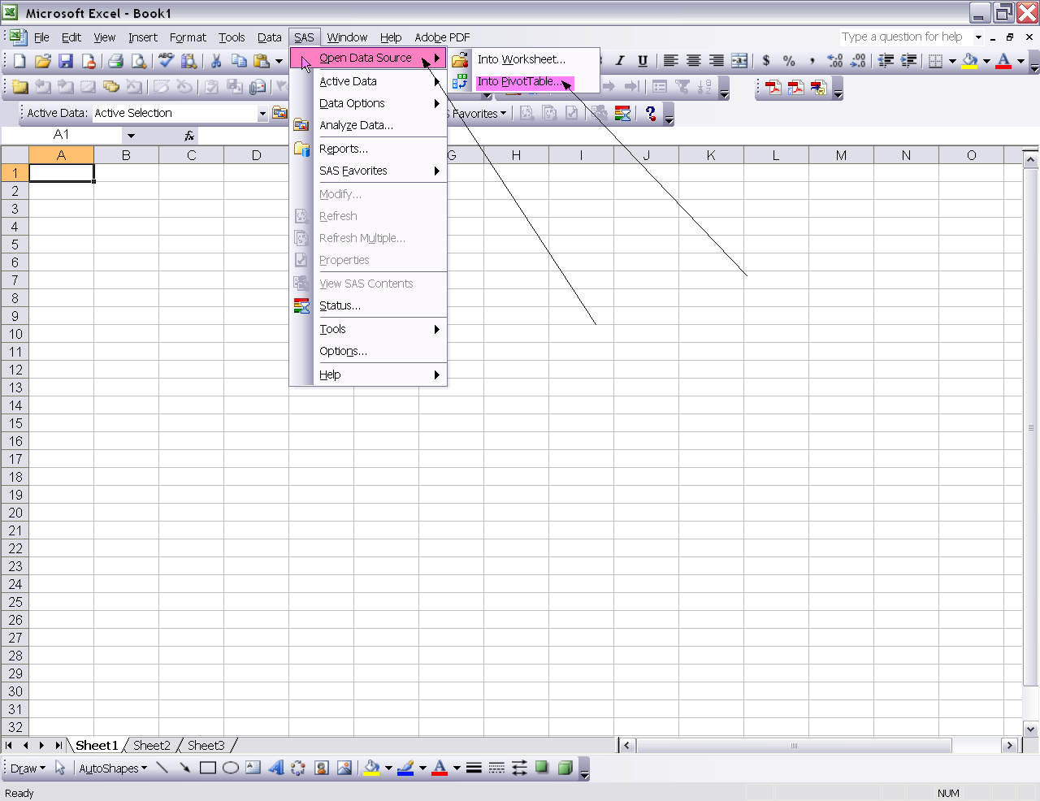
  - The SAS Metadata Server Login box will appear.
  - Type in your Atlas User name in the User name box.
  - Type in your Atlas Password in the Password box.
  - Click the ok button.
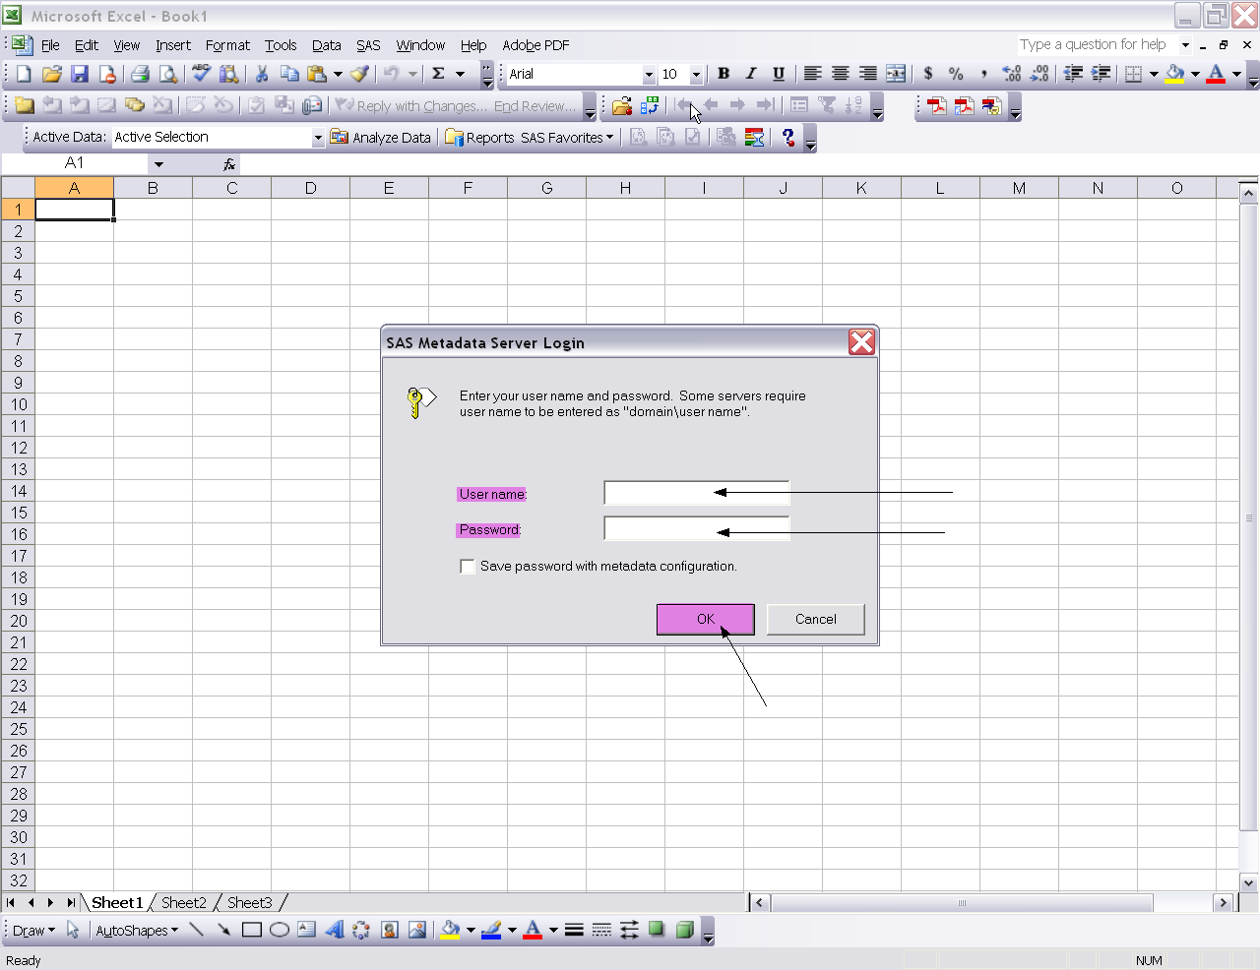
- The Open into PivotTable dialogue box will appear.
- Select SASMain, then double click Strategy_Detail_Cube.
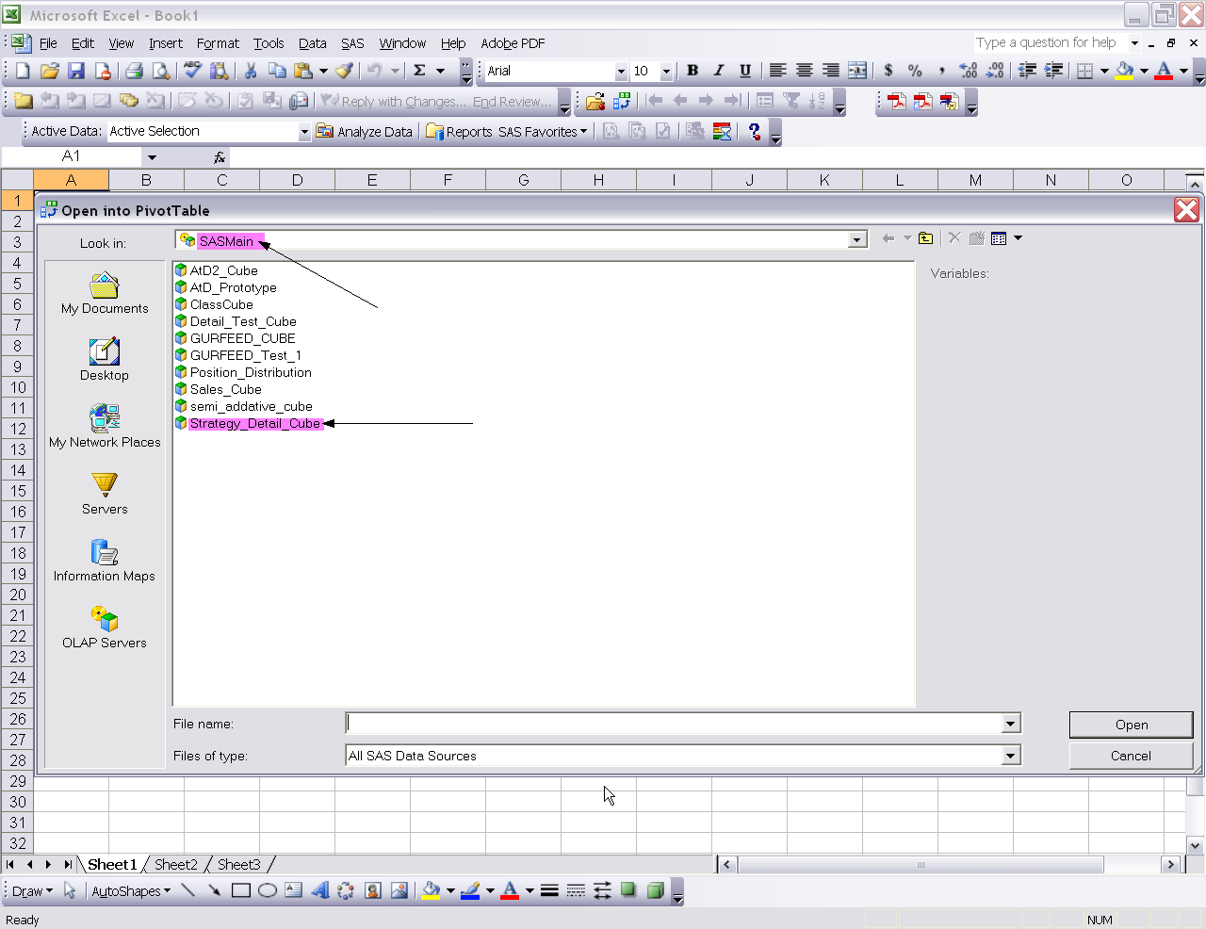
- The Modify Data Source – Strategy_Detail_Cube box will appear.
- Click the radial button to the left of Existing worksheet.
- Click the ok button.
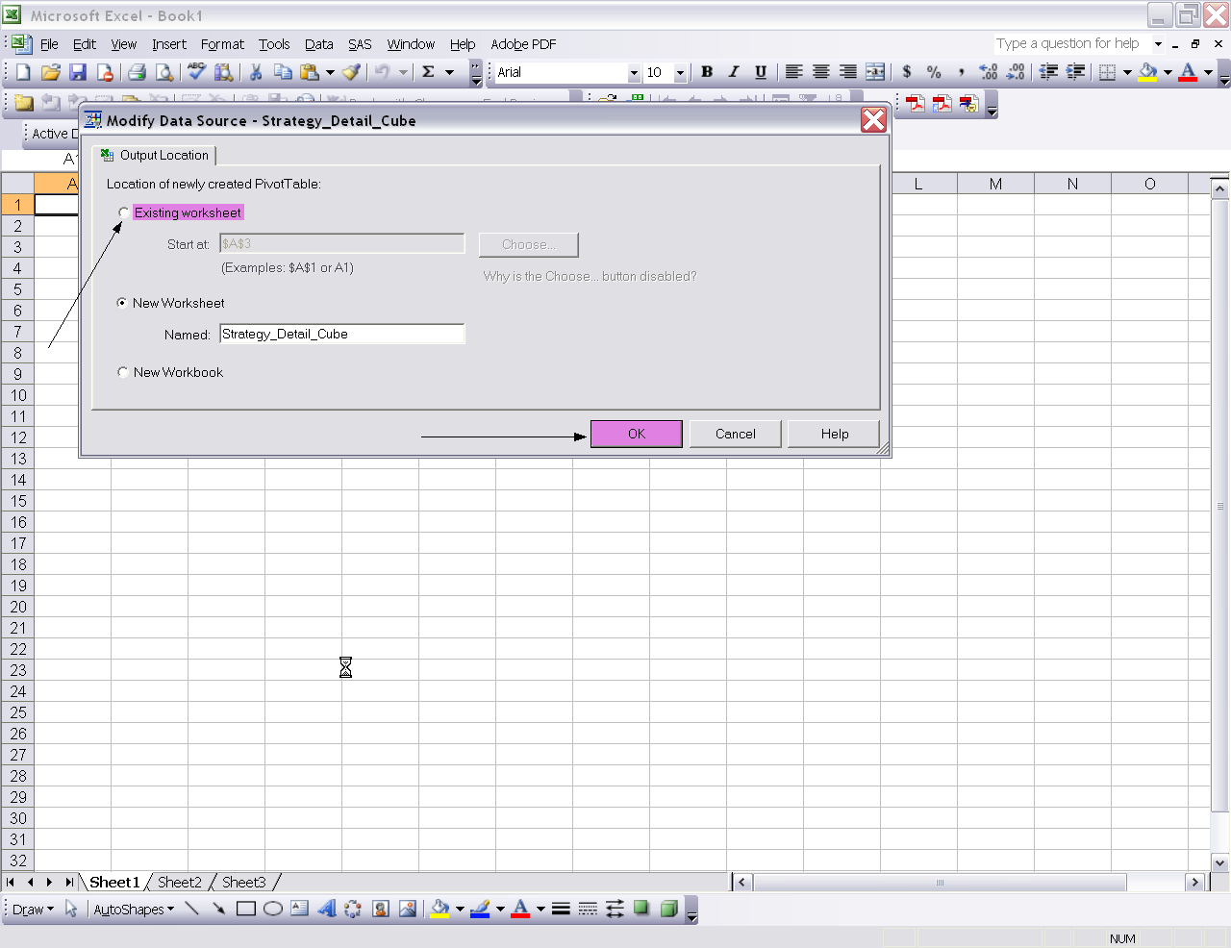
- This is how the Pivot Table first appears.
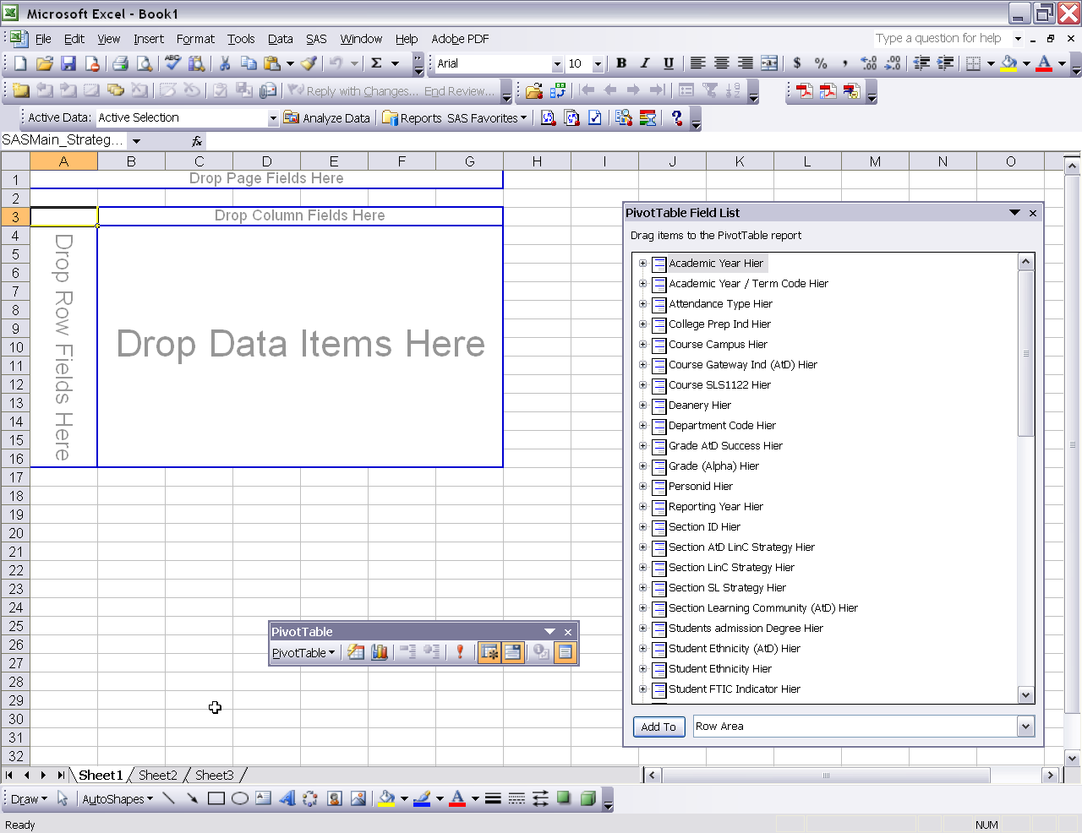
- Single click Student Ethnicity (Atd) Hier from the PivotTable Field List.
- Single click the Row Area button.
- Single click the Add To button.
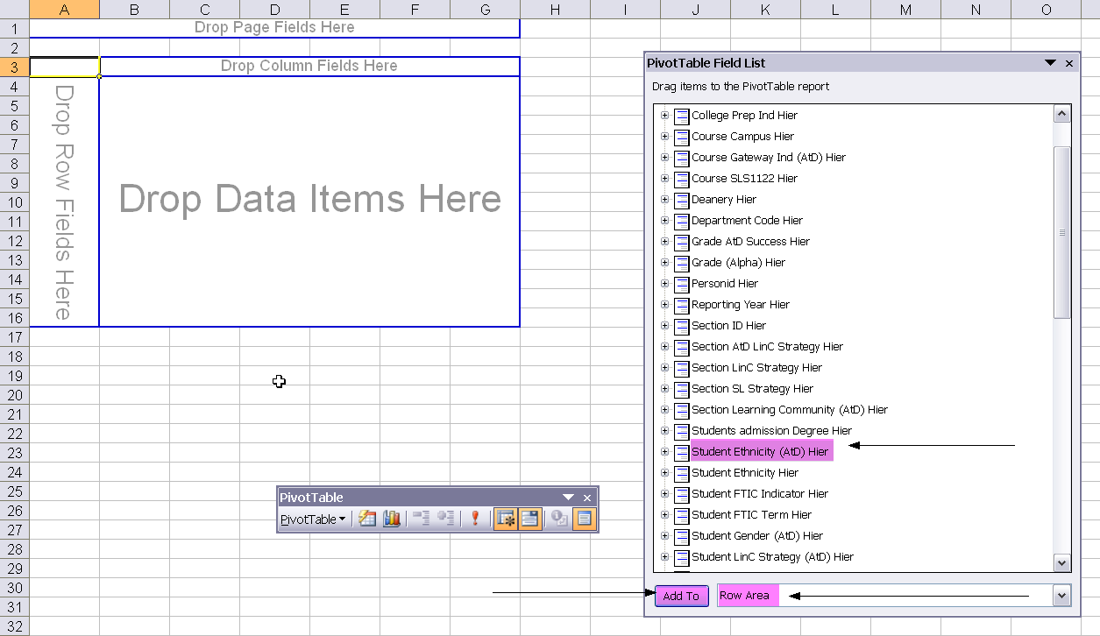

- Single click Section SL Strategy Hier from the PivotTable Field List.
- Single click the Row Area button.
- Single click the Add To button.
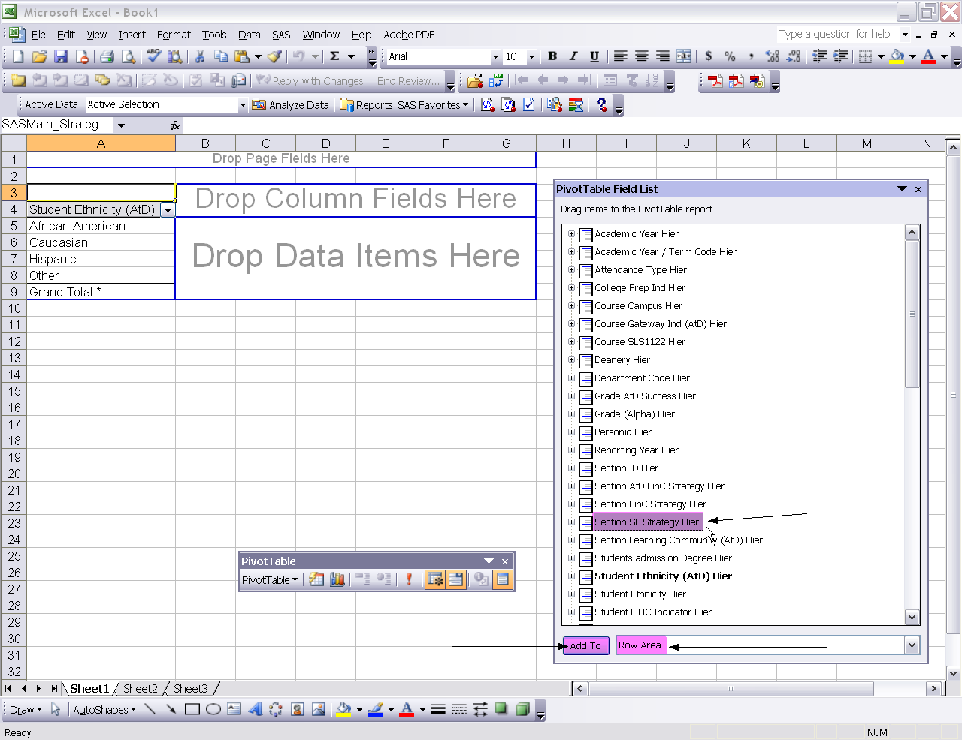

- Single click Student FTIC Term Hier from the PivotTable Field List.
- Single click the Page Area button.
- Single click the Add To button.
- 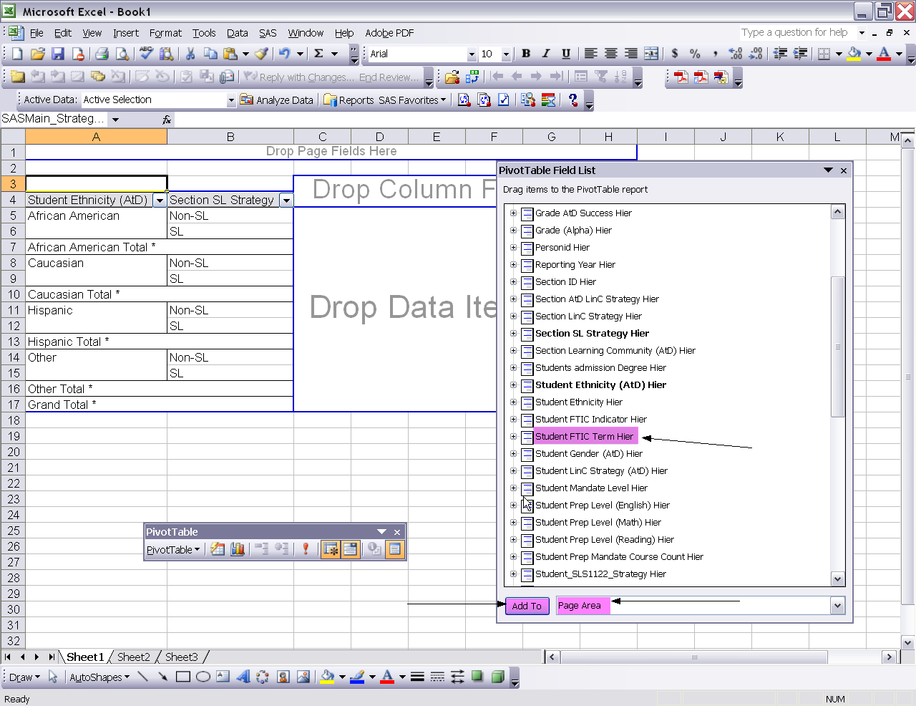

- Single click Subject Code and Course Number Hier from the PivotTable Field List.
- Single click the Page Area button.
- Single click the Add To button.
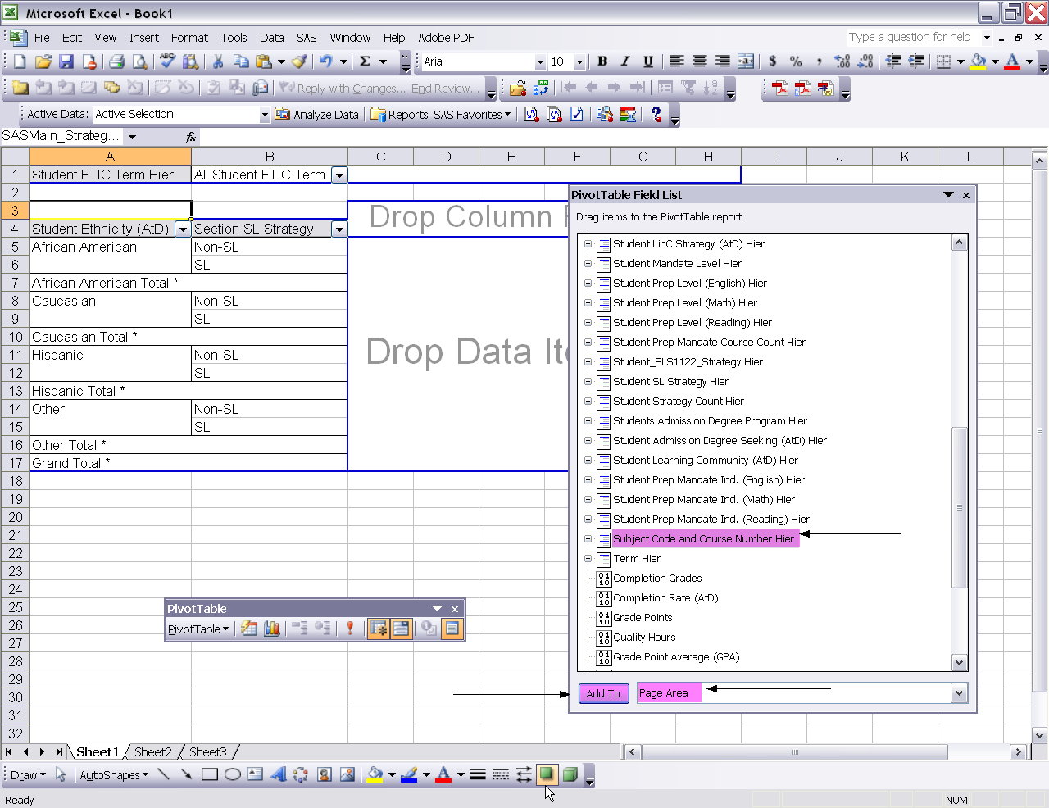
- Single click Academic Year/Term Code Hier from the PivotTable Field List.
- Single click the Page Area button.
- Single click the Add To button.
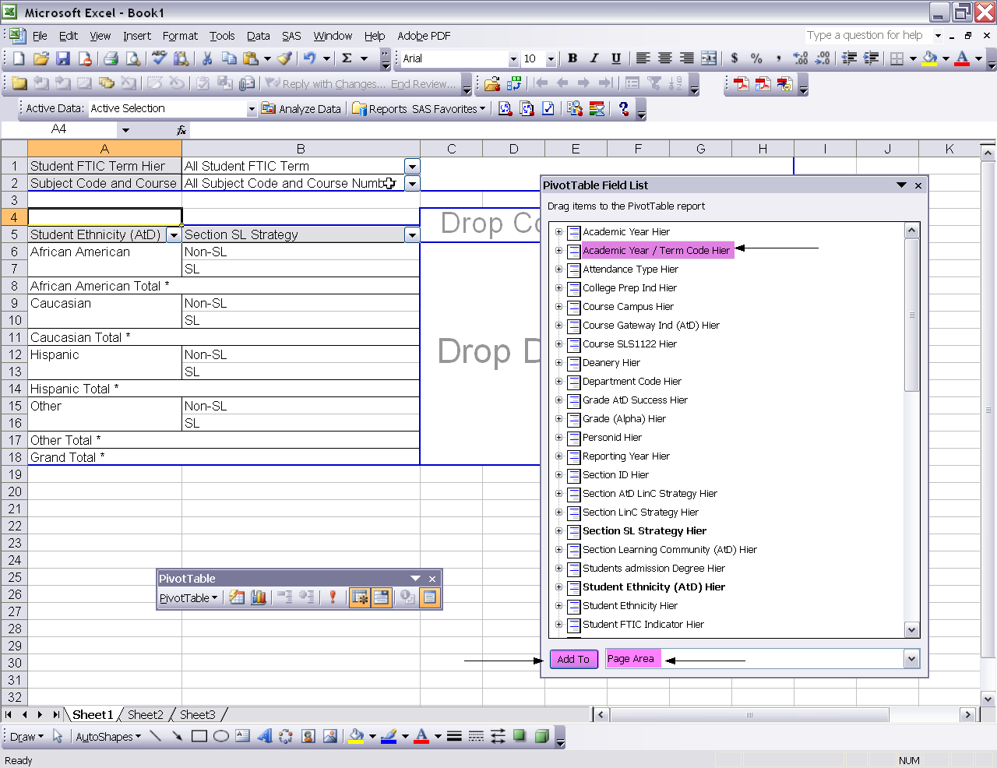
- Select the pull down arrow next to All Student FTIC Term located in column B.
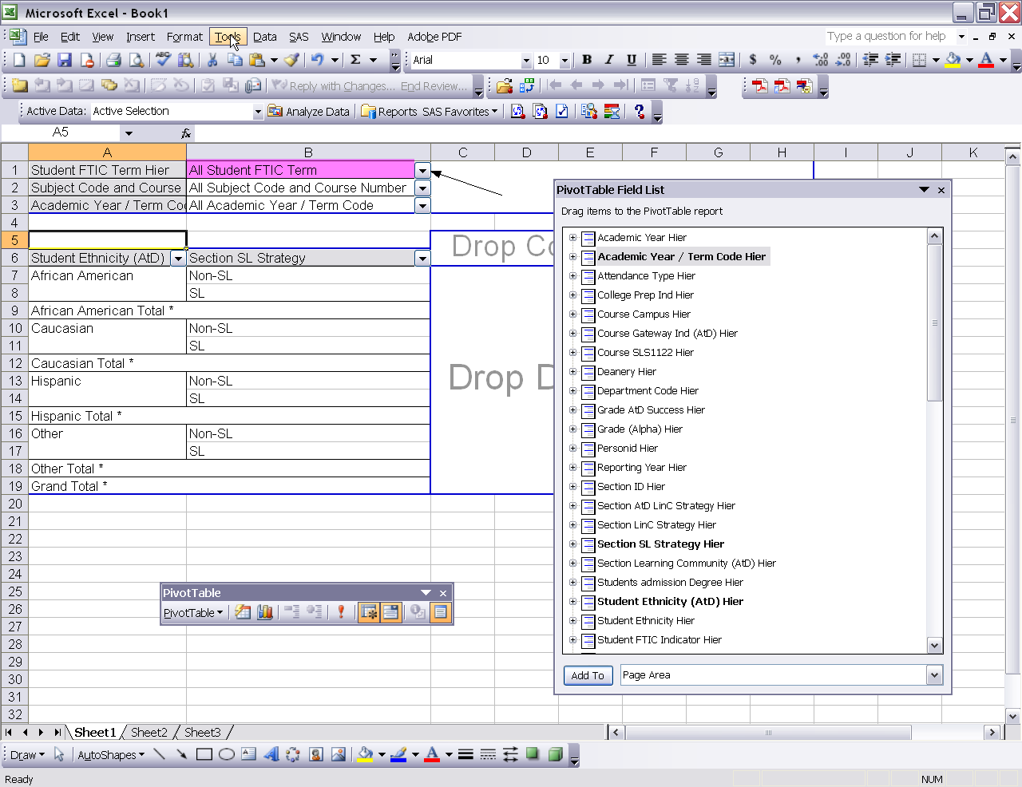
- The Filter dialogue box for All Student FTIC Term appears.
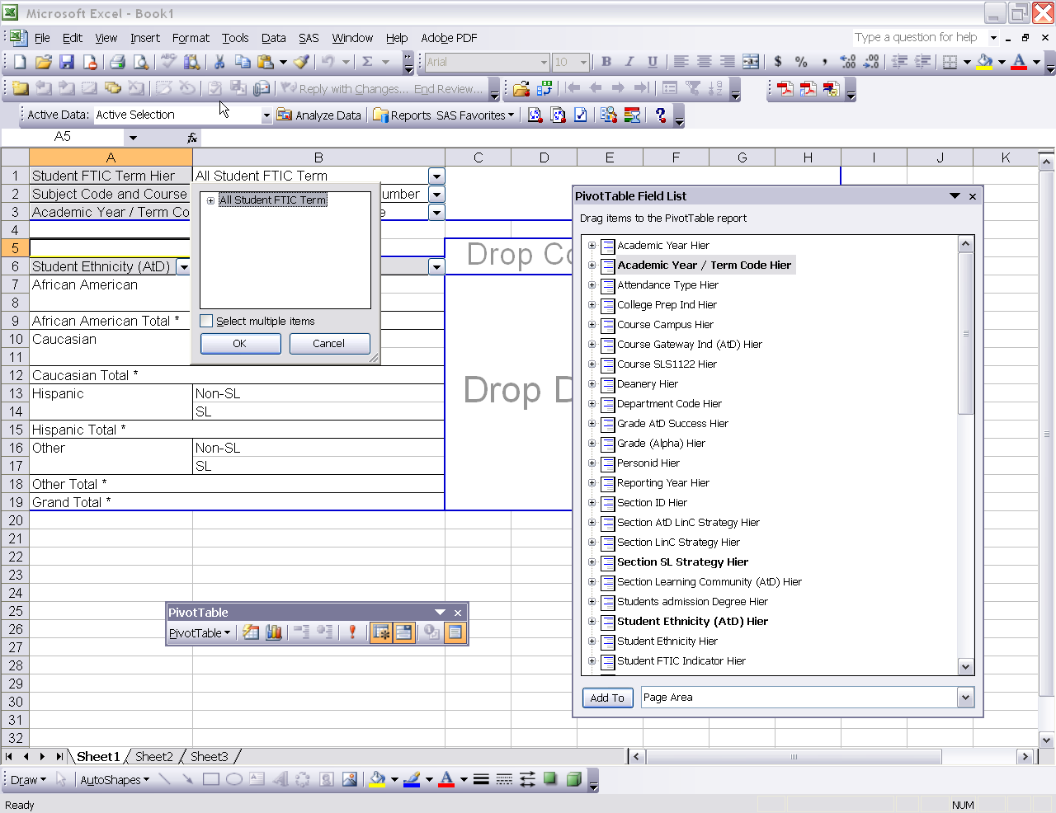
- Single click the plus sign to the left of All Student FTIC Term.
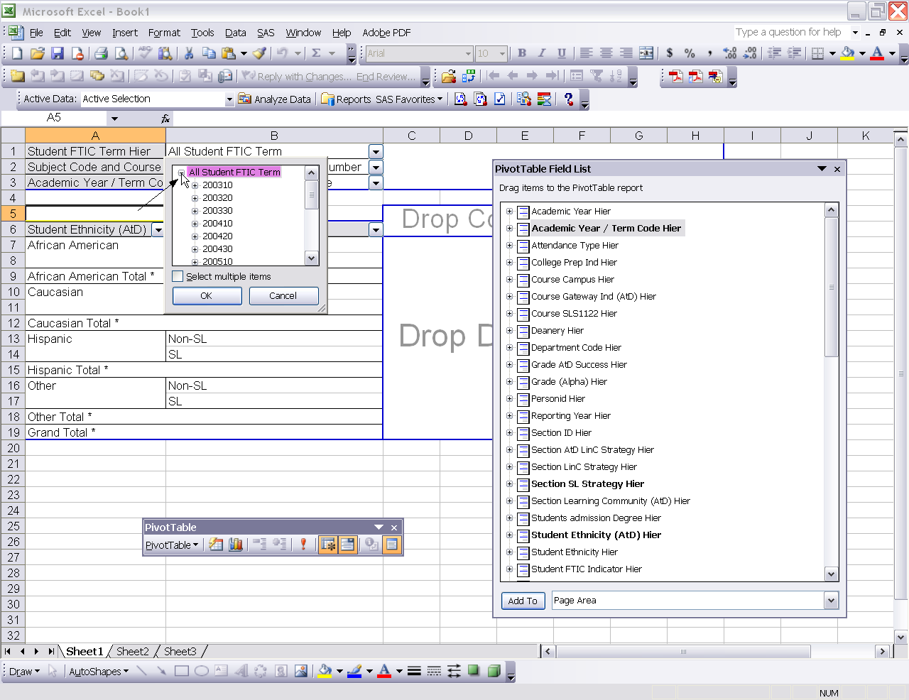
  - Single click the check box to the left of Select multiple items.
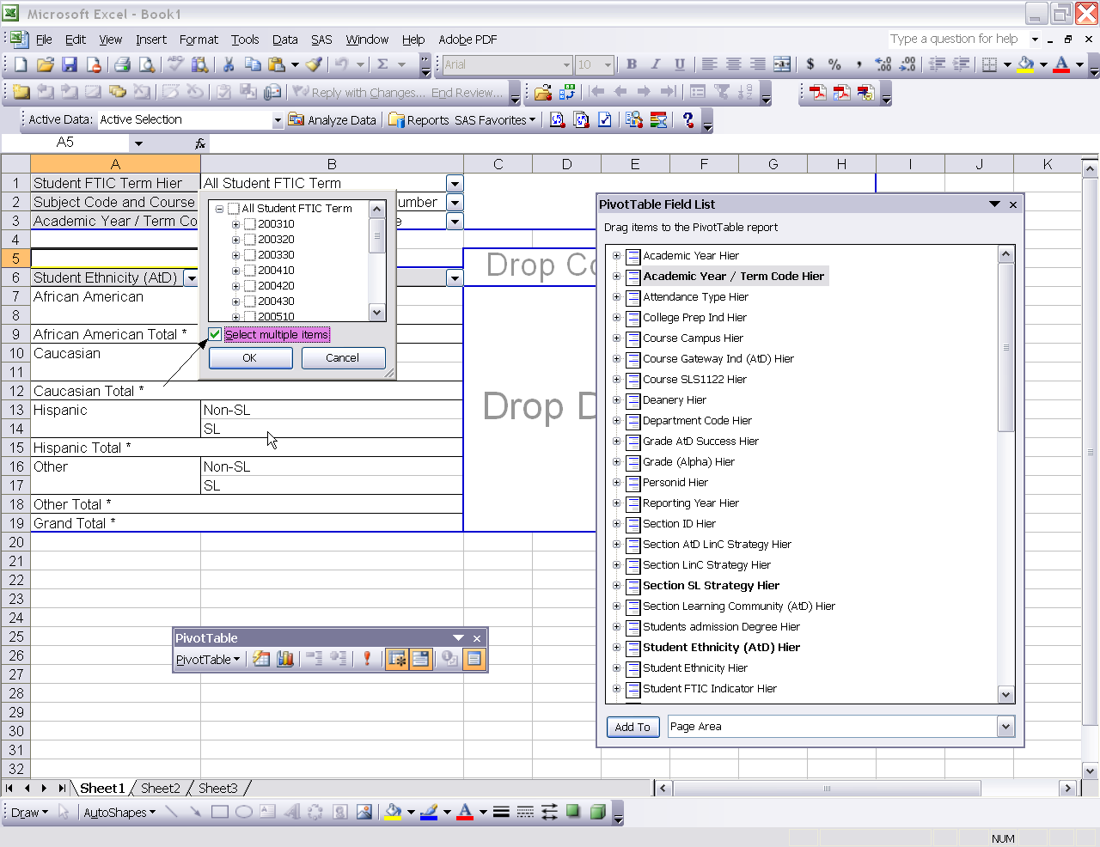

  - Single click the check box to the left of All Student FTIC Term to clear out all check marks.
  - 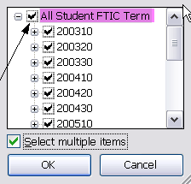
Use the scroll bar and single click the check box to the left of 200730 and 200810.
  - Click the ok button.
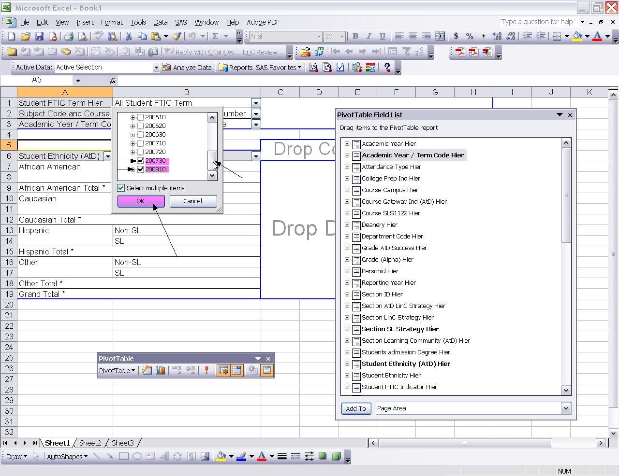
- Use the pull down arrow to the right of All Subject Code and Course Number located in column B.
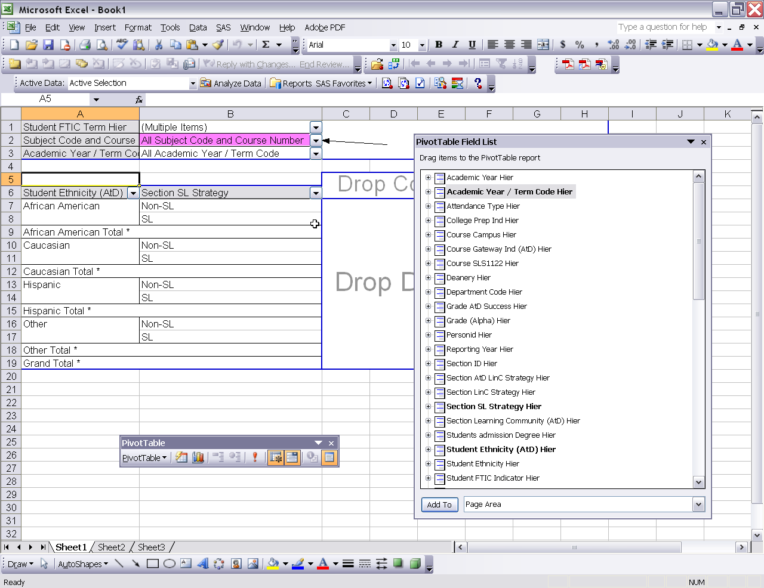
- The All Subject Code and Course Number filter box appears.
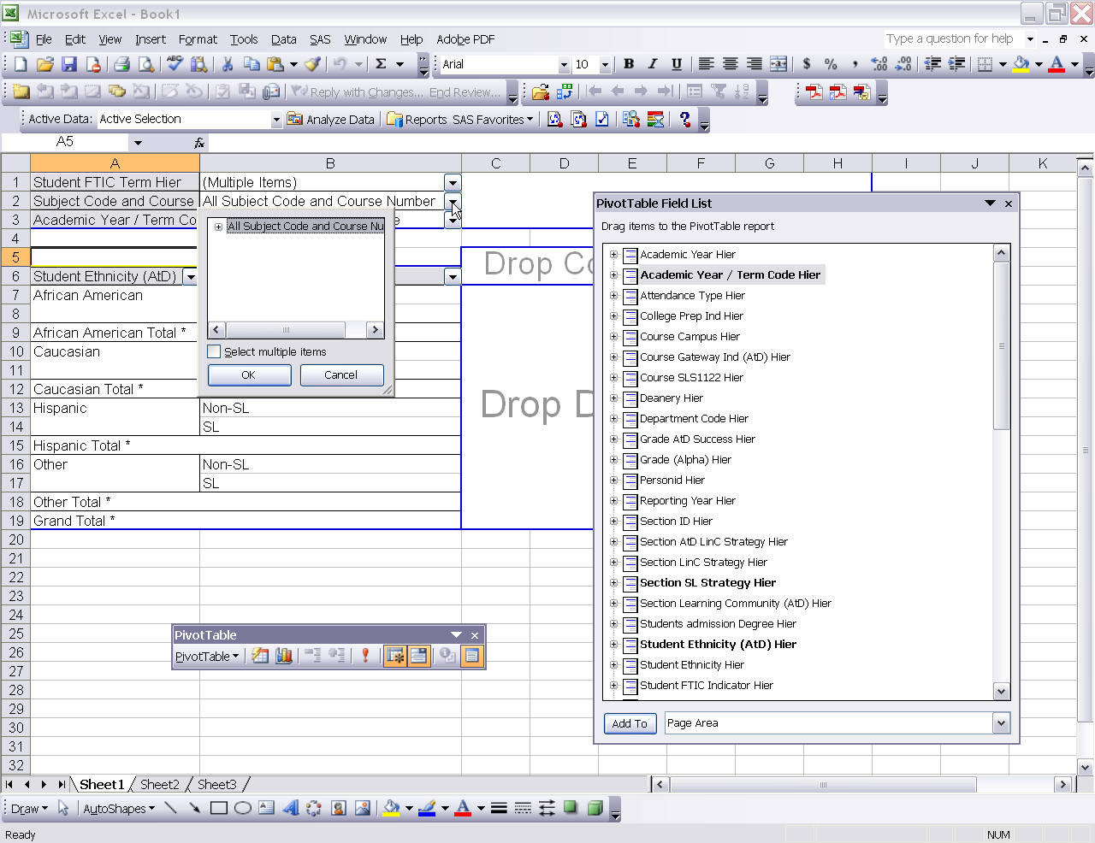
- Single click the plus to the left of All Subject Code and Course Number.
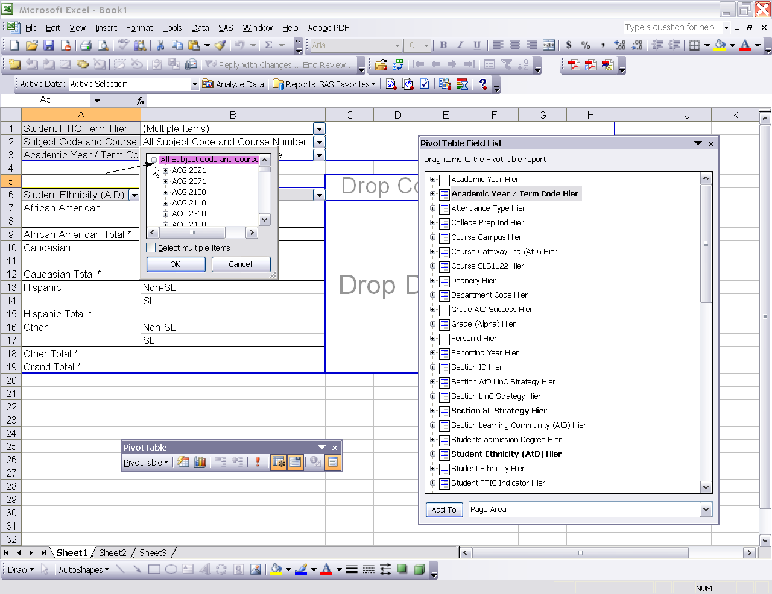
- Check the box to the left of Select multiple items.
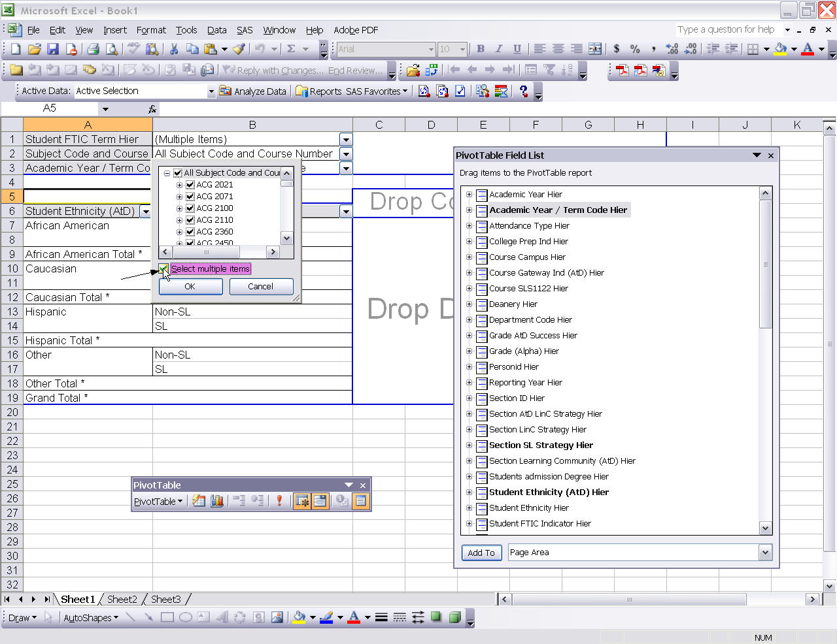
- Single click the check box to the left of All Subject Code and Course Number to remove the check in the box.
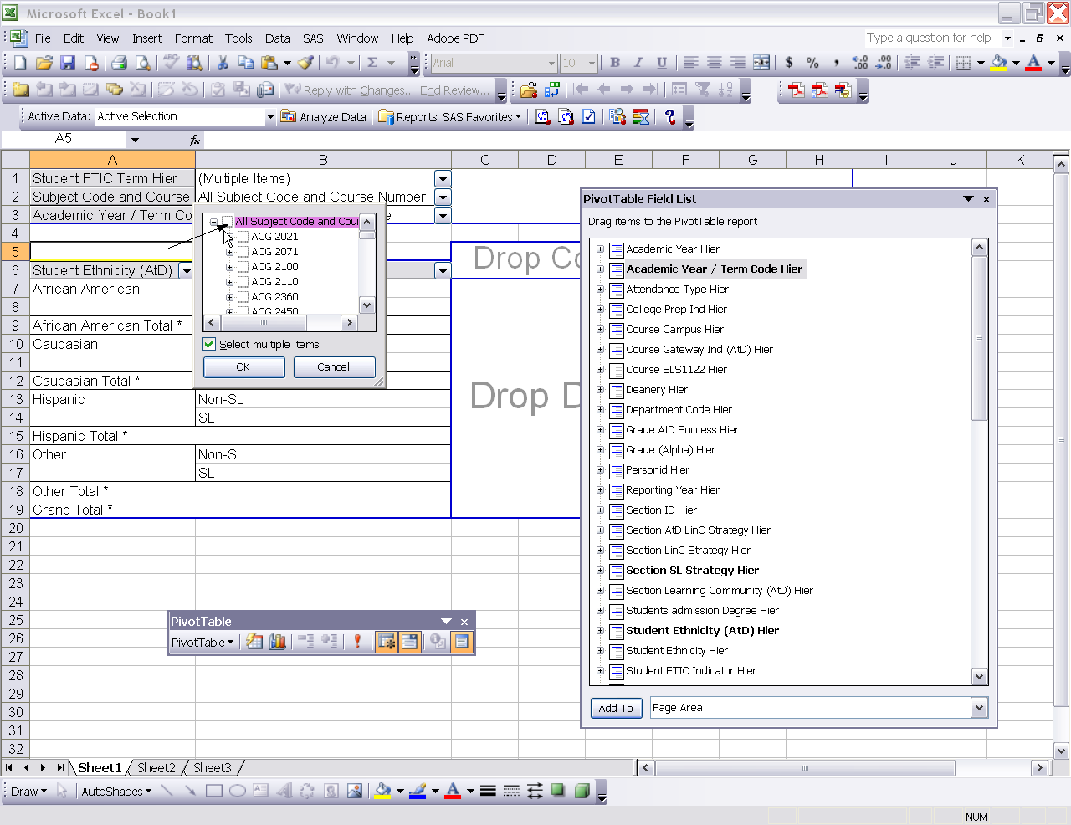
- Use the scroll bar until you find MAT0012C.
- Single click the check box to the left of MAT0012C, MAT0024C, and MAT1033C.
- Single click the ok button.
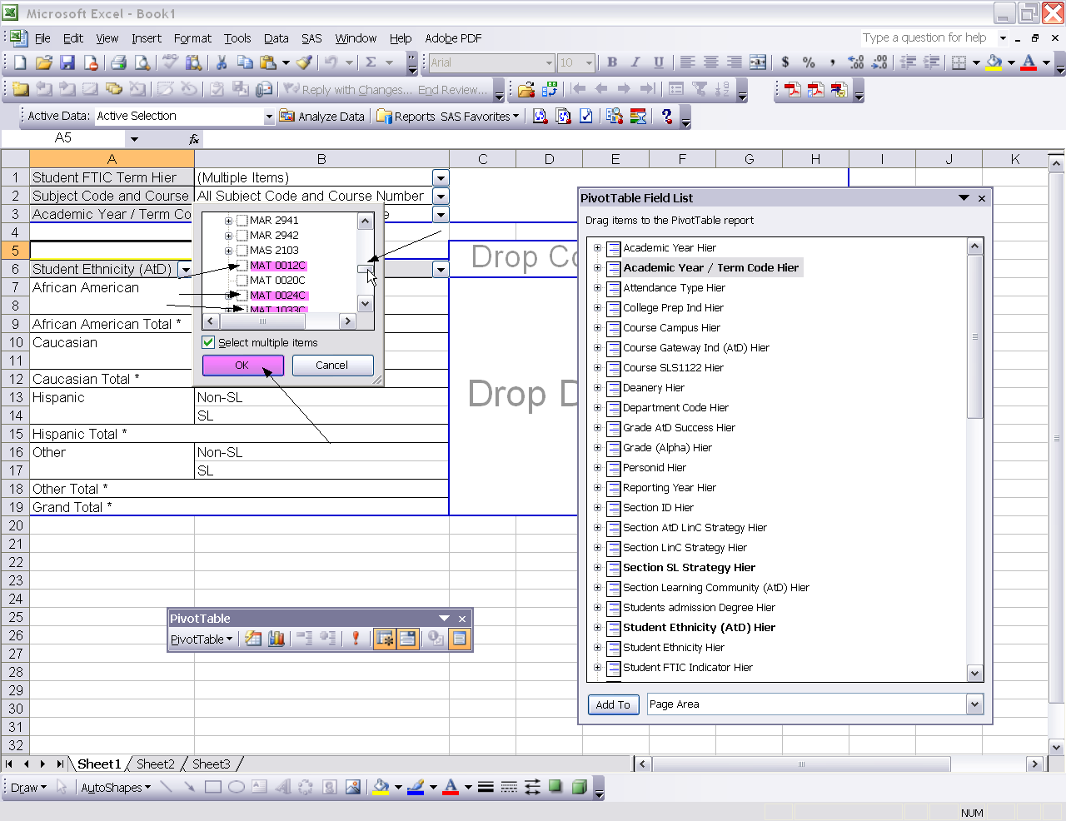
- Use the pull down arrow to the right of All Academic Year/Term Code.
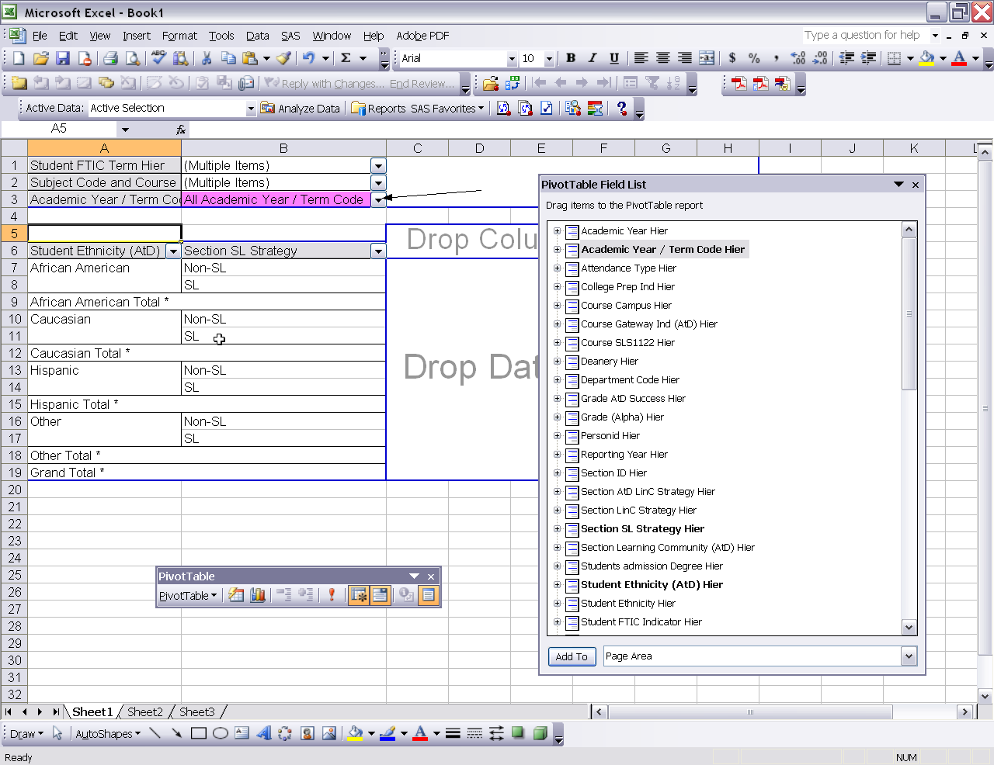
- The All Academic Year/Term Code filter box appears.
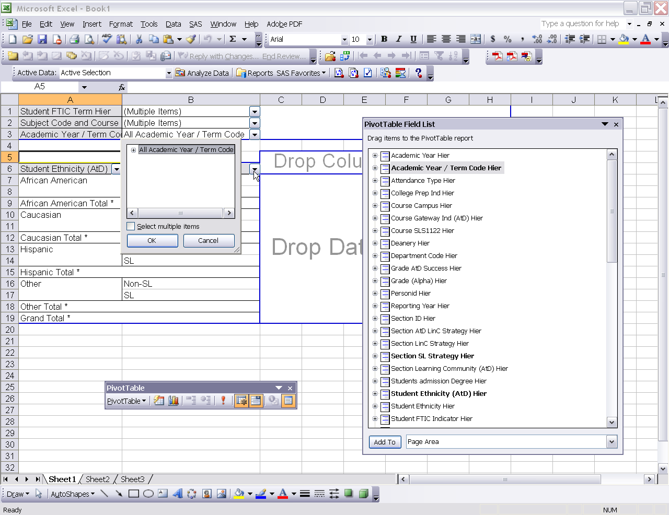
- Single click the plus sign to the left of All Academic Year/Term Code.
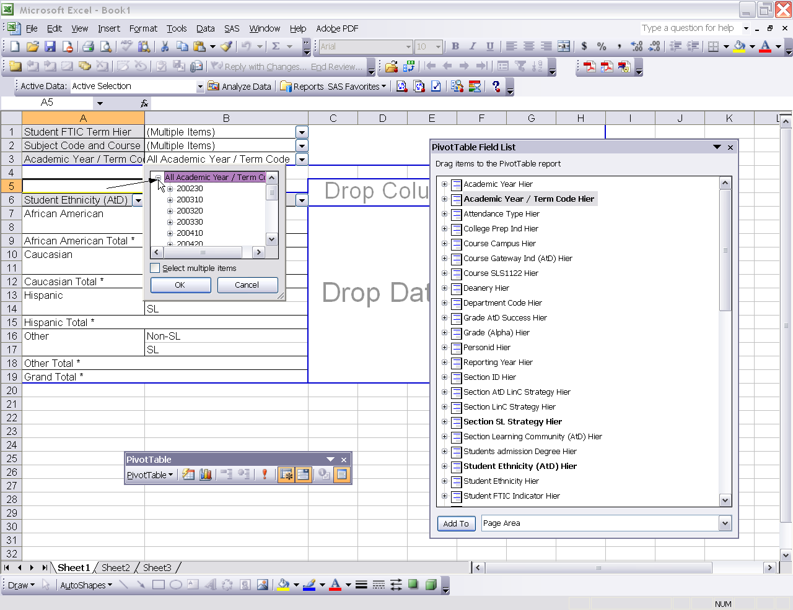
- Use the scroll bar to scroll to term 200810.
- Single click 200810.
- Click the ok button.
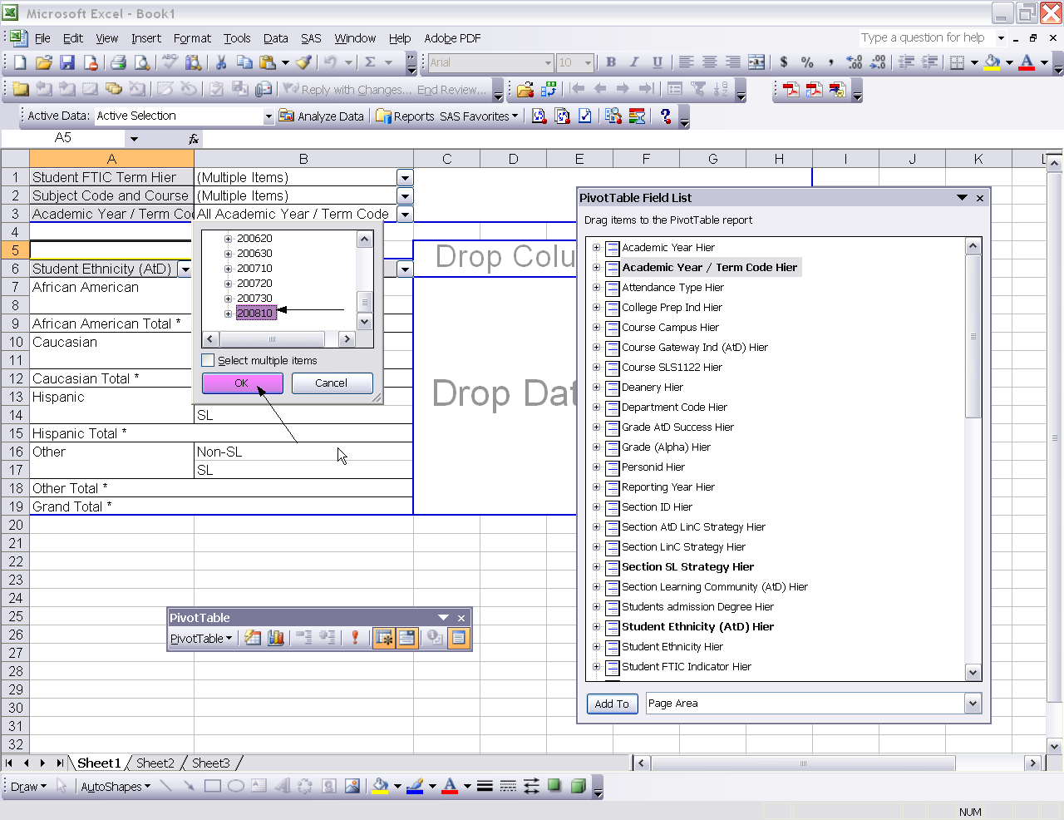
- Select Grade Atd Success Hier from the PivotTable Field List.
- Use the scroll bar to choose Column Area.
- Single click Column Area.
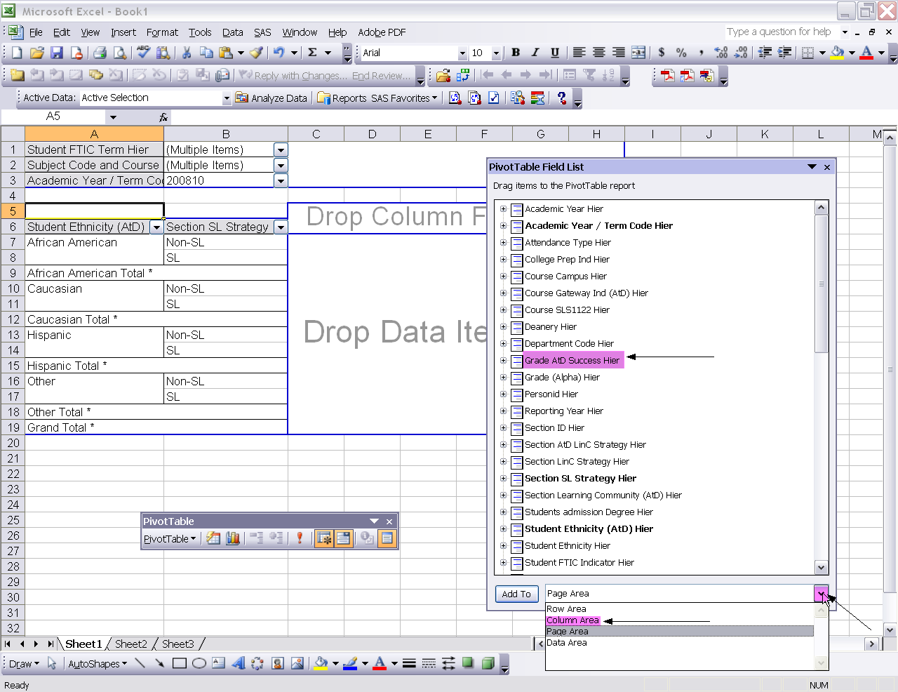
- Single click the Add To button.
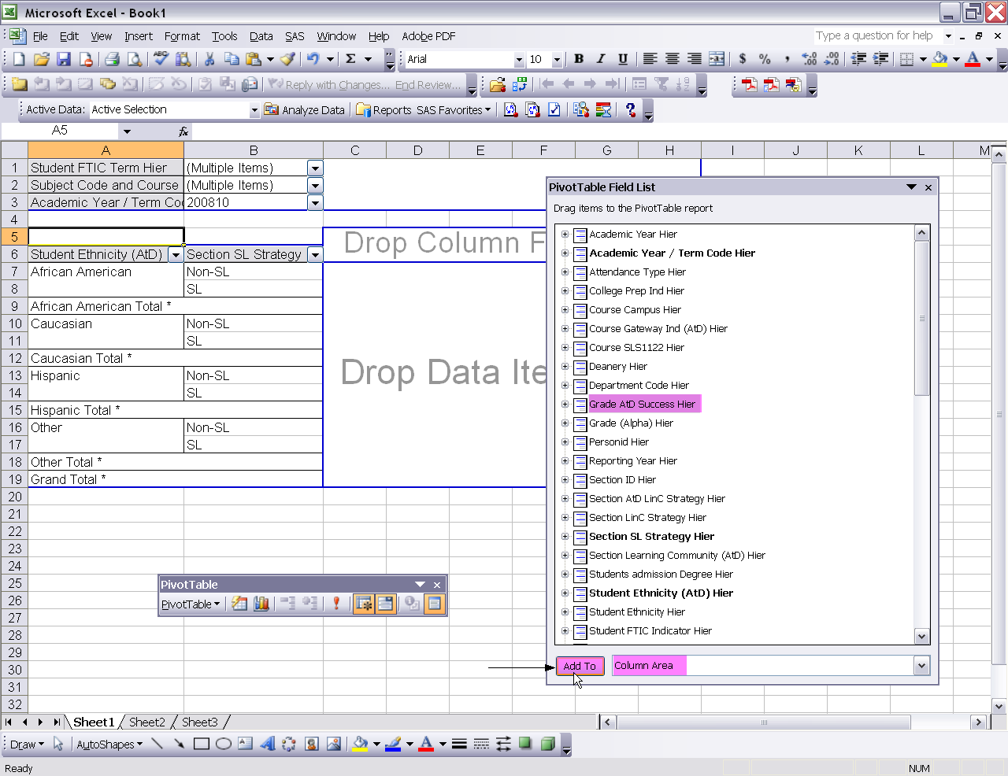
- Use the scroll bar in the PivotTable Field List to scroll to the measure called Grades Issued.
- Single click Grades Issued.
- Use the pull down arrow to the right of the Add To button to choose Data Area.
- Select Data Area.
- Single click the Add To button.
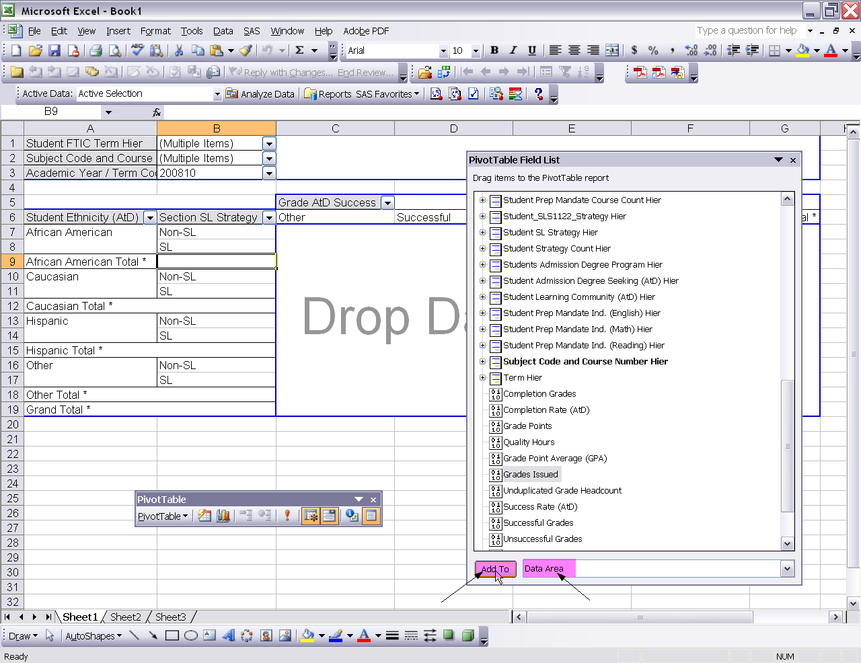
- This is how the data should appear when you are finished with the example.
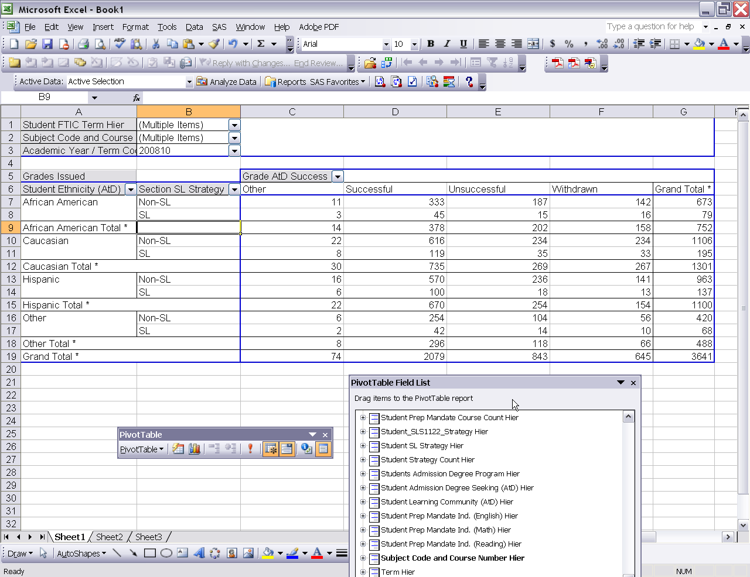
- Select File from the Excel menu.
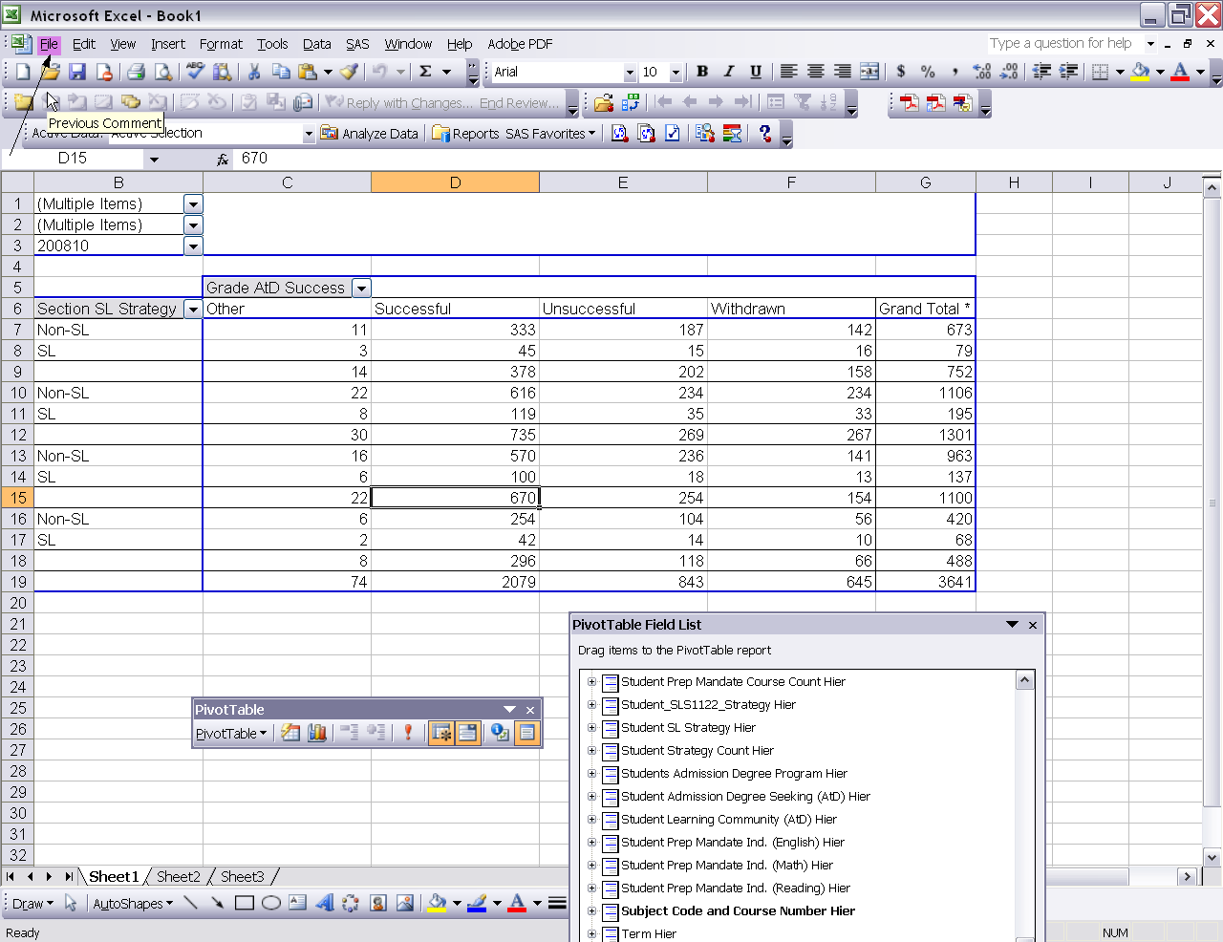
- Select Save As.
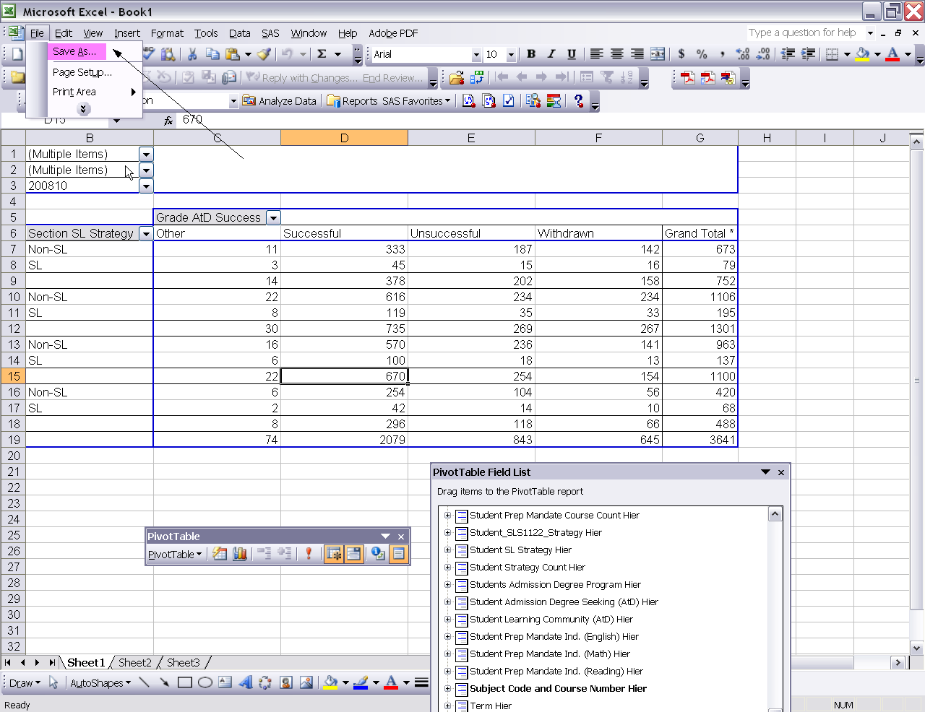
- Chose a file folder to save the file to such as Desktop.
- Give the file a name such as SAS Add-In Training Example.
- Click the Save button.
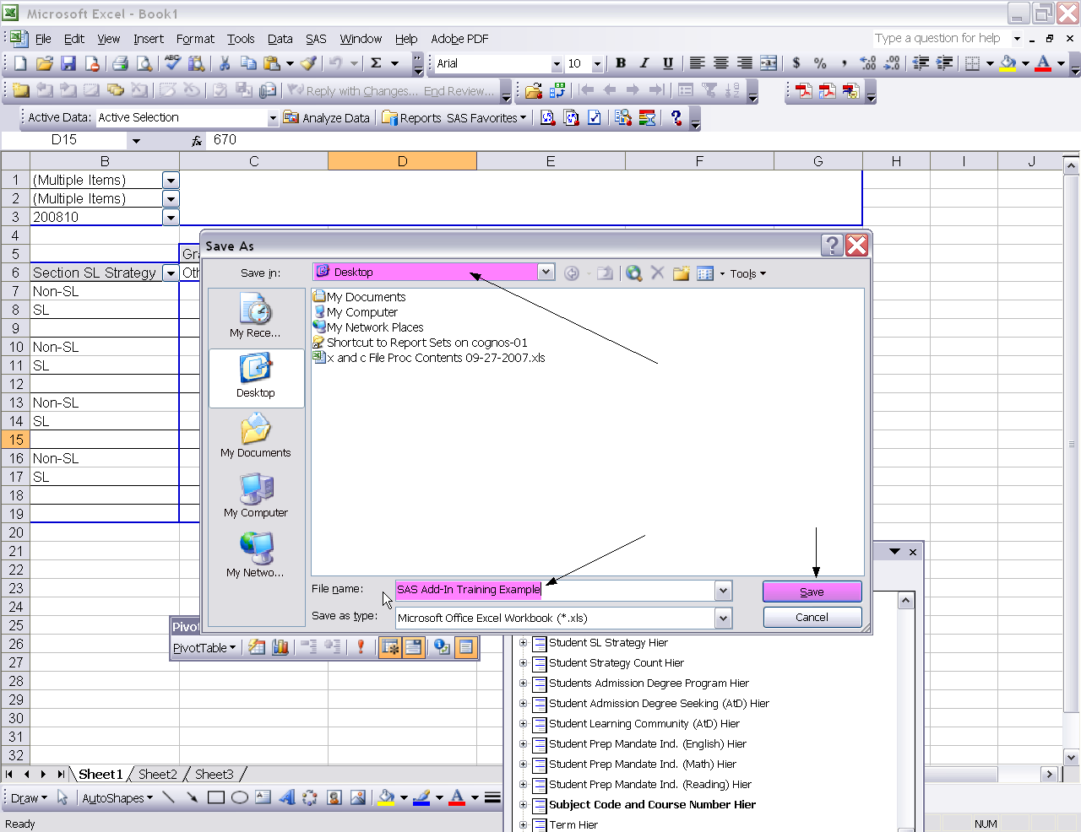
- Click the small x to close the Excel window.
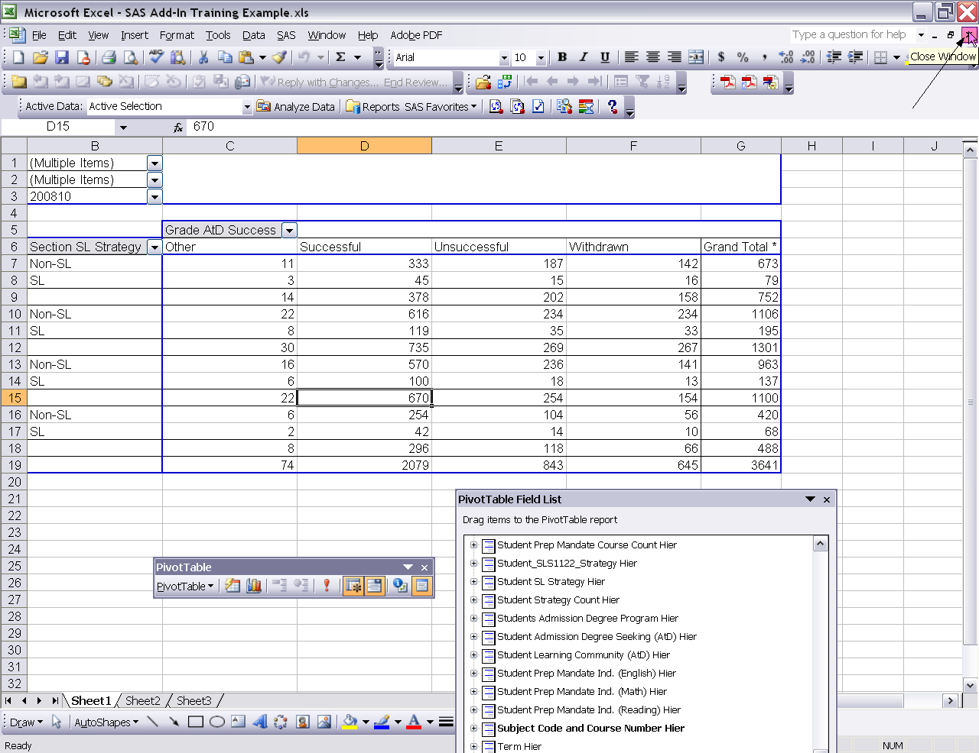
- Select the File Open icon.
- Choose the folder location where you saved your file such as Desktop.
- Double click the file name.
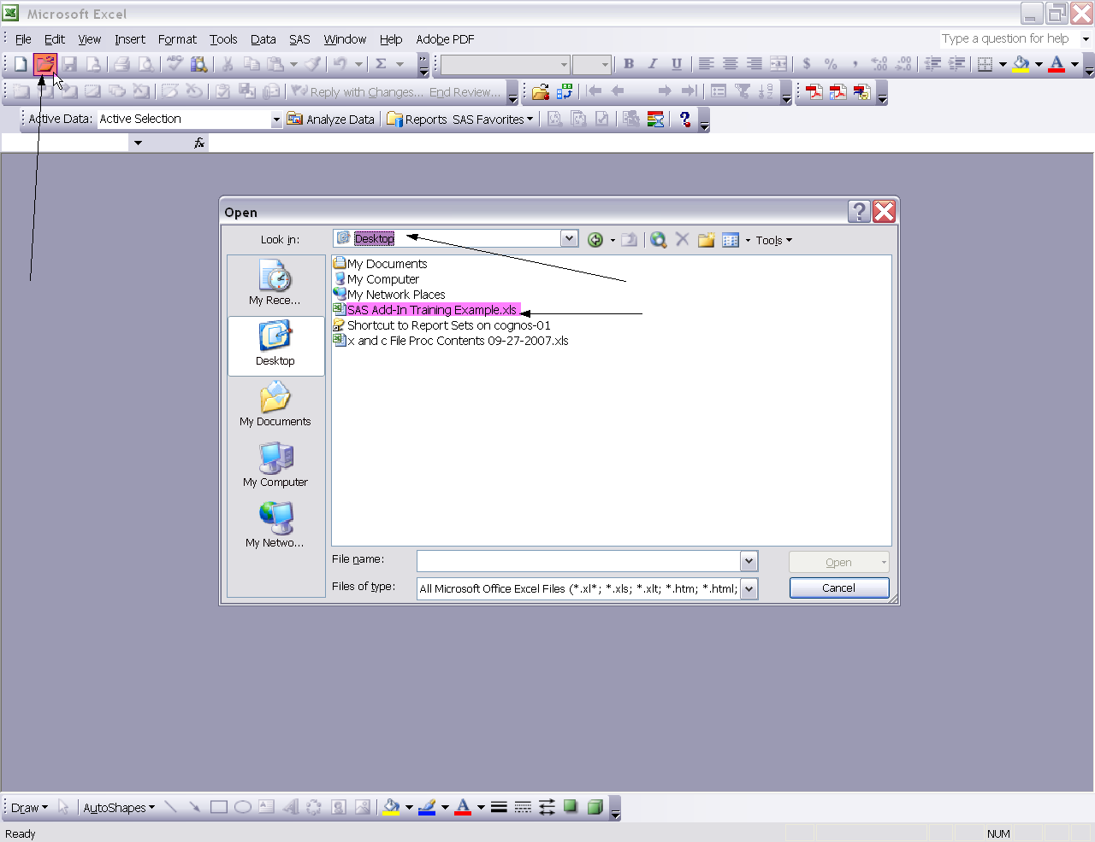

- Select Data from the Excel menu.
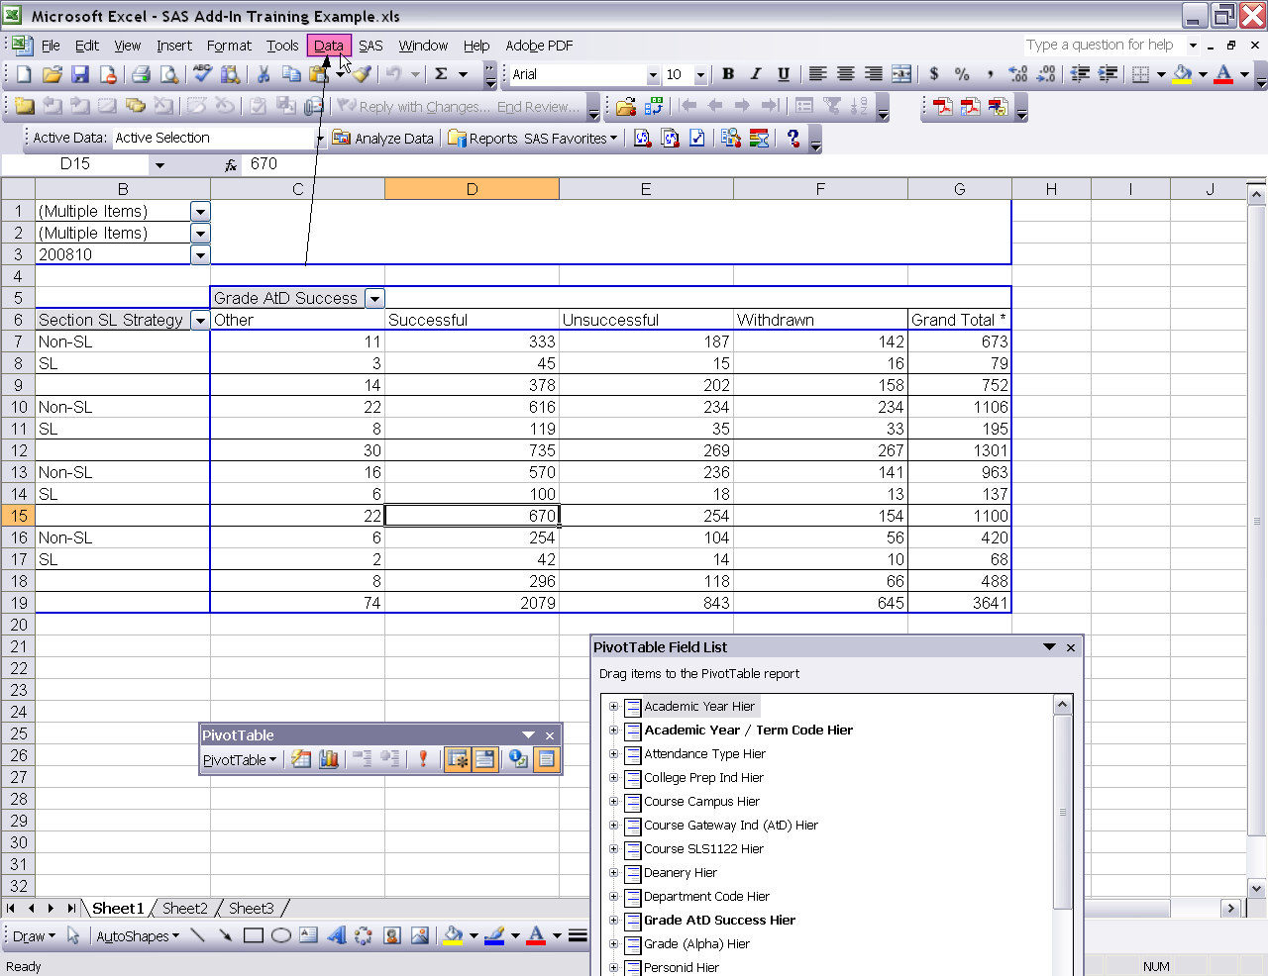
- Select Refresh Data.
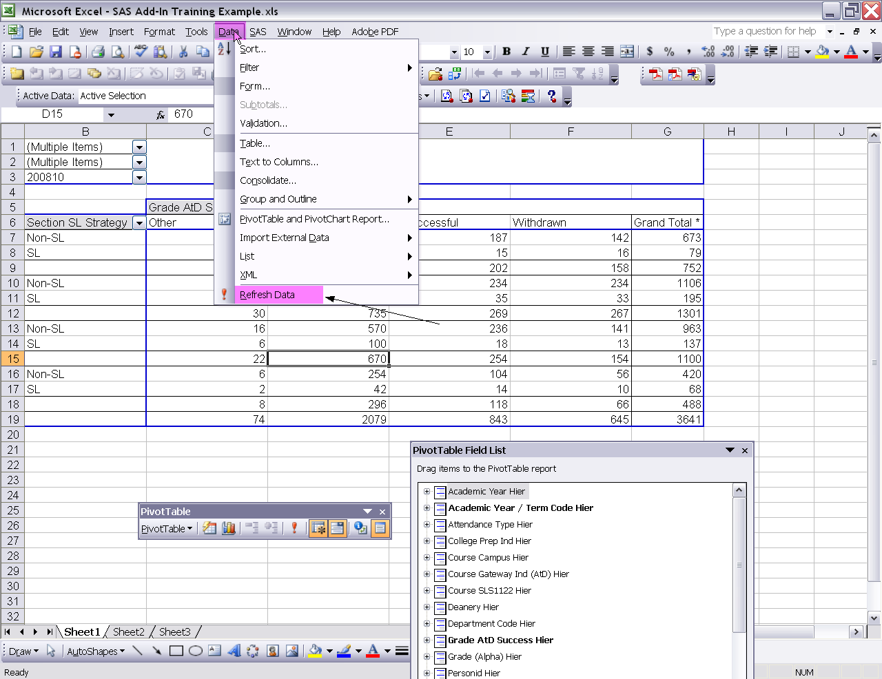
- A Refresh Data warning box will appear.
- Click the ok button.
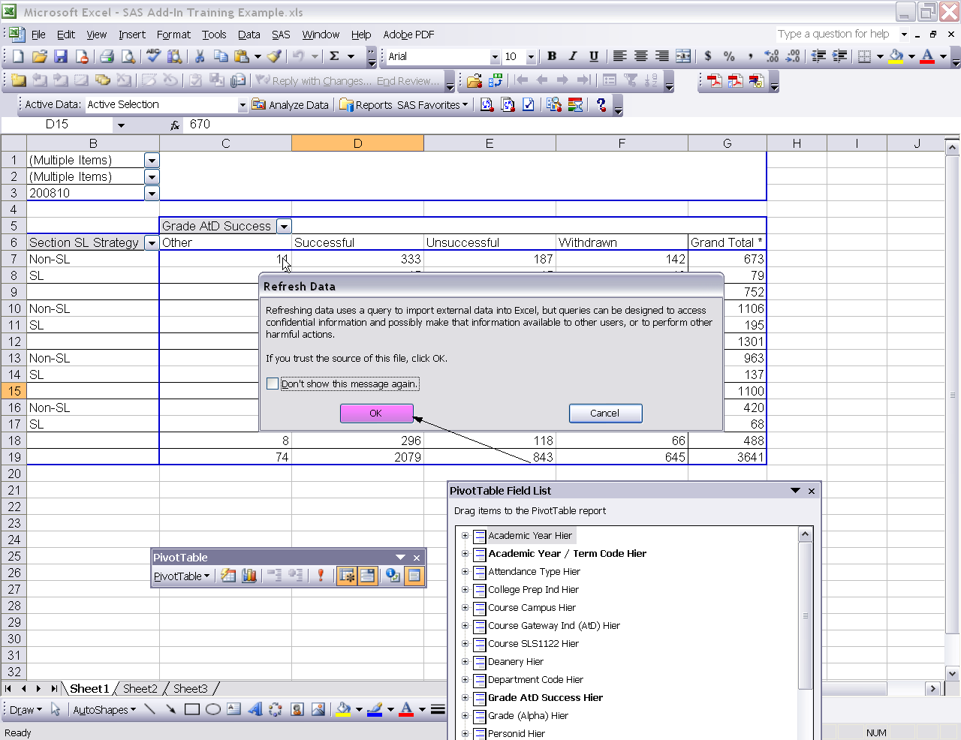
- An Excel warning box will appear.
- Click the ok button.
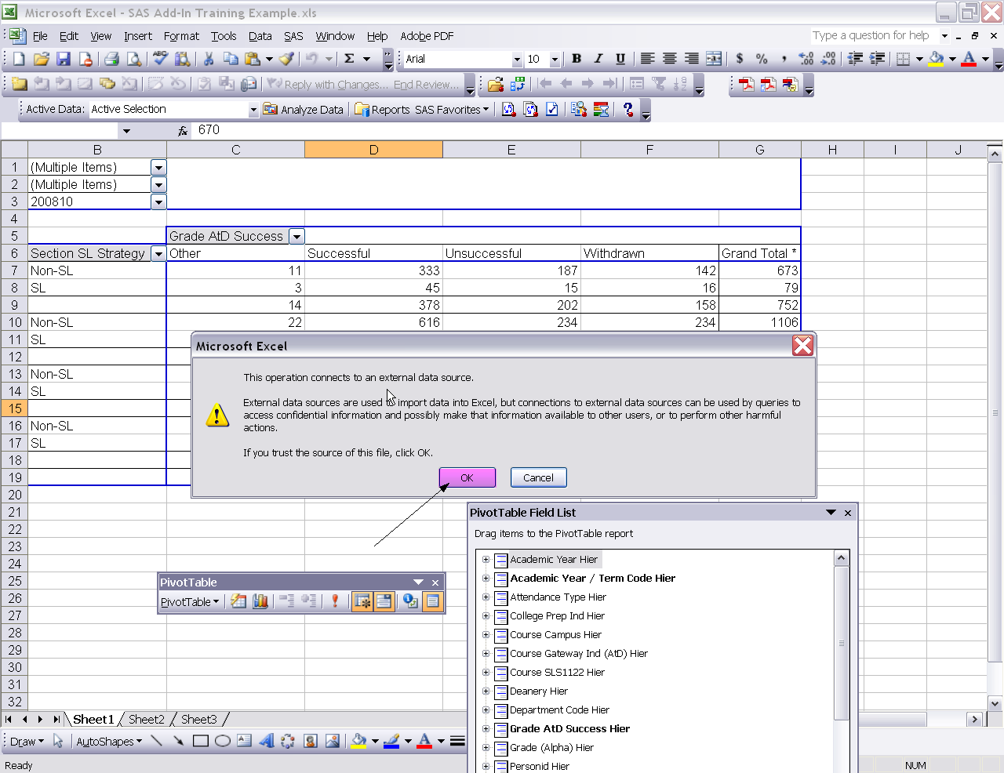
- To exit Excel click the large X at the top right hand corner of your screen.
