SAS ATD TRAINING MANUAL

FEATURING THE SAS PORTAL

- Log into the SAS Portal by double clicking Internet Explorer.
- Type in the address as http://www.valenciacc.edu/dw
- Single click Production.
- Single click Portal.
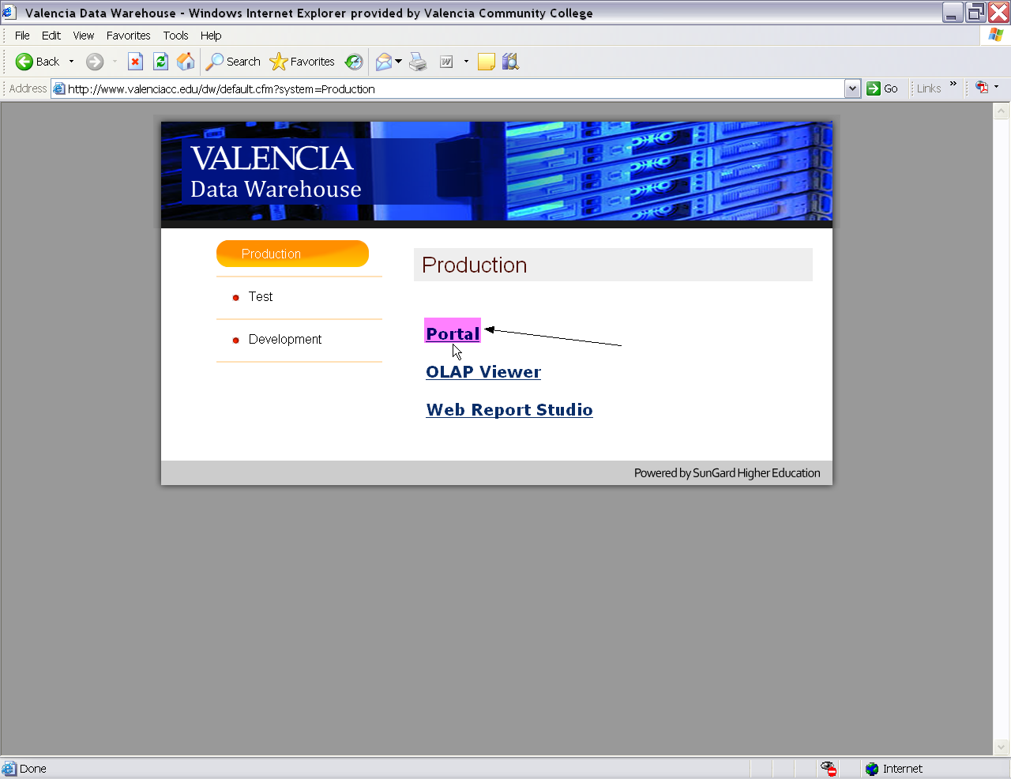
- Type in your Atlas username in the User name box.
- Type in your Atlas password in the Password box.
- Single click the Log On button.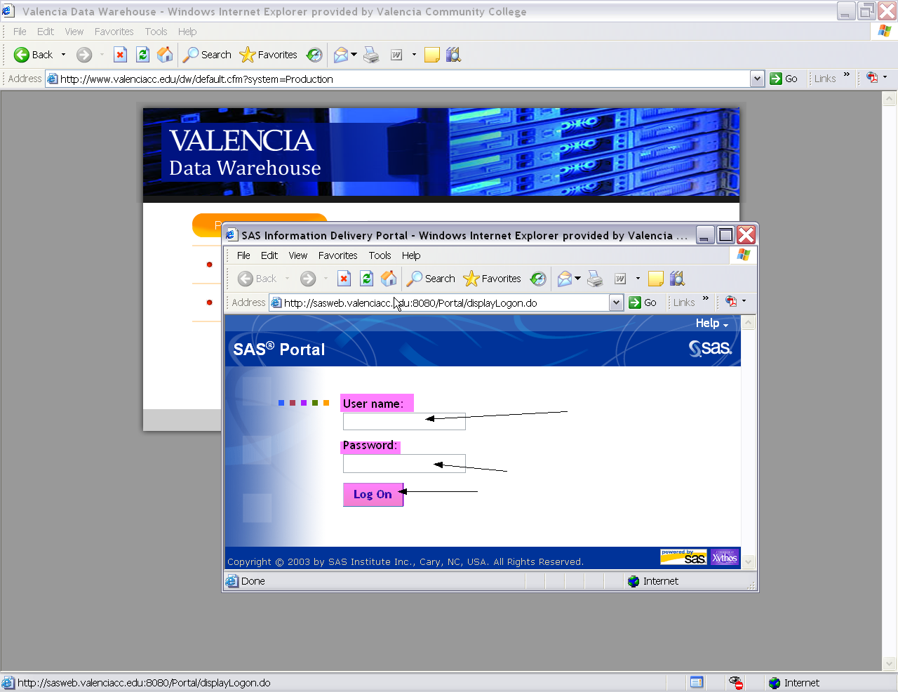
- This is how the Portal appears after you log in.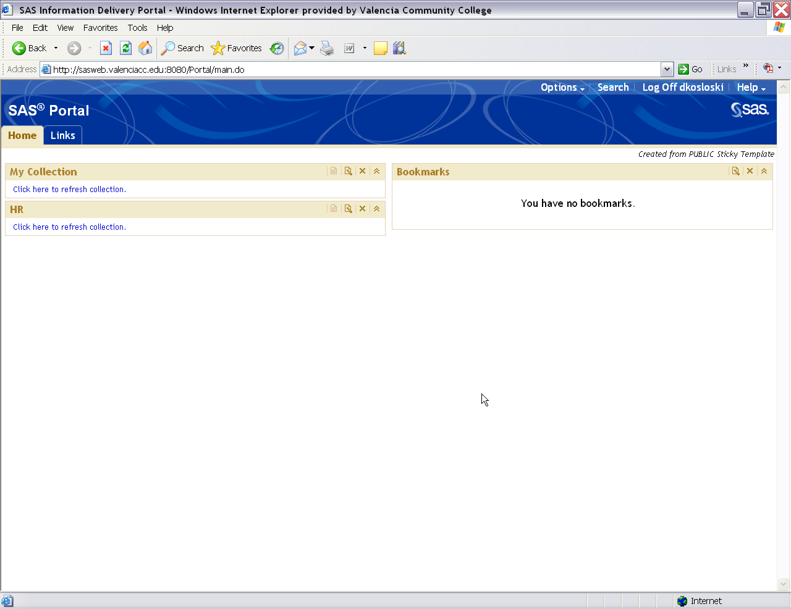

- Single click the word Search in the upper right hand corner of the screen.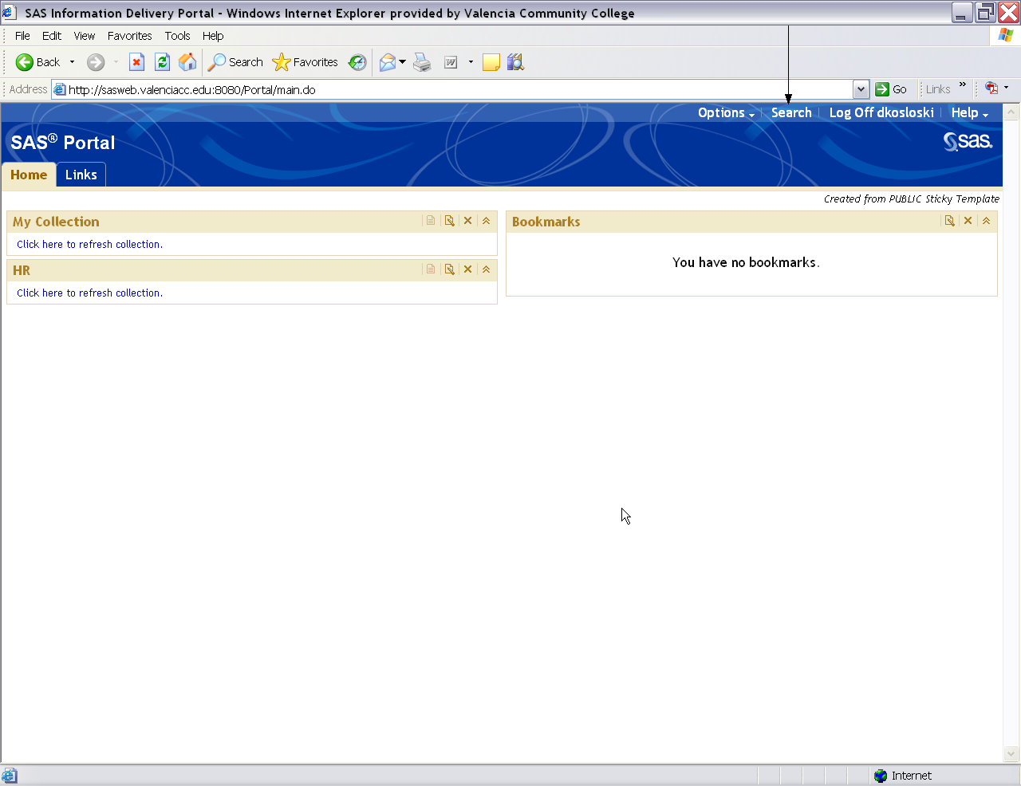

- Type the word Training in the Keywords box.
- Check the box to the left of Data Explorations.
- Click the Search button.
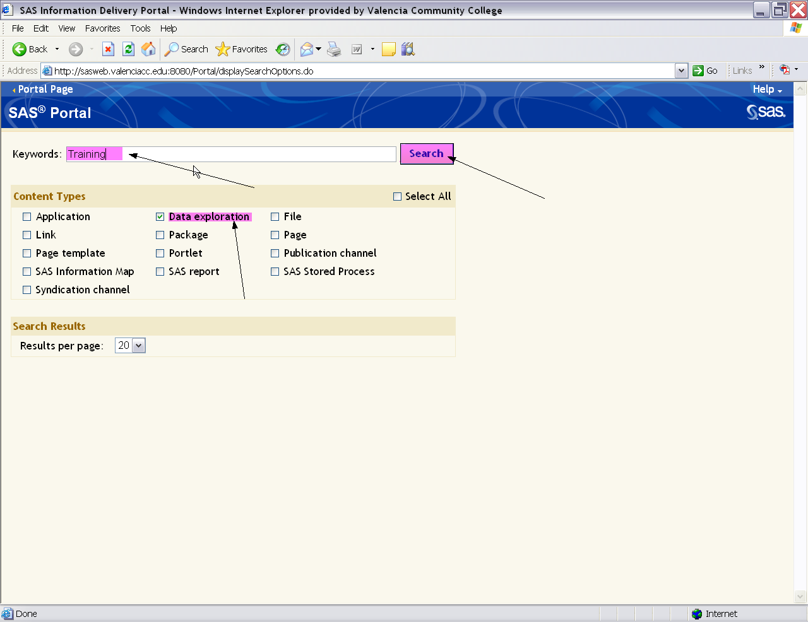

- Single click the bookmark icon which is to the left of the file type and name.
- 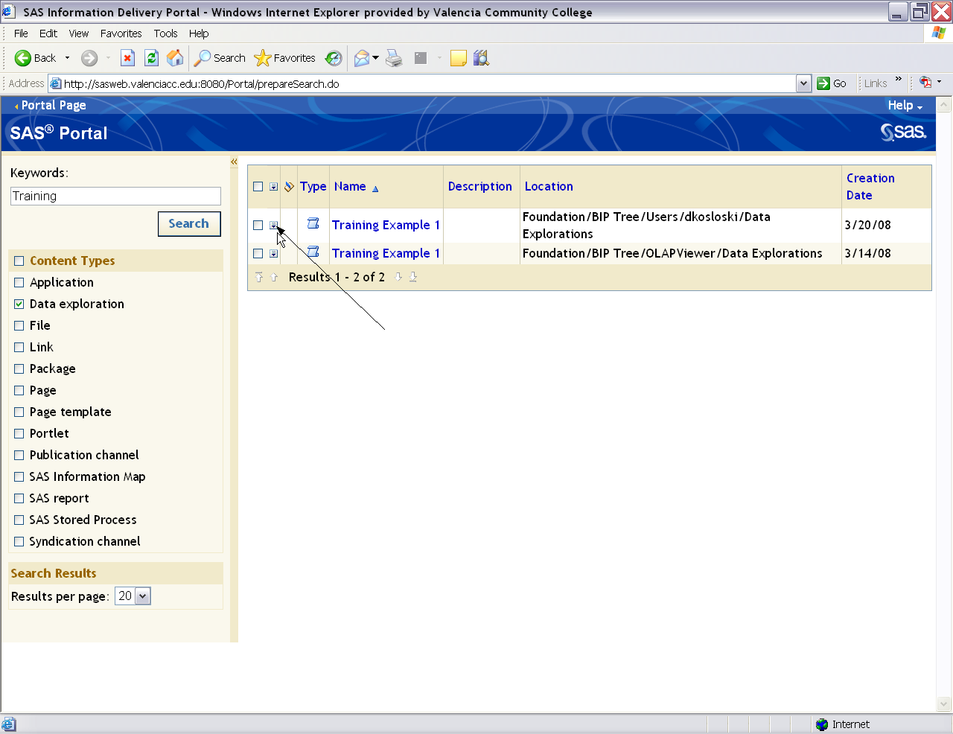

- Single click the word Bookmark.

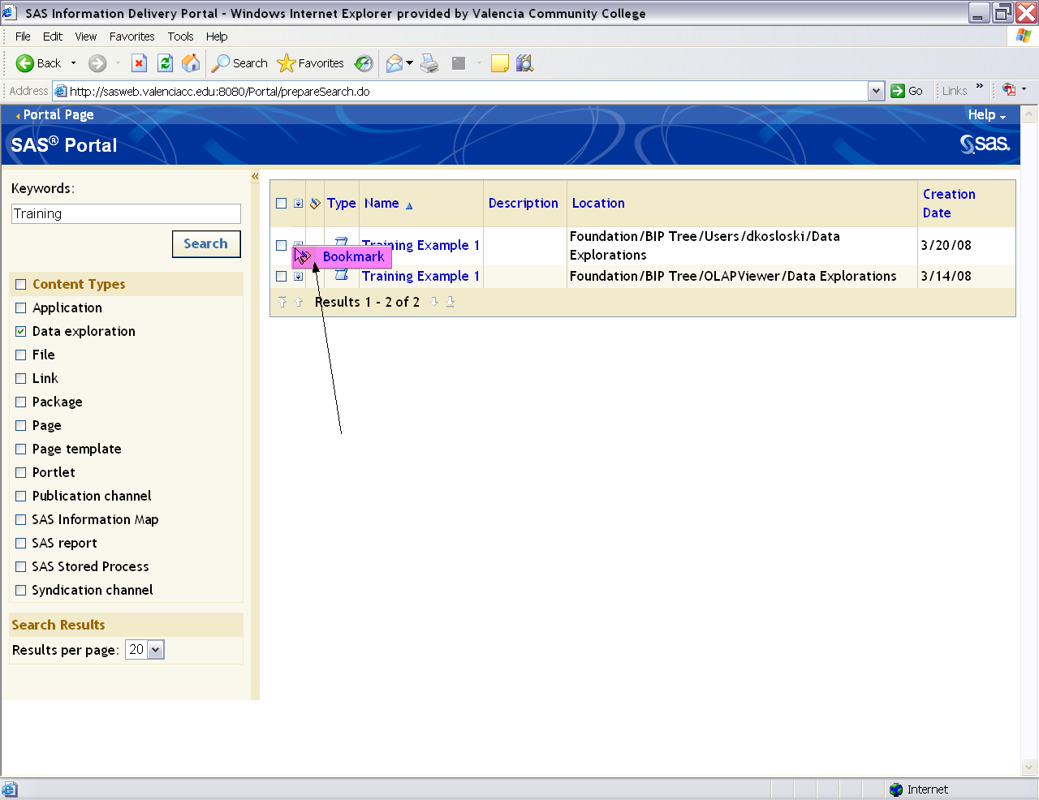

- One item has been bookmarked and will show under bookmarks on the SAS Portal Page.
- Single click the first report called Training Example 1.
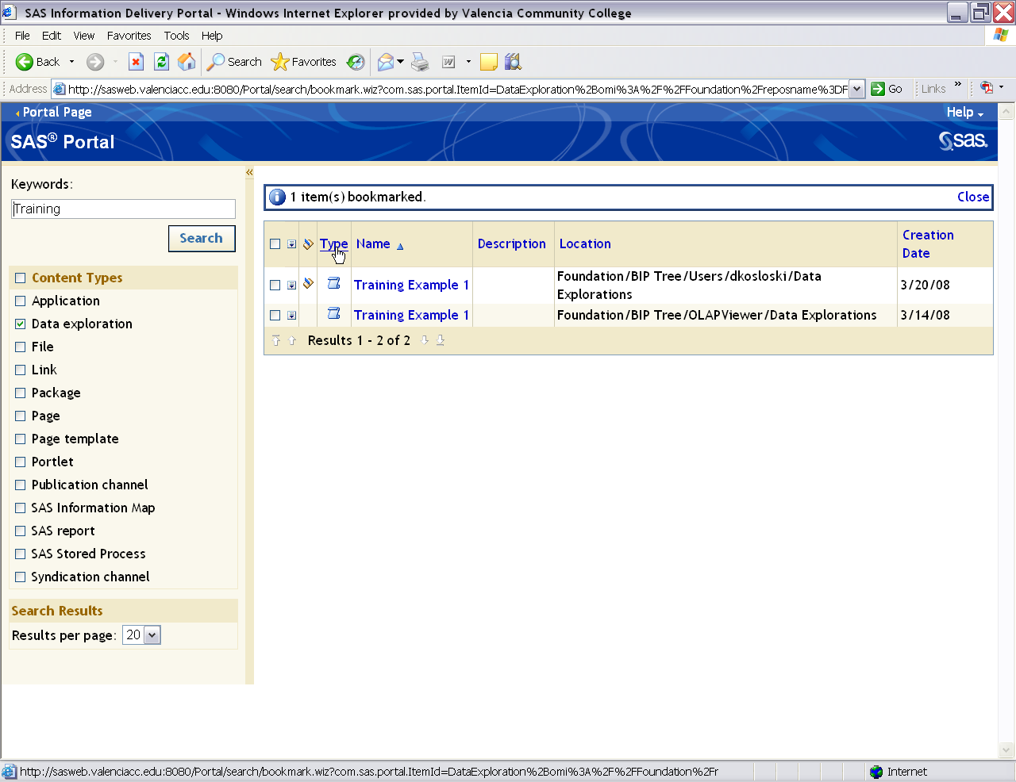
- The data exploration is displayed just as seen through the SAS OLAP Viewer.
- Click the Restore button to refresh the data.
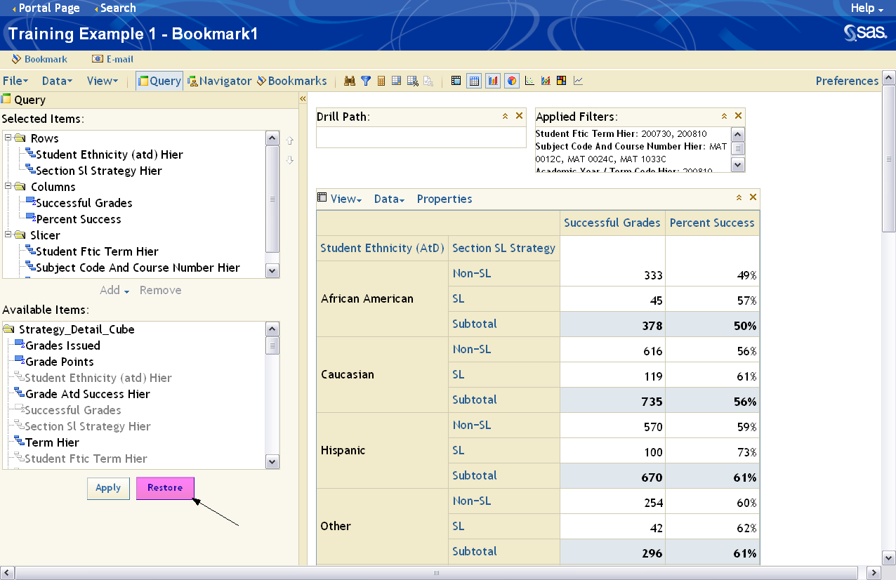

- Click the words Portal Page in the upper left hand corner of the screen.
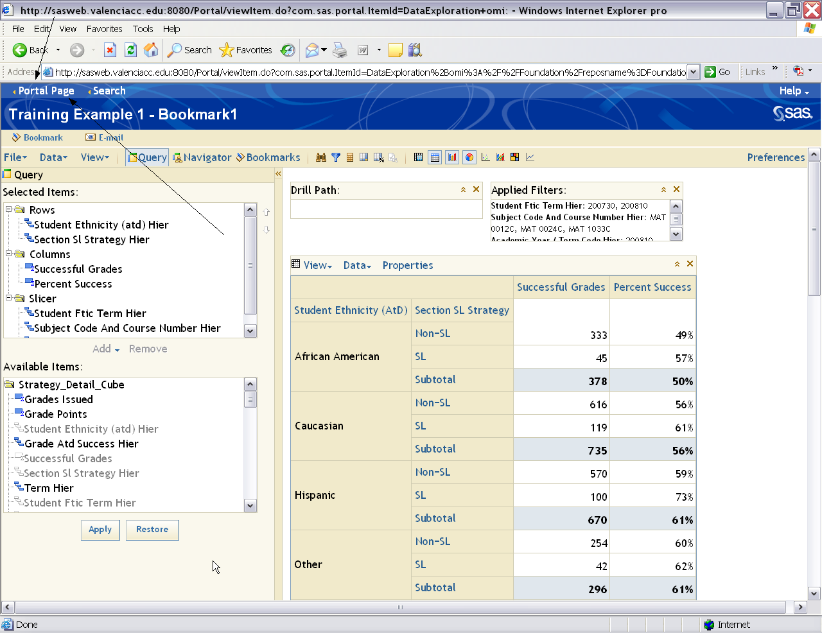
- You can see that the data exploration you bookmarked is under the Bookmarks area.
- Single click Log Off (User Name).
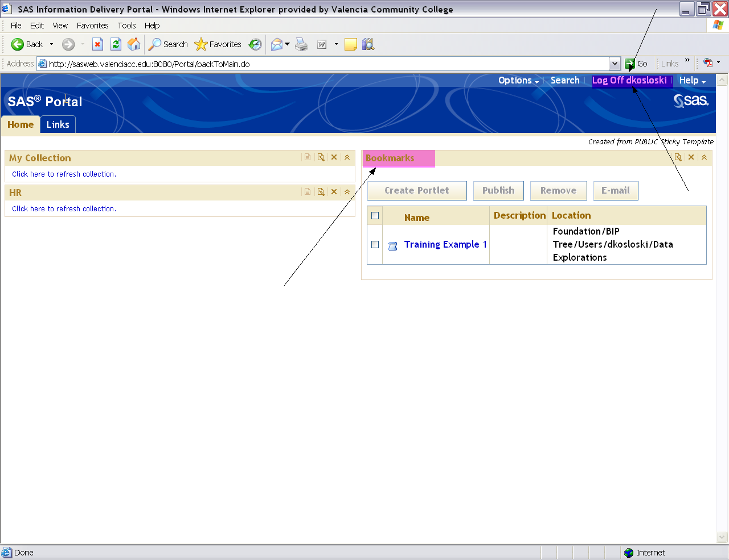
- Single click the X to exit Internet Explorer.
