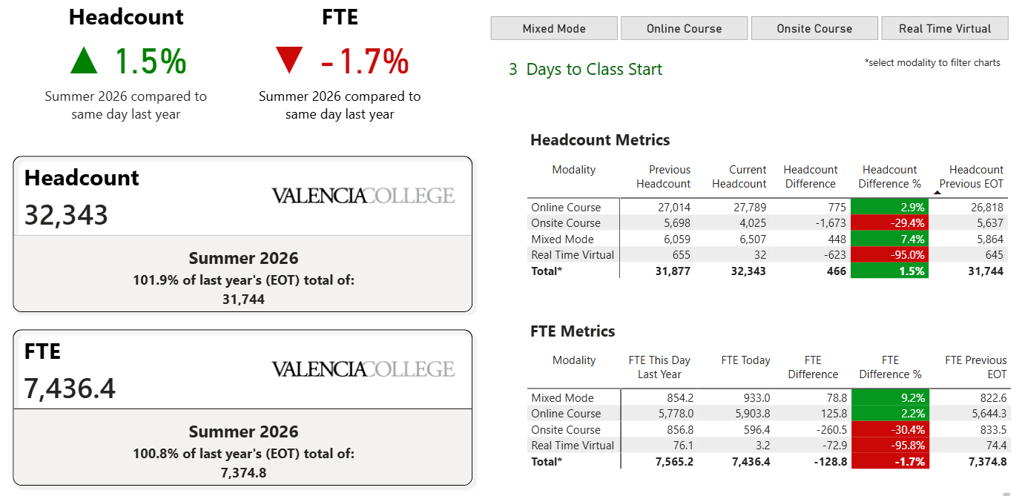
Report Documentation Coming Soon

Questions?
irreports@valenciacollege.edu

