

Welcome to the steps for logging in and setting up your CITI account

Quick steps
- Go to CITI: https://www.citiprogram.org

- Create your username and password,

- Answer the profile questions,

- Select the courses you want to take,

- Now you can take the courses.

Note: You can add or change courses at any time. You can access your certificates and record of completion at any time, also.
- Students: Please ask your instructor if you have questions related to a specific course and use the help options at the bottom of this handout if needed.

CITI is the Collaborative Institutional Training Initiative. It is a web-based training program for university personnel and students in many areas of research related to ethical decision- making and compliance, which provides certification
that typically is recognized as current for three years.

Register: If you have never registered before (you do not have a CITI Program username) please go to https://www.citiprogram.org and register an account in the system by clicking on "Register" button under "Create an account" from the homepage. After typing and selecting your institution from the dynamic drop down list, follow the prompts to create your account. If you already have a CITI Program username, please log into your account, go to Main Menu, and follow the "Click here to affiliate with another institution" link. Type and locate your institution via the dynamic drop down list and add “Valencia College.”
Follow Directions and Access Support: These directions will help you to set up your account. Directions about completing the courses can be found here: https://www.citiprogram.org/citidocuments/citiinstructions.htm
Note: TO STUDENTS AND FACULTY WHO ARE SUBMITTING IRB APPLICATIONS, CITI TRAIING MODULES REQUIRED:
- RESPONSIBLE CONDUCT OF RESEARCH
- HUMAN SUBJECTS RESEARCH

Created: 6/30/2021
If you have technical support questions, please contact CITI Support (see contact information below). If you want to read about the course content, please see the informational links below. For other questions please contact the Office of Institutional Evaluation: participate@valenciacollege.edu
To register at CITI, please follow the 7 steps:

Step (1): Type in the organization you are affiliated with in the search bar- “Valencia College”. After selecting Valencia College, a prompt will appear below asking you to check the boxes and agree to the Terms of Service and affirm the affiliation with Valencia College.
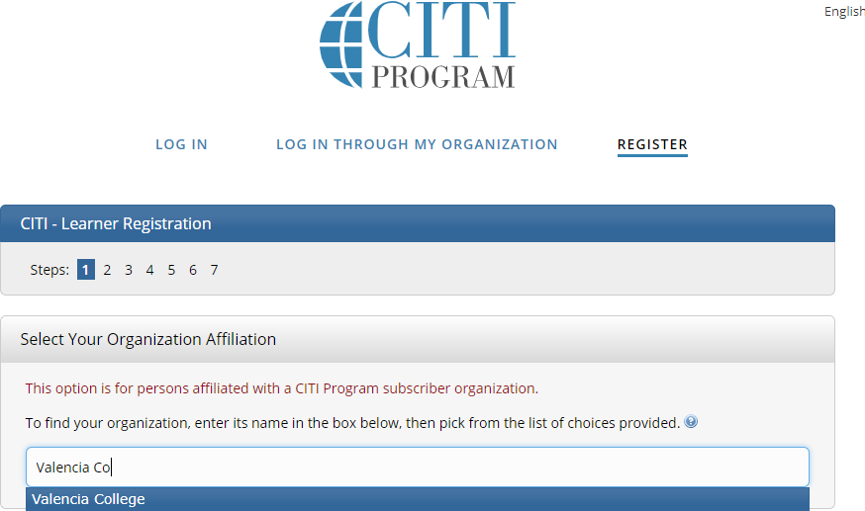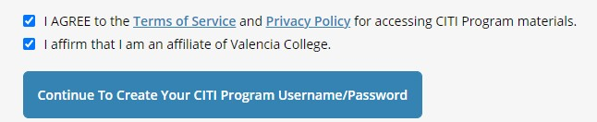

Step (2): Provide the personal information (First Name, Last Name, email address). Please use your Valencia e-mail address.
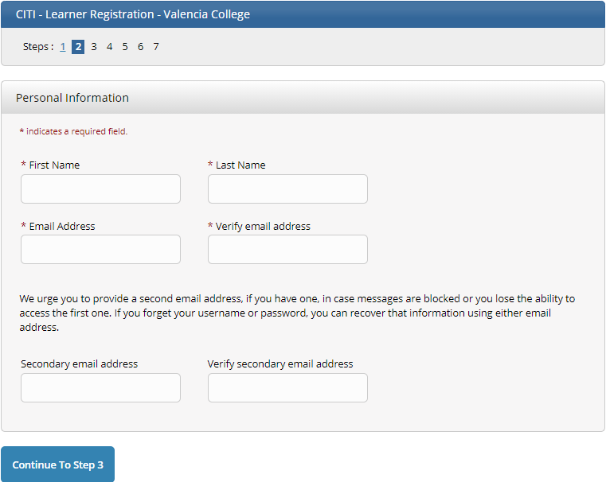

Step (3): Create a username, password and select security questions.

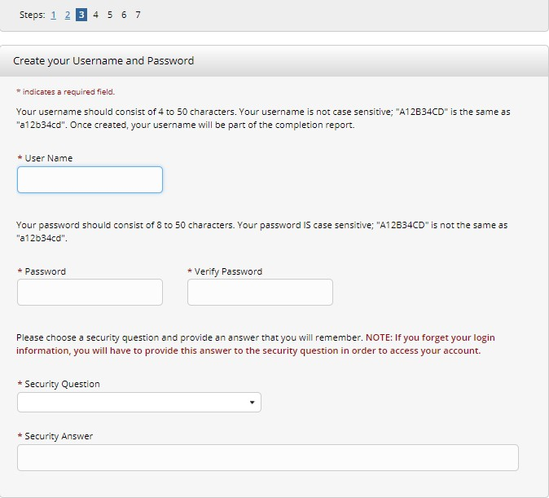
Note: Avoid using your social media password.

Step (4): Complete the prompts on step 4.

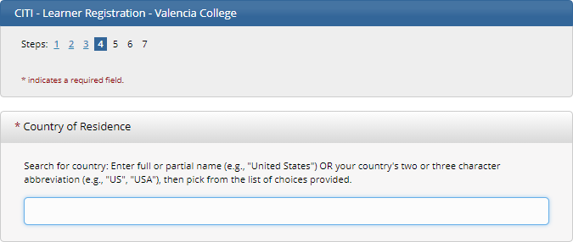

CITI is independent from Valencia College. When you are asked on this screen if you want to be contacted, that question is from CITI.

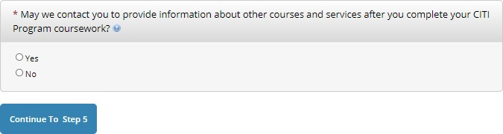

Step (5): Continue to select the answers, based on the questions and the preferences provided. Please note that this award of credits is not done through Valencia and it is not related to your courses at the College. It is for outside certification.
If you are completing CITI modules for a Valencia College course, please ask your faculty member about any course credit options and if available, how and when they will want you to submit proof of completion. Typically, the courses ask you to complete them with correct responses at 75% or higher and you can retake them as many times as you would like.
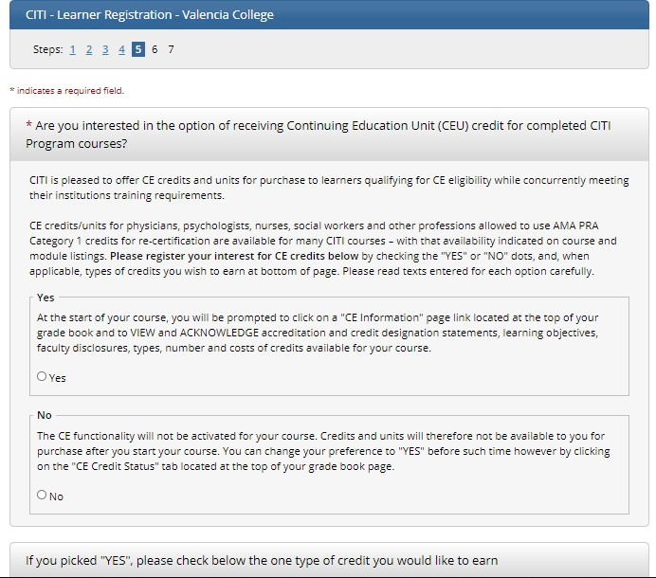

Step (6): Fill out the sections in the prompt. Please make sure to fill in the required fields marked with an asterisk *
- For Institutional Email address: be sure to include your Valencia College email address.

- For Employee number: please enter your VID without the “V” (the VID consists of 8 digits).

- For Students: please enter your VID as the “employee number” (the VID consists of 8 digits).

- For Department:

  - Faculty and staff members: please note the academic department, division, or office you work within.

  - Students: please note the department that your course is offered in, for example, “Psychology” would be “Social Science”. The College catalog may help you: https://catalog.valenciacollege.edu/coursedescriptions/courseprefixesheadings/

- For Role in Research:

  - Professors: Please select “faculty” as your role in research (as in the first screenshot below).

  - Students: Please select “student researcher- undergraduate” (as in the second screenshot below).
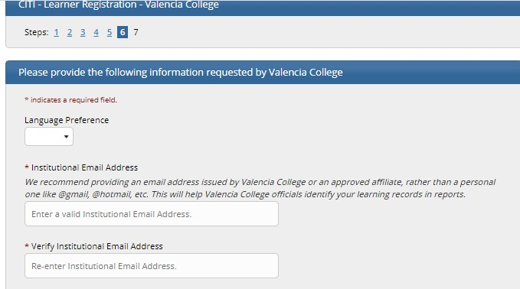

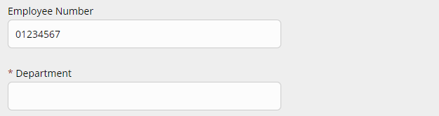
Insert your VID here without typing the “V”. Only type numbers.


Step (7): The last step involves Curriculum selection. Select the courses by answering the questions under Select Curriculum- CITI Curriculum Selection. Please note that your institution has prescribed your course curriculum.
- Students: Select the courses that your faculty member has requested and/ or that you would like to take. You can update these selections at any time. If you are uncertain about the courses you need to take, please ask your instructor.


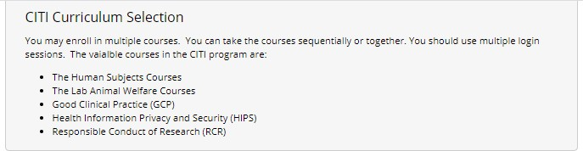
Students: Please select the Responsible Conduct of Research (RCR) course if your faculty member has asked you to, or if you would like to take it.
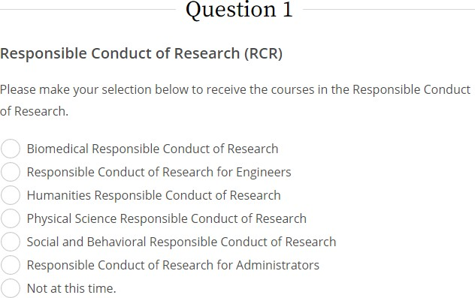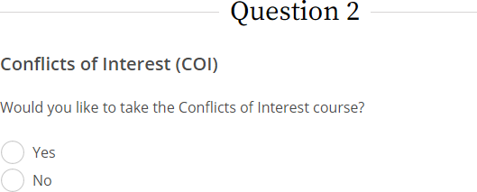

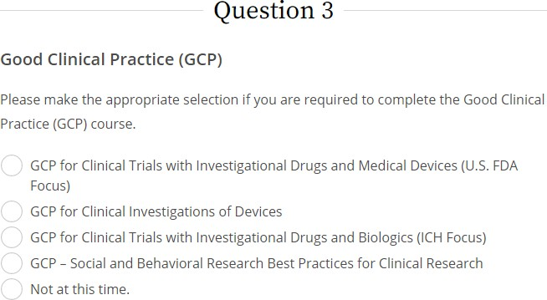

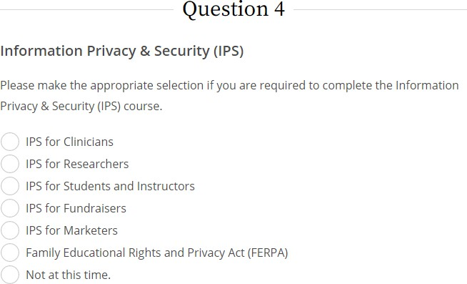

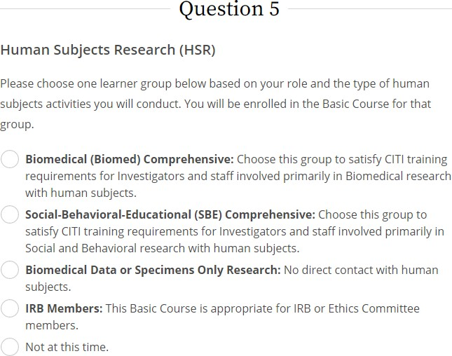

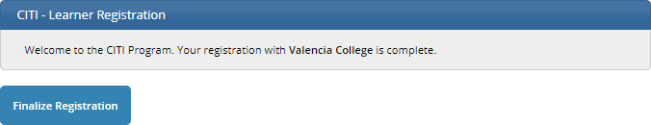

After registration is complete, the Institutional Courses will appear, with the affiliated institution (Valencia College) and the Courses available through the College.
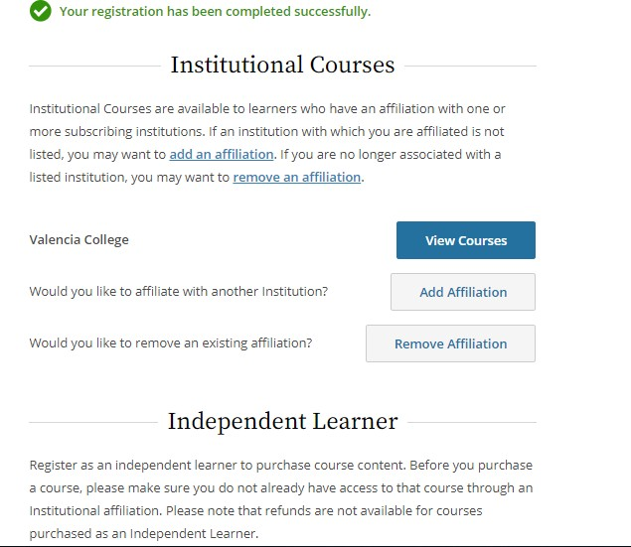

To view the courses, go to “View Courses” next to Valencia College and a prompt will show you a list of courses.

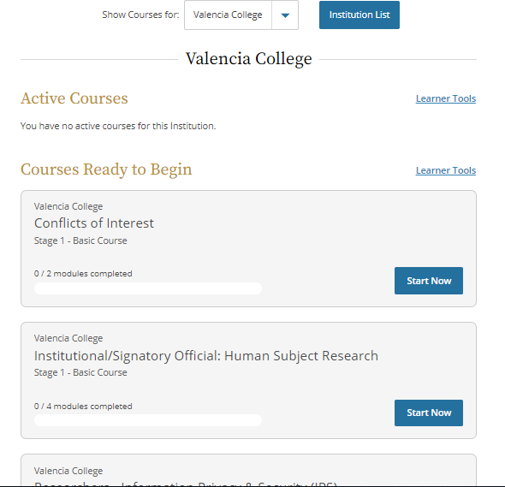Now you can take your courses! If you need help…

CITI Technical Support
- Submit an online request for help from CITI staff: https://about.citiprogram.org/en/contact-us/

- Talk to someone by phone: 888.529.5929
Hours: Monday to Friday 8:30 a.m. - 7:30 p.m. U.S. ET
Informational Links
- Frequently Asked Questions (FAQ) for Learners
https://about.citiprogram.org/en/faqs/?filter=34

- About the courses available for the Valencia community
https://about.citiprogram.org/en/new-subscriptions/
For other questions please contact the Office of Institutional Evaluation: participate@valenciacollege.edu

