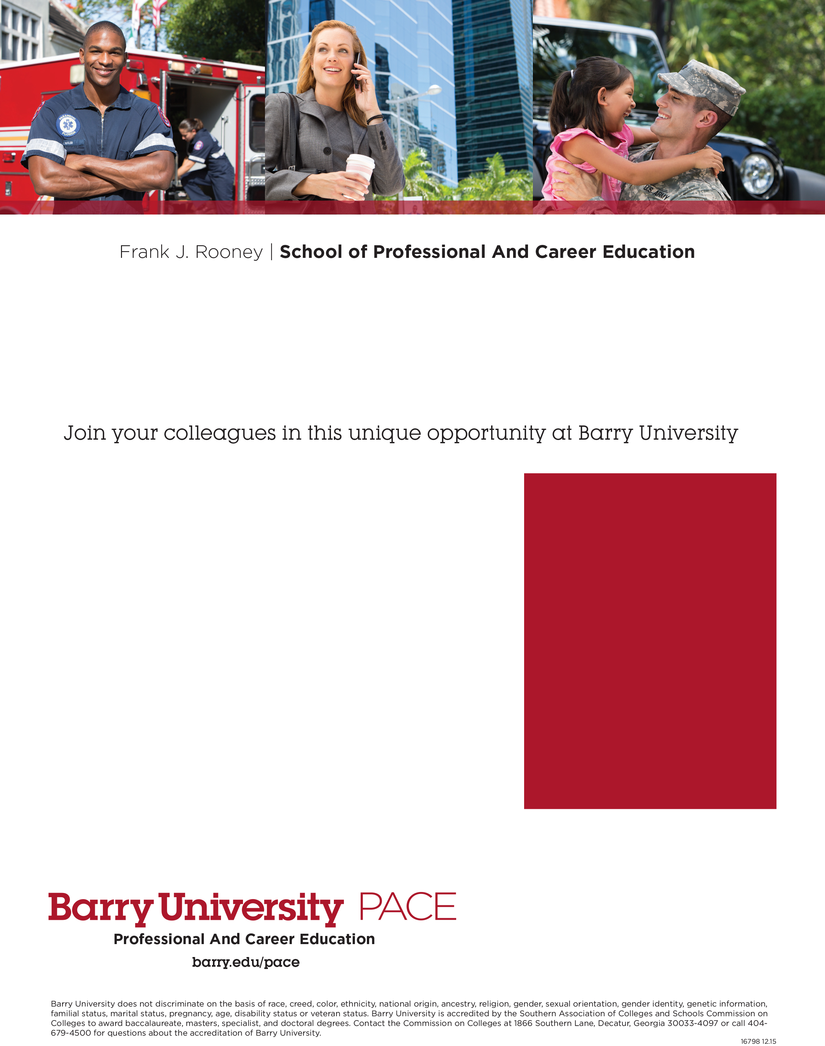

Earn your degree through   
an Educational Partnership   
with Valencia College

**LOCATION**

Barry University - PACE

1650 Sand Lake Rd Suite 390

Orlando Fl 32809

**FOR MORE INFORMATION**

Michelle Czechowski

P: 407.271.5544

[mczechowskil@barry.edu](mailto:mczechowskil@barry.edu)

**barry.edu/pace**

* Valencia College alumni are eligible for a

20% tuition discount

* Accelerated bachelor’s and master’s degree programs
* Classes meet once a week in the evening or Saturdays
* Convenient locations throughout Florida and online
* College credits for learning acquired through professional work experience (up to 30 credits –

the equivalent of one year of college coursework!)

* Earn additional college credits for specific licenses
* Transfer college credits from regionally accredited institutions (international credits considered as well)
* Financial aid available for students who qualify
* Design an educational plan with your own advisor
* Small classes and personal attention from experienced faculty

**LOCATIONS**  
***Site***

*Street*

*City, State, ZIP*

*Contact: Name*

*Phone*

*@mail.barry.edu*

***Site***

*Street*

*City, State, ZIP*

*Contact: Name*

*Phone*

*@mail.barry.edu*

**www.barry.edu**