1a. Banner 9 General Information | Finance Module  INB Banner

Banner Finance Version 9.3.8.0.4

This section is intended to provide the user general information and tips to make navigation with Banner easier.

General Navigation in INB (Internet Native Banner)

1. The Banner Website is located at: http://valenciacollege.edu/banner

Or you can type in banner at the URL

Different ‘instances’ will be available. Please pick the appropriate database.

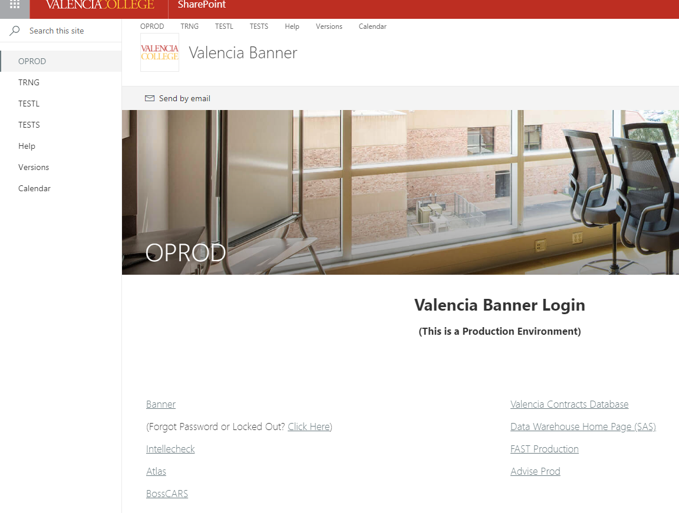

2. Whatever instance you pick, it will tell you what database you are about to enter. In this example, the Banner Training database was selected.

Click on Banner

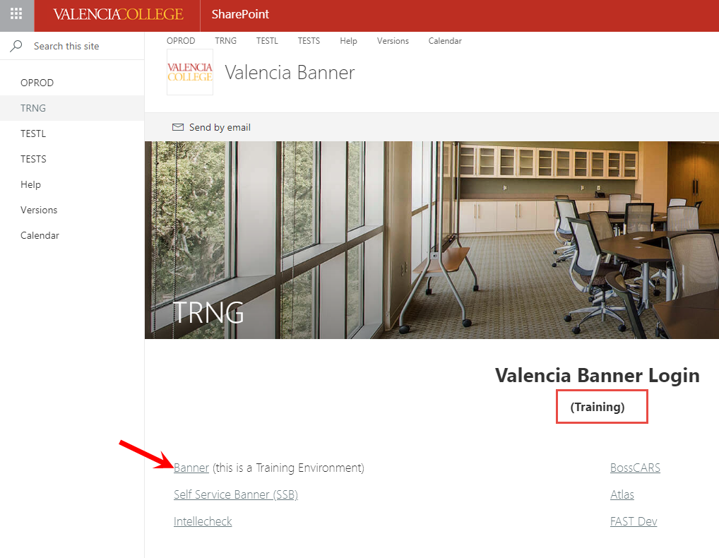

3. Enter your user ID and password.
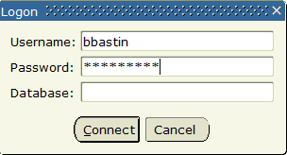
4. After you sign into Banner, you will see your Home page. By clicking on the Toggle Menu , it will open up your menu bar.

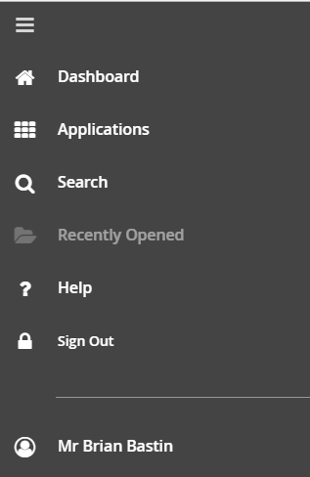

From here you can go to Applications, due a search, see recently opened forms, get online help and sign out.

- If you would like to add a form to “My Banner”, type GUAPMNU in the search field and hit enter.

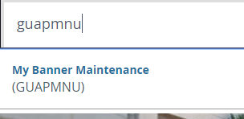

- The My Banner Maintenance form will open. Double click on the forms you wish to have in “My Banner”, (they will turn blue), the click on Insert Selection. These forms will now be added to “My Banner”. To remove items from “My Banner”, double click on the forms on the right side and click on Remove Selection.
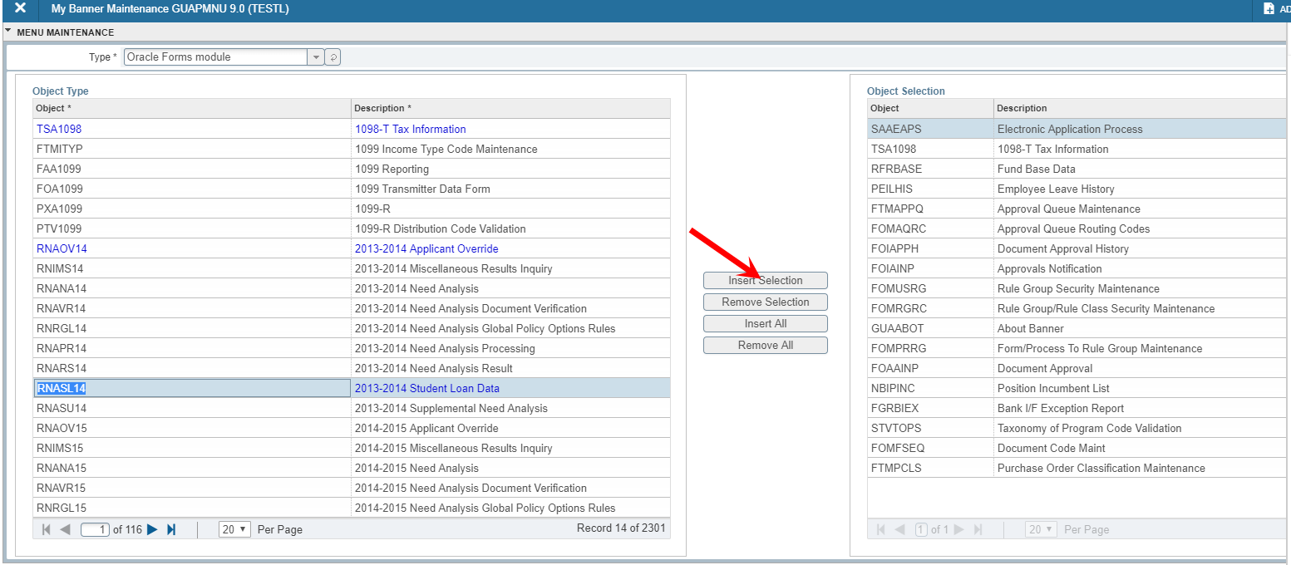

- Shortcut for Dates

In the date field, you want to enter….
- System date = type “S”
- Today = “T”
- 091418
- Always check the top right hand corner of the form for information regarding the transaction processing. If you get stopped in the form, the message will tell you how to proceed.

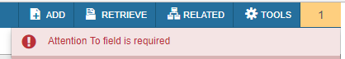

- Required Fields

Most of the required fields will have a * by the field.
