2. Banner Budget  (Budget Queries – Available Balances)  (Budget Transfers)  (Payroll Information) | Finance Module  FGIBAVL  FGITINP  FGIBDST  FRIGITD  FGAJVCM  NHIDIST

Banner Finance Version 9.3.14.0.3

This section will cover how to look up available balances at the account code and organizational levels.

Very important to budgeting and available balances is the introduction of pooled budget accounts. These accounts were established to reduce the need of budget transfers between common account codes, such as 605010, 605020, and 605030.

BANNER

Account Code | Budget | Expense | Commitment | Available  Balance
6050 | $100,000 | $ 15,000 | $ 1,000 | $ 84,000
605010 |  | 5,000
605020 |  | 5,000
605030 |  | 5,000 | 1,000

From the above example you will no longer budget at each individual account code. If you think about this as a Parent/Children relationship then the Account Code 6050 is the Parent and Account Codes 605010, 605020, 605030 are the children. All children account codes roll up to the parent account codes.

The forms available to view your current available balances are:

FGIBAVL – Budget Availability Status Form: This form provides a quick review of the current information on the Adjusted Budget, Year-to-Date expenses and commitments, Budget Reservations and Available Balances. This form will display unapproved and unposted transactions and is real time. Drill down capability to Transaction in Process Status (FGITINP) is available on this form.

FGIBDST – Organizational Budget Status Form: This form is used to query the organizational status of accounts on the Adjusted Budget, Year-to-Date expenses, budget commitments, and available balances. The form displays ONLY approved and posted transactions. Drill down capability to the transaction detail (FGITRND) information and Payroll (NHIDIST) is available on this form.

FRIGITD – Grant Inception to Date Form: This form is used to query the grant budgets to see the Adjusted Budget, Year-to-Date Activity, Commitments and Available Balance. The form displays ONLY approved and posted transactions. Drill down capability to the transaction detail (FRIGTRD) information and Payroll (NHIDIST) is available on this form.

Budget Availability Status Form (FGIBAVL)

This form is used as a QUICK look at your available balances with drill down capabilities to FGITINP. FGIBAVL displays all transactions that have a FOAP entered on them. This will show why there is a difference from FGIBAVL and FGIBDST.

1. On the Home page, type FGIBAVL in the search field then hit enter.

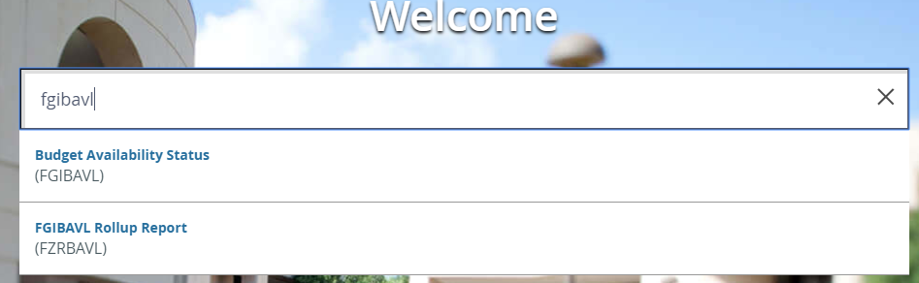
2. FGIBAVL page will open. Now enter your Index, and account code.

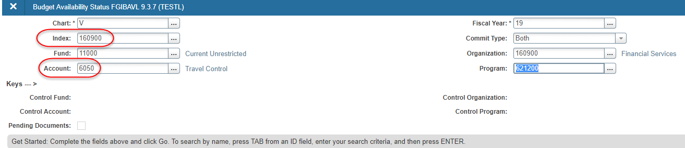
Note: The index code will populate the Fund, Organization, and Program.
3. Click on the go button in the upper right hand of the page or ALT & Page Down or the down arrow in the bottom left corner of the page.

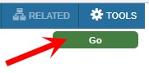
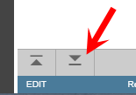

Budget Availability Status Form (FGIBAVL) Cont’d

4. Look for the check in the radial box in the pending documents column. This indicates there are documents that have not posted to the General Ledger.
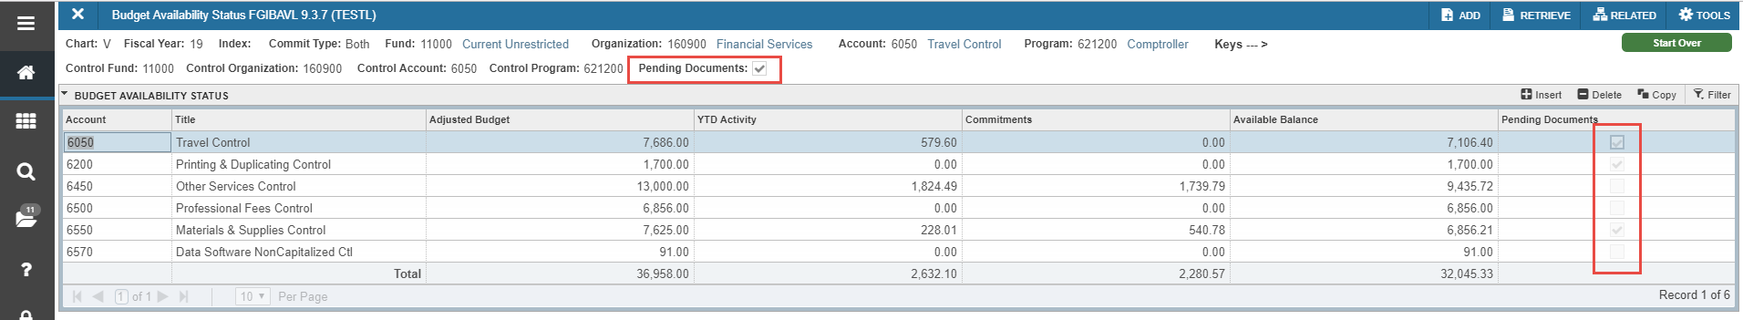
5. Click on the account code with the check mark, click on Related – Pending Documents or you can hit the F3 key on the keyboard.

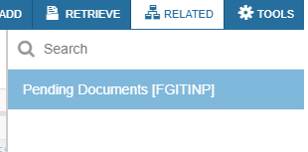
6. This will take you to Transaction In Process Status (FGITINP). This will show all transactions that are pending for that account code.

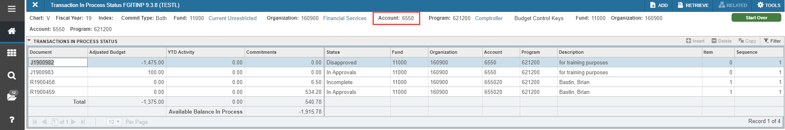

Budget Availability Status Form (FGIBAVL) Cont’d

7. Now you will see all transactions associated with that account code and their status. See notes.
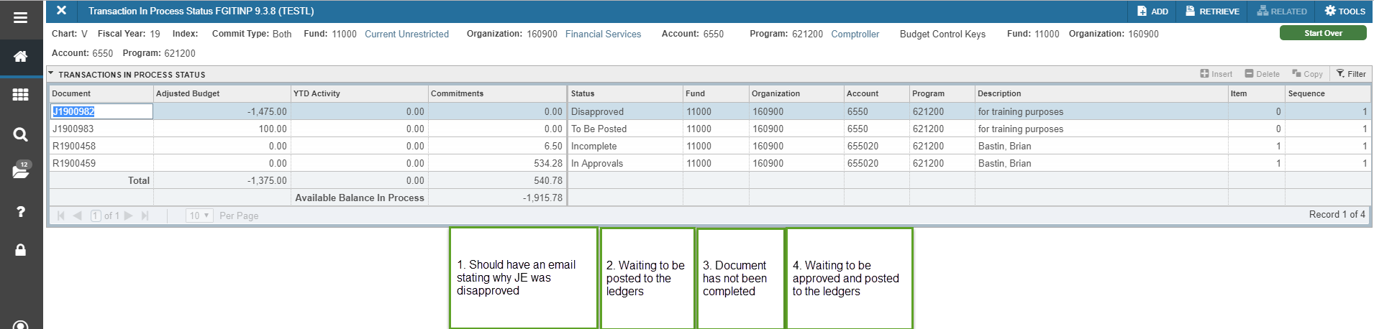

Budget Availability Status Form (FGIBAVL) Cont’d

8. Comparing the figures on FGIBAVL and FGIBDST. To Show that there is a difference on the two forms.

Budget on FGIBAVL for account code 6550 is 7,625.00 and on FGIBDST it is 9,000.00 for a difference of 1,375.00. The two budget transfers that have not posted.

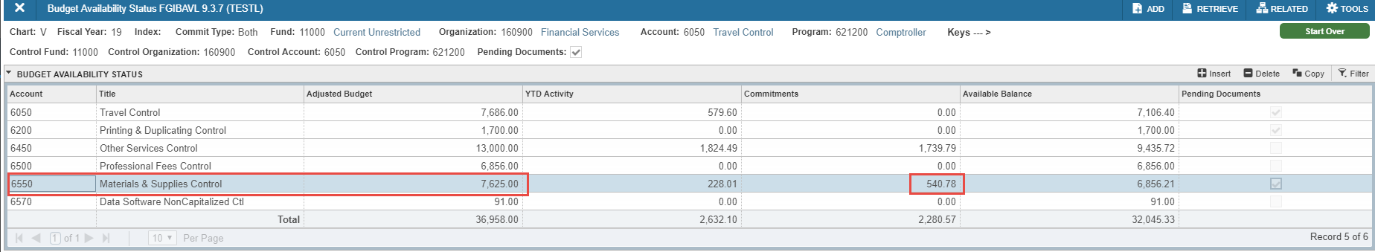

Commitments on FGIBAVL for account code 6550 is 540.78 and on FGIBDST for account code 655020 it is 0.00 for a difference of 540.78. The requisition that is in the approval process and the incomplete requisition.

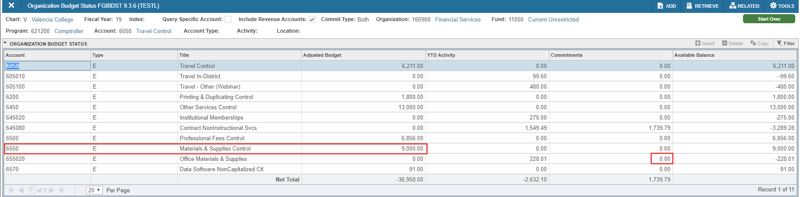

Budget Availability Status Form (FGIBAVL) Cont’d

9. Click in one of the status lines, then click the arrow under the status column to see all the different reasons to why the transaction hasn’t posted.

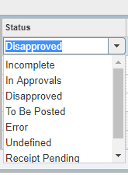
10. Click on the X icon to exit the form and go back to FGIBAVL. Click on the X icon again to go back to the Home Page.

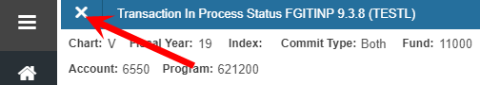

NOTE: If you would like to view another FOAP then click on Start Over.

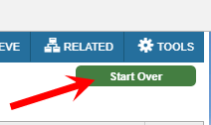

Organizational Budget Status Form – (FGIBDST)

This form is used to query the organizational status of accounts. It displays ONLY approved and posted transactions. The form also has drill down capability to the transaction detail information and Payroll.

1. On the Home page, type FGIBDST in the search field then hit enter.

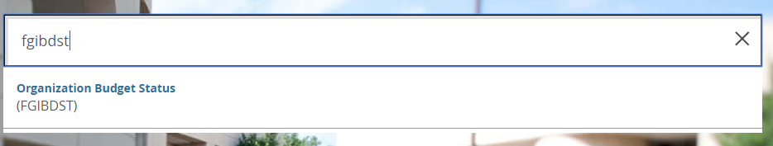
2. Enter the Index code, and then press the tab key. You will see the Fund, Organization and Program will populate automatically.
No account code is necessary on this form.

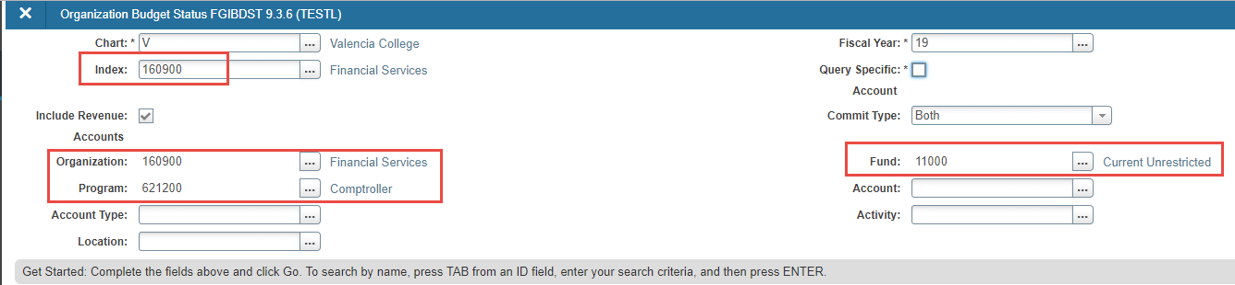

3. Click on the go button in the upper right hand of the page or ALT & Page Down or the down arrow in the bottom left corner of the page.

Organizational Budget Status Form – (FGIBDST) Cont’d

4. Now the form will populate showing you the account code you entered and all account codes that follow.
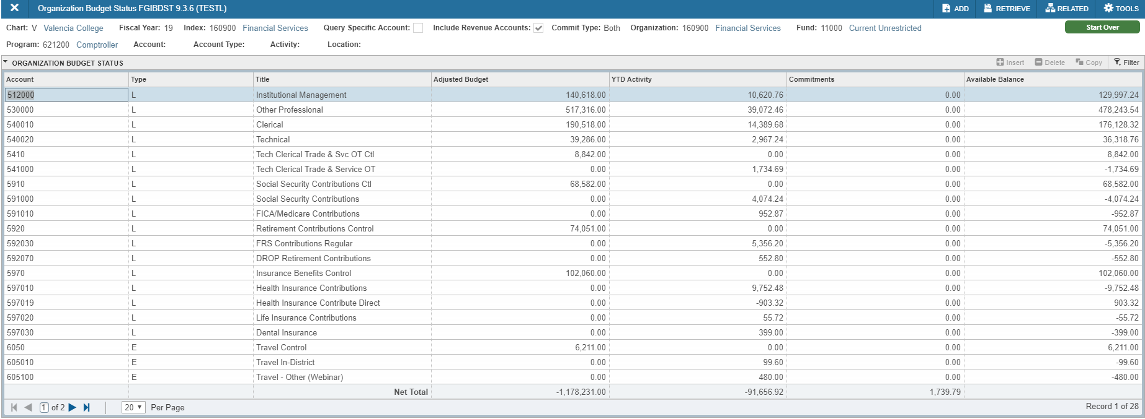
5. Click on the field you want to research, then click Related on the menu bar and then select the type of information you would like to see.

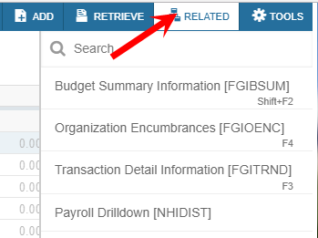

Organizational Budget Status Form – (FGIBDST) Cont’d

5a. Budget summary information (Shift+F2) will take you to the FGIBSUM budget query form.
Press the X icon on the menu bar to go back to FGIBDST.
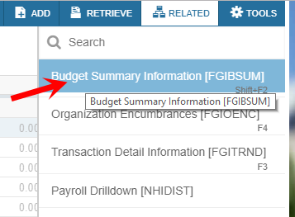
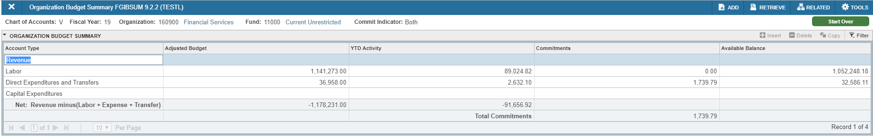

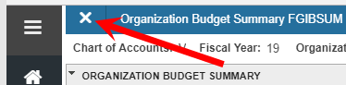
5b. Organization encumbrances (F4) will take you to FGIOENC. You will now have a listing of encumbrances for that account code.

Press the X icon on the menu bar to go back to FGIBDST.
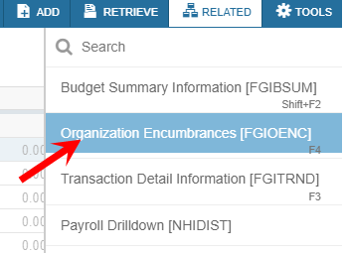

Organizational Budget Status Form – (FGIBDST) Cont’d

5c. Transaction Detail Information (F3) will take you to FGITRND. You will now see the detail information depending on which field you click in. F3 will also take you to FGITRND.

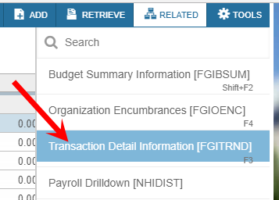

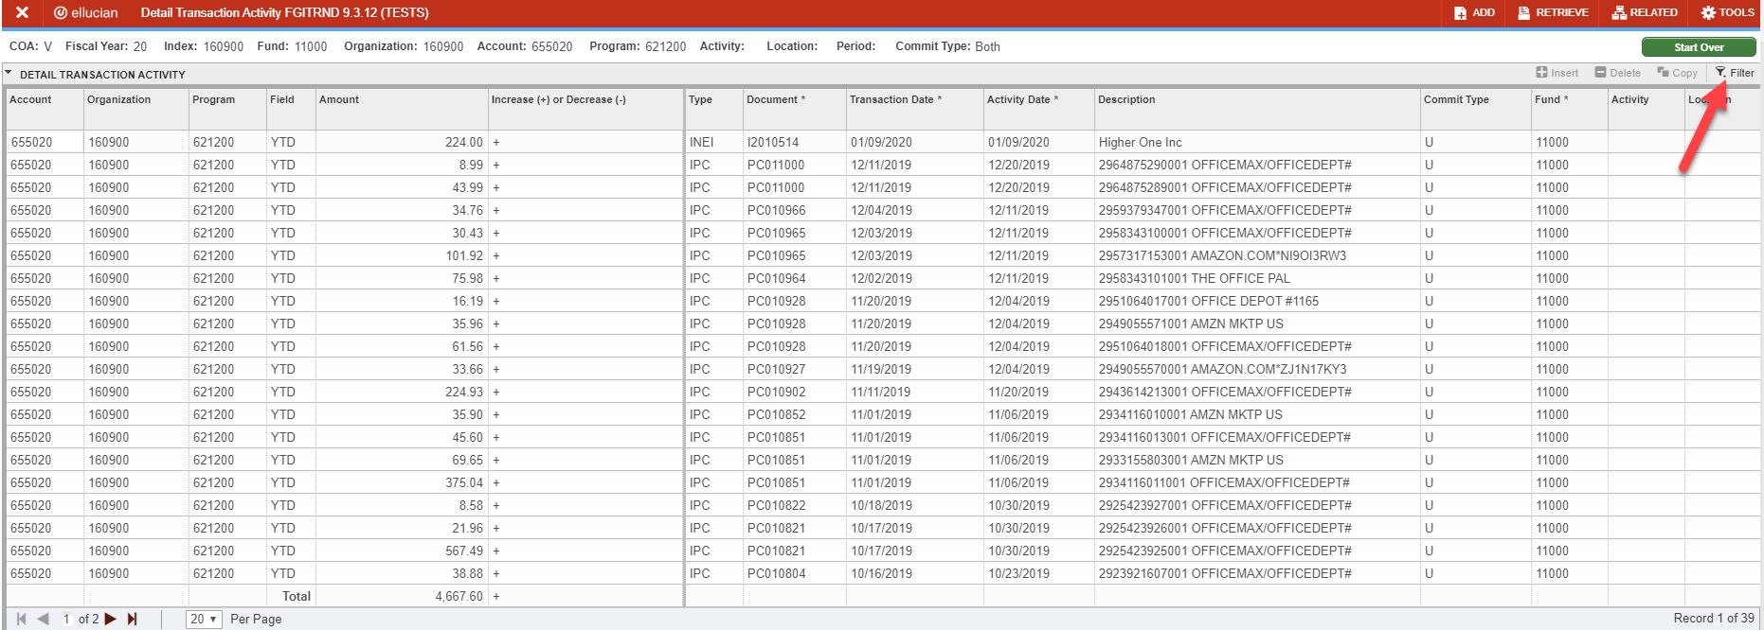

Organizational Budget Status Form – (FGIBDST) Cont’d

5d. To filter, click on the filter option.

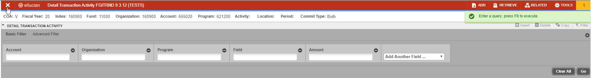

If the filed you want to filter one does not appear, click on Add Another Field drop down list and choose the field you want.
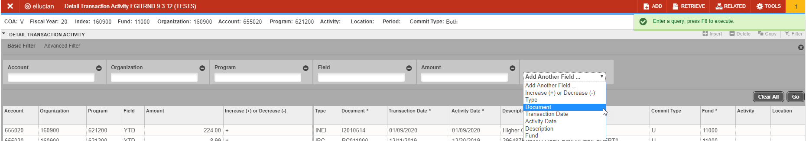

Enter your criteria for your search. In this case, I want to see all Invoices transactions. I will put I% in the Document field and then hit Go.

This will return all invoice for this particular FOAP.
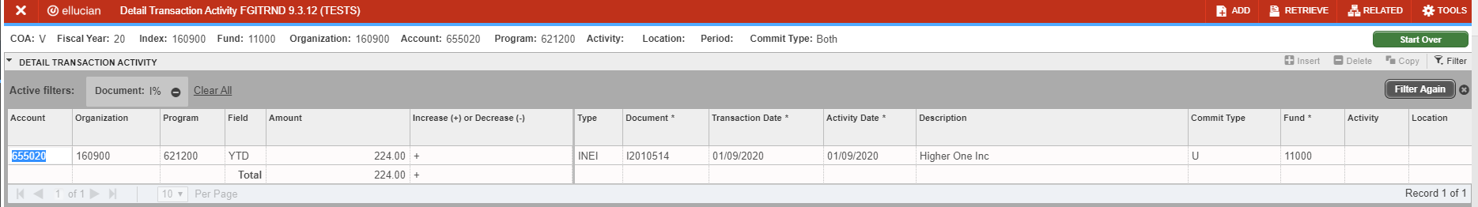

Press the X icon on the menu bar to go back to FGIBDST.
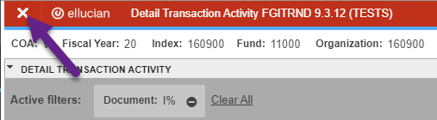
Organizational Budget Status Form – (FGIBDST) Cont’d

5e. Payroll Drilldown will take you to NHIDIST. You will now see Payroll details if you have access to Payroll information.
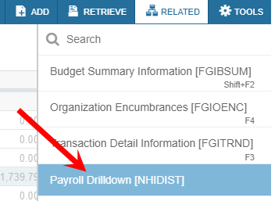
You will need to enter the appropriate account code you wish to research.

Please use the From Date and To Date fields to restrict the amount of information returned.

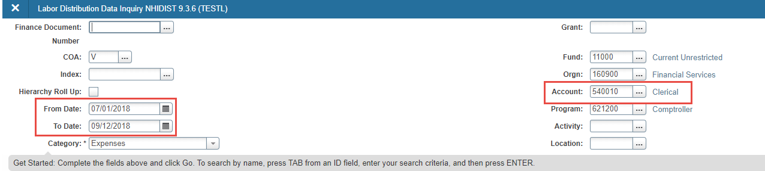

5f. Click on the go button in the upper right hand of the page or ALT & Page Down or the down arrow in the bottom left corner of the page.

Organizational Budget Status Form – (FGIBDST) Cont’d

5g. After clicking on Go or ALT & Page Down, the system will bring up a filter form, if you already have your FOAP on the previous form, just click the Go button to go to NHIDIST.

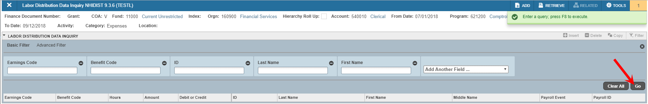

5h. This will show you what people are being paid out of that account code. There will be several lines associated with each person.
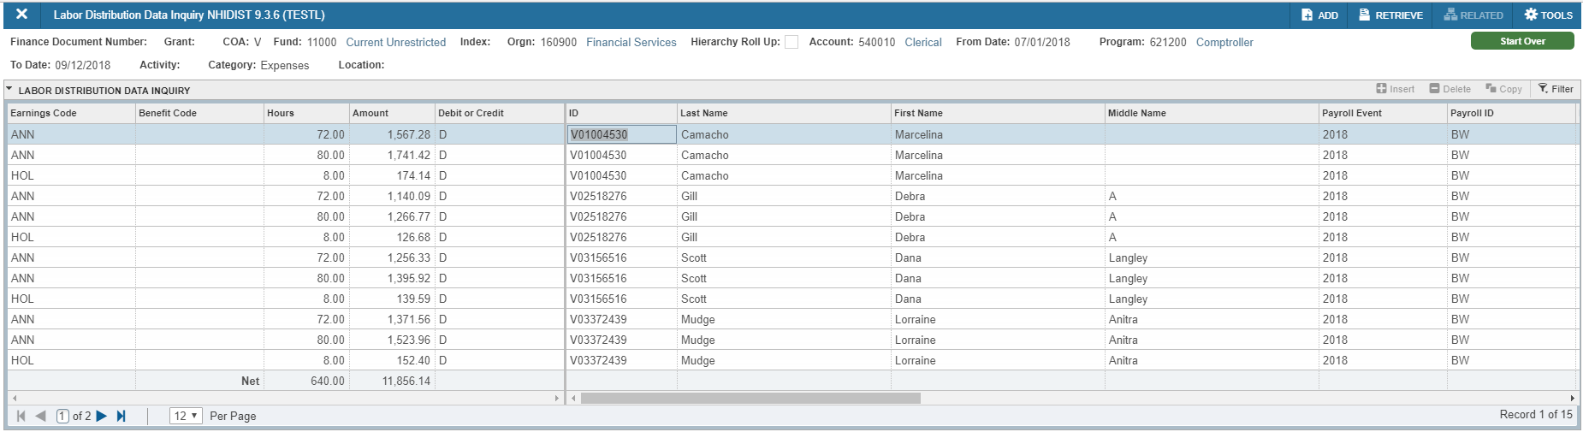

Press the X icon on the menu bar to go back to FGIBDST.

6. Press the X icon to exit the form.

Grant Inception to Date – (FRIGITD)

1. On the Home page, type FRIGITD in the search field then hit enter.

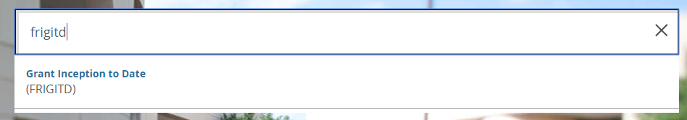
2. Enter the Index code. Tab through to the Organization and the Grant will default in.

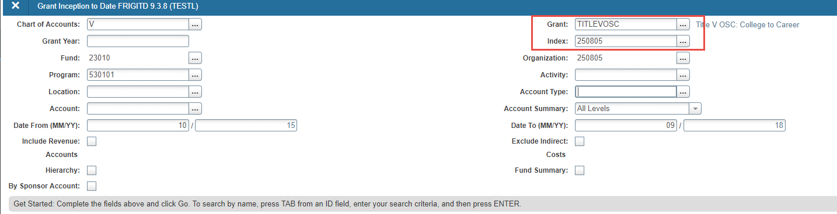
3. Click on the go button in the upper right hand of the page or ALT & Page Down or the down arrow in the bottom left corner of the page.

Grant Inception to Date – (FRIGITD) Cont’d

4. Now the form will populate showing you all account codes that are associated with this Fund, Orgn and Prog. This will bring in all information from the beginning of the grant.
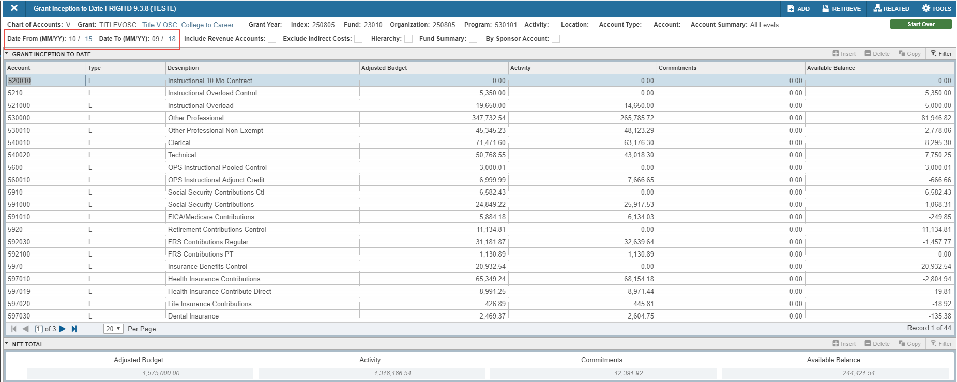
5. For more information, click in the field you want to research. This brings up information from the day the grant started until current day. Example: October of 2015 until September 2018.
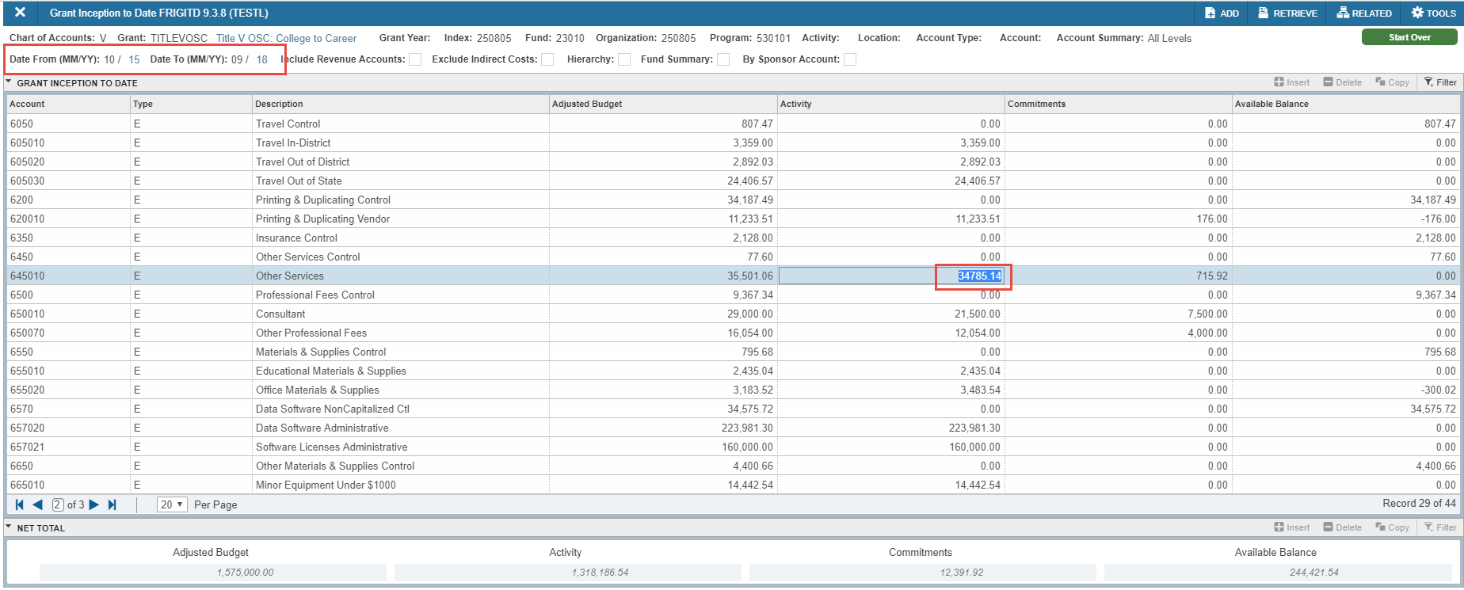

Grant Inception to Date – (FRIGITD) Cont’d

6. Click Related on the menu bar and then select the type of information you would like to see.
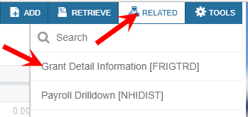

7. Grant Detail information will take you to the FRIGTRD form. This will show you all the transactions associated with the account code you chose.

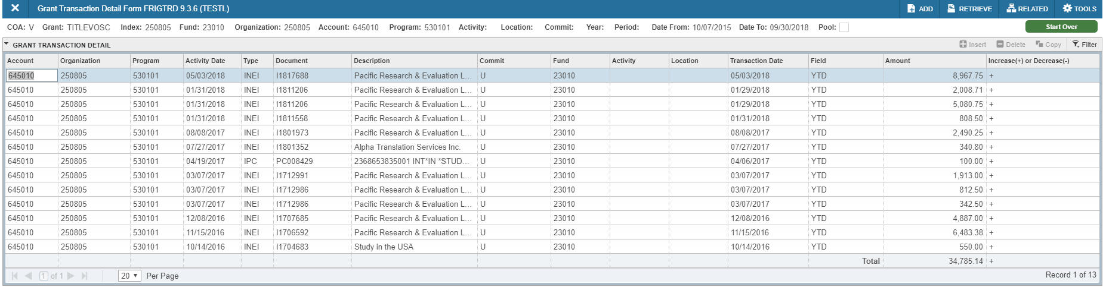

Press the X icon on the menu bar to go back to FRIGITD.

Grant Inception to Date – (FRIGITD) Cont’d

8. If you want to look at just the current fiscal year, click on the Start Over icon on the menu bar. Then change the Date From to 07/18 and leave the Date To as current month and year.
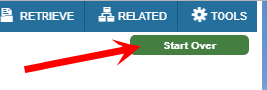
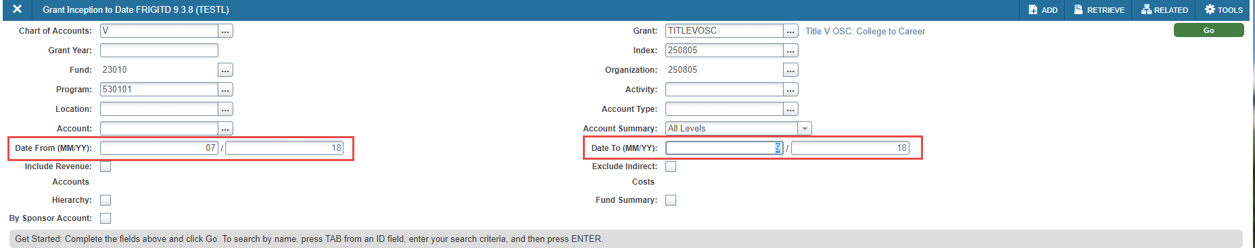

Click on the go button in the upper right hand of the page or ALT & Page Down or the down arrow in the bottom left corner of the page.

Grant Inception to Date – (FRIGITD) Cont’d

9. This will bring in only the information associated with the current fiscal year.

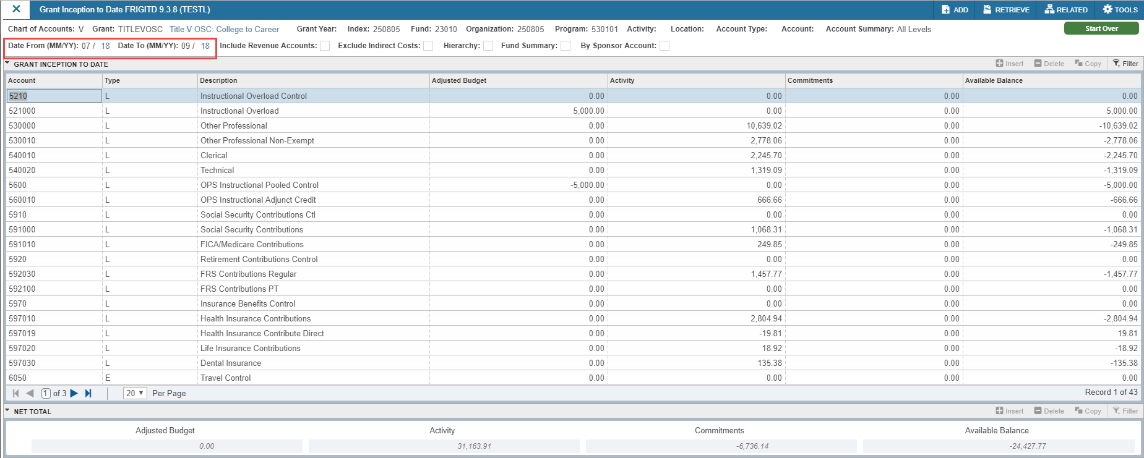

10. Press the X icon on the menu bar to go back to the Home page.

Funds Available Exercises

1. How much funds are available in Index 161800 Account 6050?

2. How much is Committed in Index 170004 Account 660010?

3. How many invoices have been paid out of Index 160900 Account 655020?

4. What was the original budget amount in Index 160500 Account 6570?

5. How many PCard transactions are there in Index 160500 Account 655020?

Budget Transfers – (FGAJVCM)

1. On the Home page, type FGAJVCM in the search field then enter.

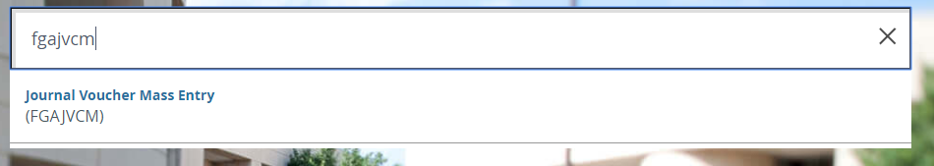

2. Leave Document Number field blank and click on the go button in the upper right hand of the page or ALT & Page Down or the down arrow in the bottom left corner of the page.

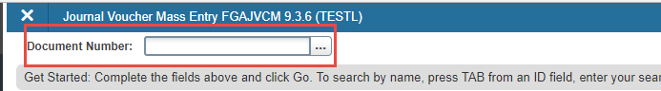

3. Today’s date will default in. Enter the Document Total (Remember this is the amount column added together).
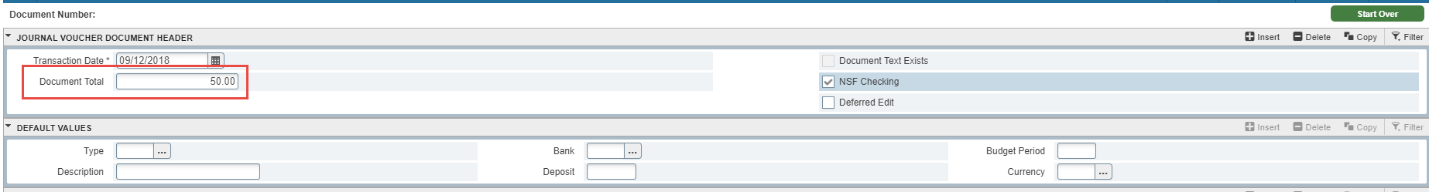

Budget Transfers – (FGAJVCM) Cont’d

4. Tab to the Default Values areas: under Type enter BUD for Indexes that begin with 1, BFR for Indexes that begin with 2 or 7, a description, 35 characters max. Budget period is required.

5. Click Related and then Document Text(FOATEXT)

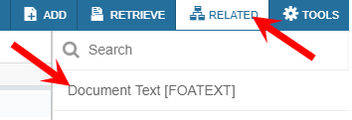

Budget Transfers – (FGAJVCM) Cont’d

6. Enter your user id (to identify who did the journal entry) and any additional description that would not fit in the description field here.

Click the save icon in the bottom right hand of the form or F10 to save.
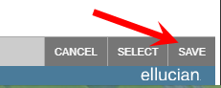

Click the X icon to close the form and go back to the FGAJVCM

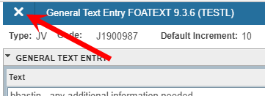

7. The system will assign the journal entry number.

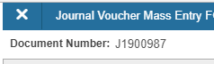

8. Click on Next Section or ALT & Page Down to enter the Journal Voucher Detail area.

Budget Transfers – (FGAJVCM) Cont’d

9. Tab over to the Index and enter your index code, account code, percent or amount and + or -. Use the down arrow on the keyboard to go to the next line. Seq number will automatically populate.

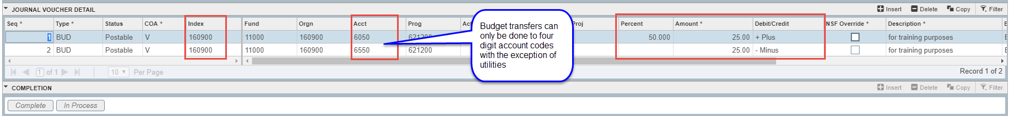

10. Once all lines are complete, Click on Next Section or ALT & Page Down

11. You will be taken to the Completion section. Click on the Complete icon.

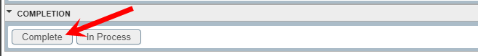
12. In the top right of the form, you should see the following message.

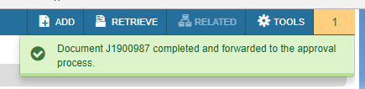

Budget Transfers – (FGAJVCM) Cont’d

1. If a Budget Transfer has been disapproved, you will receive an email from Workflow stating a document has been disapproved.

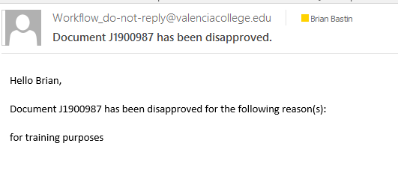

2. After reading your email from Workflow, enter GUAMESG in the search field and hit enter. This will open the General Messages form. Read the reason for the disapproval and Click the Complete radial button. Look for the item number and remember it.

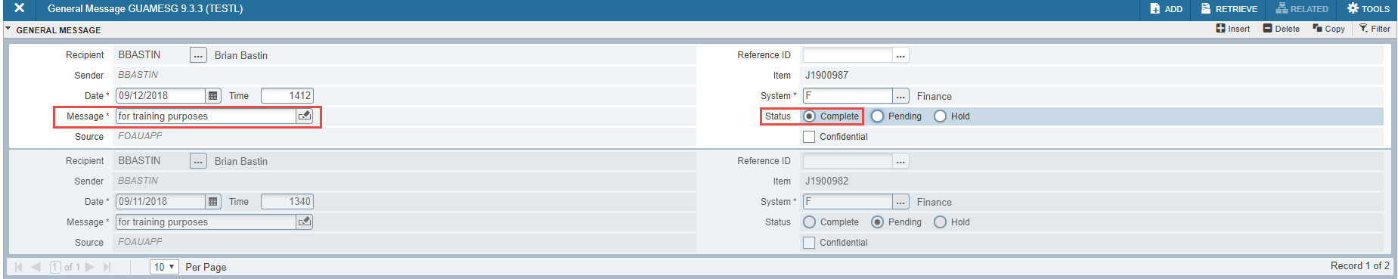

Then click on the Save icon in the bottom right of the form or F10 to delete the message.
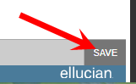

Click the X icon to close the form and return to the General Menu.

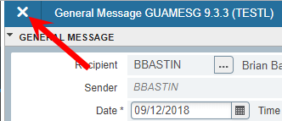

Budget Transfers – (FGAJVCM) Cont’d

3. On the Home pate, type FGAJVCM in the search field then enter

4. Click on the search box.

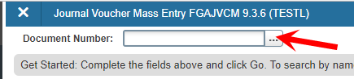

5. When the list of suspended journal vouchers opens, find your document number and double click on the number.

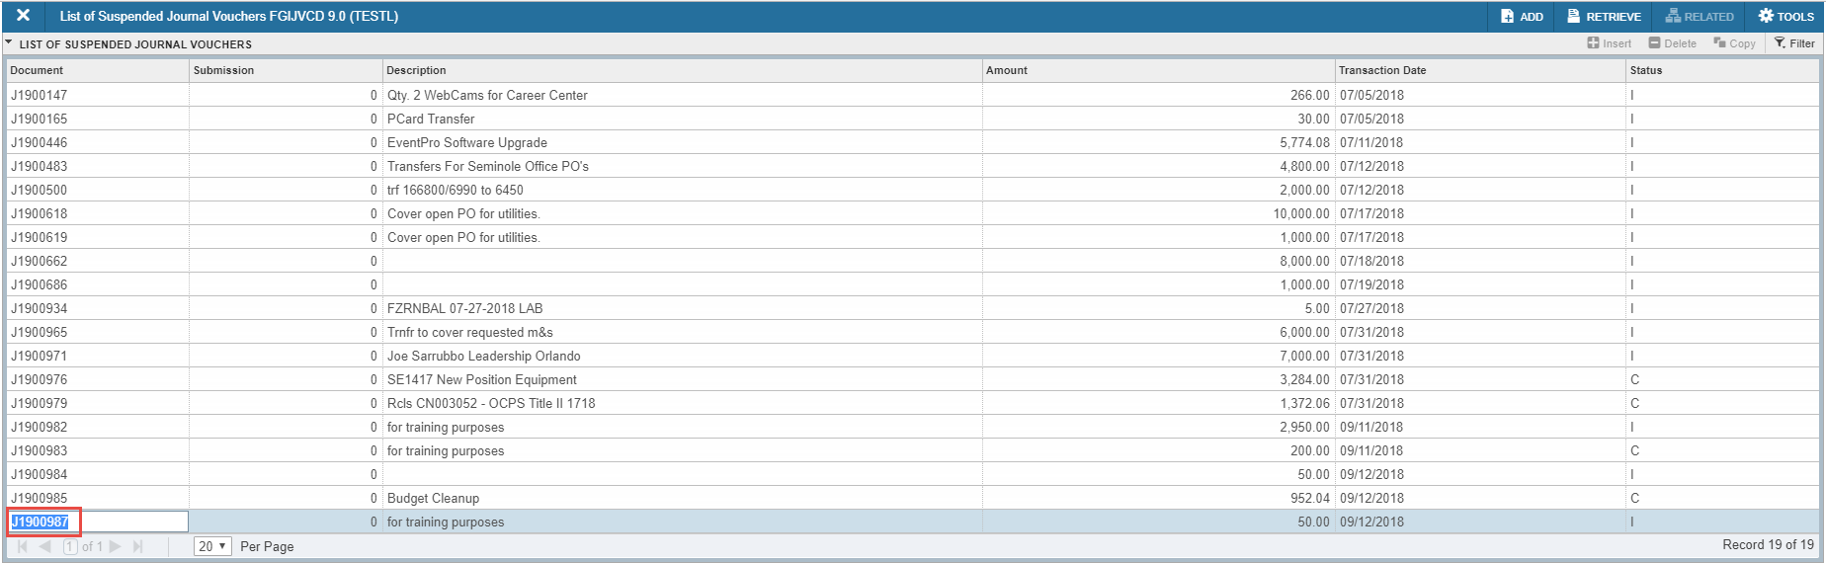

6. You will now see your number in the Document Number field.
Click on Next Section or ALT & Page Down or Go

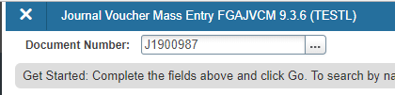


Budget Transfers – (FGAJVCM) Cont’d

7. This will take you to the Journal Voucher Mass Entry form. Notice that the Default Values section is blank. This is ok it is just the way the form works.

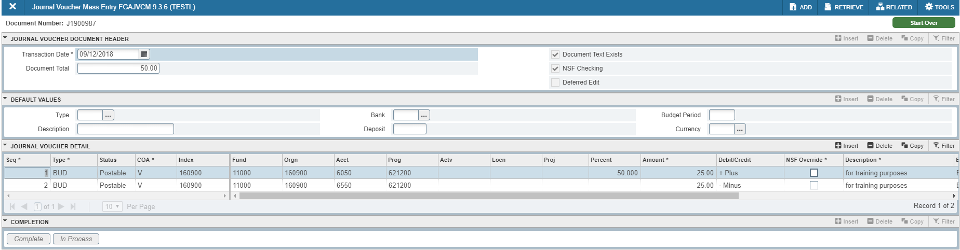

Click on Next Section or ALT & Page Down to go to Journal Voucher Details.

8. Make the appropriate changes. In this case change account code 6050 to 6200.

9. Click on Next Section or ALT & Page Down to go to Journal Voucher Details.

10. You will be taken to the Completion section. Click on the Complete icon.

Budget Transfers – (FGAJVCM) Cont’d

11. In the top right of the form, you should see the following message.

Budget Transfer Exercises

1. Transfer 25.00 from Index 170200 Account 6550 to Account 6650.

2. Transfer 30.00 from Index 161800 Account 6450 and split it between Account 6550 and Account 6200.

