Financial Advisor Channel
Banner Version 8.1

Screen-by-screen instructions to access the Banner Self-Service system.
- The Financial Advisor Channel is part of the Banner Self-Service system. You will need to use Atlas to access this channel. Please enter http://valenciacc.edu in the url and press the enter key. Now select Atlas login. | 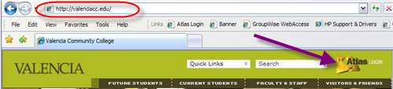
- Enter your user name, Atlas PIN and press the Log in button. | 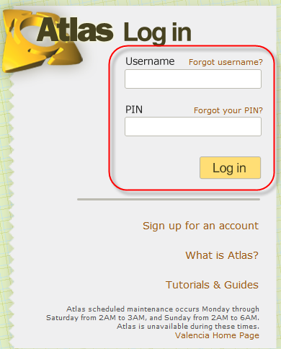
- Click on the Budgeting Tab. | 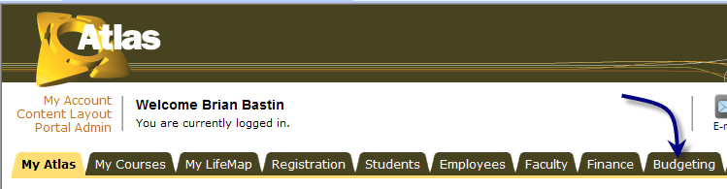

Financial Advisor Channel Cont’d
- The Financial Advisor channel is under the Banner Messages channel on the Budgeting tab. | 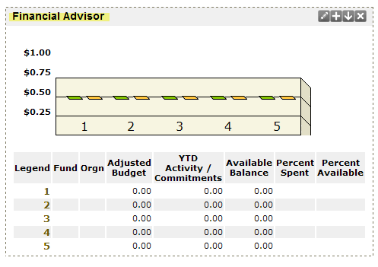
- Click on the edit button. | 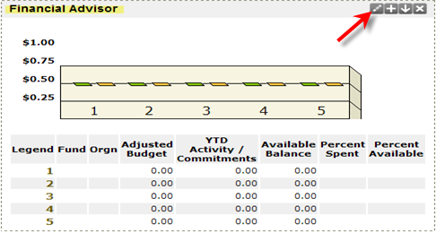

Financial Advisor Channel Cont’d
- The Financial Advisor Preferences will open up. You can add up to five (5) organizations for a quick reference. You can choose from nine (9) different colors to display the Adjusted Budget and YTD Activity/Commitments. Enter V for the COA and your Orgn code. Click Apply. Then click back. You must have access to the Org’s to view them. | 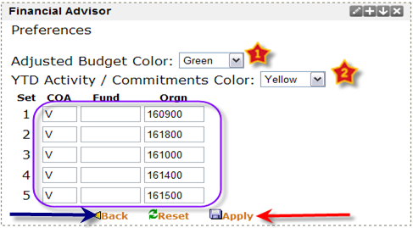
- You will now see the graph and the summary of your organizations. | 