**INSTRUCTIONS FOR PRINTING RED FLAGS RULE CERTIFICATE**

Sign into Atlas

Go to Employees tab

Go to My Development Channel

Click on Access Valencia Edge



This launch you into the Valencia EDGE. Click on the “Learning” menu option

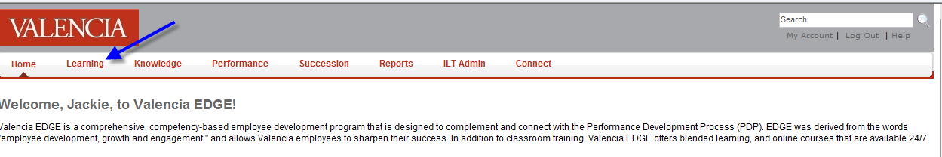

Select “View Your Transcript”

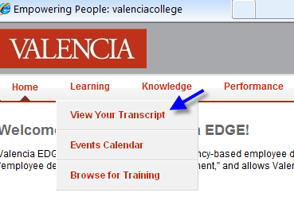

Go to the Transcript box, and click on the Completed Tab

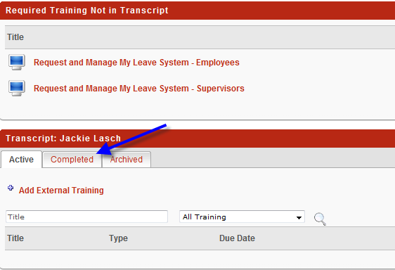

You should then see something similar to this screen.

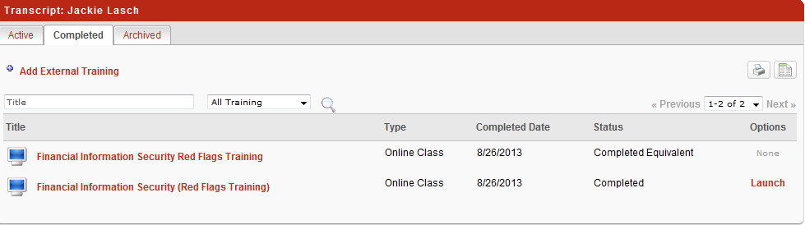

Note: I just figured out how you can print a certificate, so I did not give you these instructions over the phone.

Click on the title of the course with status of “Completed”.

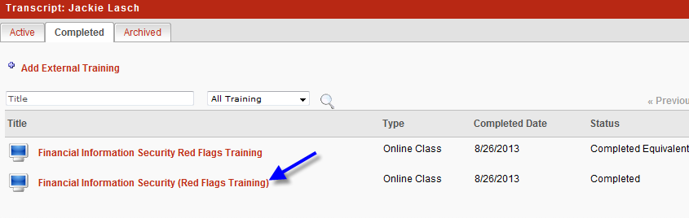

You should then see the following window appear.  If you click on “Print Certificate”, a new window should open up with a certificate displayed which you should be able to print as you would any other pdf file.

