Login into your Atlas email

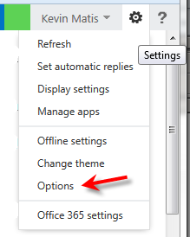

Click on the “settings” icon in the top right

And select Options

Click on “account” and then “forward your email”

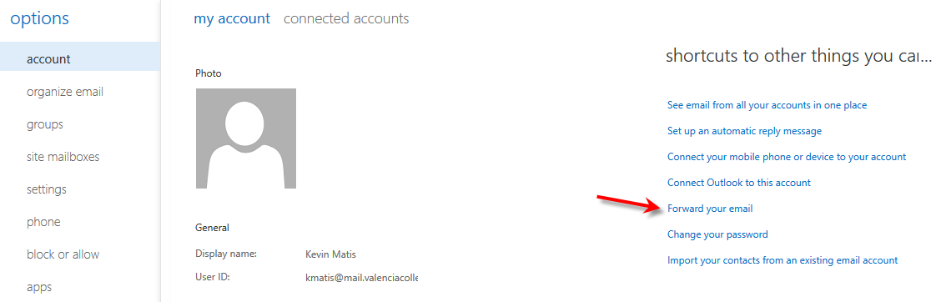

Verify there is nothing in the forwarding box and the box is checked to keep a copy.

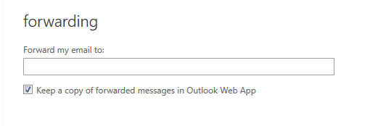

If you name is in the box, click on “stop forwarding”

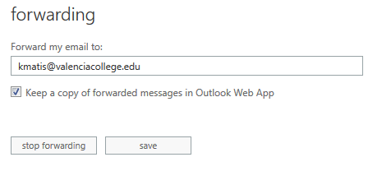

Click on Organize email and verify these settings, check or uncheck to match

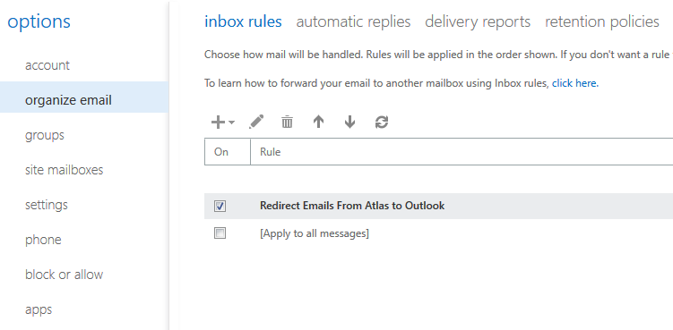

Click on the circled arrow to return to your inbox and your account is ready.

