FLASHLIGHT SURVEY PLANNING SHEET

Course:
Name of Survey:

Purpose of Survey: (What do you want to find out?)

Format(s): (see examples on “Survey Overview for Participants”)

Draft Likert questions: (Each survey item should only ask one question at a time.)

Draft open-ended questions:

Check your survey for potential usefulness:
- Review each question and ask yourself if it is worth asking. Imagine that you had to pay each student to answer each question. Is it worth their time and yours?
- Ask yourself how you will use the data you generate from this survey. Too much information? Too difficult to analyze in the time you have? Will the responses from this survey be in a form that will be useful? Are you asking the right things? Will the answers be what you really want/need to know?
- Ask a few colleagues and a few students to preview your draft survey to see if they read the questions as you intend them to be read.

Sample of Survey Question Types
This survey is meant to demonstrate the different question formats available in Flashlight. Questions from the question bank cannot be edited. All parts of all custom questions may be changed while creating a survey. It is important to decide on question formats BEFORE you start a survey.
Top of Form

Since you began this course, how frequently have you done one of the following?
 |  | Check the most appropriate answer.
 |  | Three or More Times | One or Two Times | None/Not at All
1. | Worked on optional tasks or assignments
2. | Studied with other students for quizzes or examinations for this course

Indicate the number of hours you spend on this class by answering the questions as honestly as possible. Your name will not be given with your answers.
 |  | Select the most appropriate response.
 |  | Six or more hours weekly | Four to six hours weekly | Two to four hours weekly | Less than two hours weekly
3. | How much time do you spend on homework for this class?
4. | How much time do you spend studying for tests and examinations for this class?
5. | How many hours of lab work do you complete for this class?

Indicate how strongly you agree or disagree with the following statements:
 |  | Mark the appropriate circle. Select only one response per question.
 |  | Strongly agree | Agree | Disagree | Strongly Disagree | Don't Know/Not Applicable
6. | Assignments for this course were stimulating.
7. | Assignments for this course were excessive.
8. | This course taught me to work with a team/group in order to complete a project.

9. | Please rate the overall quality of the training provided in this course.
 | Excellent
 | Very Good
 | Good
 | No Basis for Judgment
 | Fair
 | Poor
 | Very Poor
 | I do not wish to answer

Think about a time you have relied on paper and pencil exercises to learn a new concept. Compared to that time, because of the way this course uses technology, answer the questions as candidly as you can.
How likely are you to: |  | Mark the appropriate circle. Select only one response per question.
 |  | Much More Likely | Somewhat More Likely | About the Same | Somewhat Less Likely | Much Less Likely | No Basis for Judgement/Not Applicable
10. | ...work on assignments with other students?
11. | ...complete assignments on time?

12. | My overall rating of this class is (A-F) because:

13. | In order to have a record of those student completing the survey, please add your first and last name to the answer box below.
Flashlight Question Bank Contents by Category

This page indexes the items in the Current Student Inventory item bank by category outline. You may include a selection of these items in your Flashlight survey. Begin by choosing a category from the outline below. You will see all the items for that topic with checkboxes next to each item. Check the ones you want to include on your survey. When you have finished your selections, choose "Save Selections" located by scrolling to the bottom of the page.

I. Educational Strategies
A. Teaching and Learning
These are questions about the prevalence of, and student reactions to, various teaching and learning practices, whether or not technology is used.

B. Teaching, Learning and Technology
These questions address how various teaching and learning practices are helped or
hindered by the use of each of the following technologies.
a. Audio Conferencing
Use of multi-party live audio, usually by telephone lines but also
through the Internet.
b. Commercial Software
From spreadsheets to research computer applications (not word
processors).
c. Courseware
Computer-aided instruction, computer tutorials.
d. Electronic Communication
E-mail, newsgroups, listservs, chat, real-time writing.
e. Calculator
Graphing and scientific calculators.
f. Internet/World Wide Web
Creation of web pages and other web materials by students.
g. Internet
Using the internet and WWW for a combination of purposes in
support of an entire course, for distance, distributed, or
campus-based learning.
h. Internet
Using the Internet and WWW for research (compared with
traditional library).
i. Multimedia
Creation of multimedia materials by students.
j. Multimedia
Use of multimedia texts or course modules by students.
k. Multimedia
Use of multimedia presentations and lecture support by faculty.
l. Televised Lectures
Live.
m. Video
Videotaped lectures or video course materials.
n. Voice Mail
Items on using voice mail.
o. Word Processing
Items on using word processing software.

C. Student Satisfaction
a. Course Satisfaction
Items about how students feel about the course innovation.
b. Training Satisfaction
The following questions refer to the training you have received
on how to use technology.
D. Self-Reported Learning Outcomes
This section provides templates to help faculty frame questions about whether technology helped students learn specific content or skills. You can use these templates to ask a question customized to the particular course technology.

E. Open-ended Questions
These more open-ended questions can be used in a survey to identify unanticipated issues and more divergent outcomes (e.g., unique uses) and aid in the interpretation of responses to forced choice questions.

II. Experiences with Technology

A. Technology Use
These items ask the student to estimate how much time was spent using various
technologies for various purposes in a typical week, for academics, as part of employment, and for personal reasons. This section is especially useful in helping you understand whether the use of technology is specific to a single course or whether the student is also getting experience from other sources. The academic items can be tailored either to refer to use of technology in a single selected course or to all the students coursework.

B. Technological Sophistication
This section includes self-rating of skill in using a variety of specific technologies and questions about technology availability for the student.

III. Student Academic and Demographic Items

A. Academic Goals
Items such as, why take this course, grade expected, degree questions.

B. Retention
Items on dropping out and incomplete assignments.
C. Optional Academic Information
Items on credit hours, gpa, hours worked for pay per week.

D. Optional Demographic Information
Items on age, sex, race.
E. Additional Items Specific to Distance Learning Programs.
Access and attitude items specific to distance students.
FLASHLIGHT ON-LINE SURVEY
STEP-BY-STEP USERS GUIDE
(A pictorial guide follows on the next pages.)

To Develop a New Survey:

- Complete Flashlight Survey Planning Sheet

- Access Flashlight program: http://flashlightonline.wsu.edu/ Click on “Click Here to login to Washington State University's CTLSilhouette to use Flashlight™ Online” and enter your user ID and password. For most new users your ID is first initial and last name and your password is your full first name. You may change your password after logging in.

- Click on “New Survey” (top of screen)

- Enter “Survey Properties Information” (required) and click “OK”

- Select a template if appropriate.

- Enter Instructions for Respondents and click “OK”

- Click on “Add Items” (top of screen)

- Click on “Custom Questions” if not using the question bank.

- Select Block Format or Open Format Questions (i.e. Likert 3, 5, or 6, open-ended etc.)

- Fill in the instruction boxes and column headers as appropriate.

- Enter draft questions, review and revise

- PLACE A CHECK IN THE BOX ON THE LEFT HAND SIDE OF EACH QUESTION All your questions will disappear if you do not do this!

- Click on “SUBMIT”

- Add items or select a different format for additional questions if desired

- Review/proof and check box on left hand side of each question

- Click “PRINT FRIENDLY” at the top of the screen to preview survey and print

- Note URL for your survey ________________________

- “START SURVEY” (CAUTION: survey cannot be changed after activation)
FLASHLIGHT ON-LINE SURVEY
Pictorial Step-by-Step Users Guide

Before you start creating a survey in Flashlight, it is important to plan the contents and format of your assessment. This will make the software much easier to use.

Go to the Flashlight Online web site at http://flashlightonline.wsu.edu/. Click where it says “Click Here to login to Washington State University's CTLSilhouette to use Flashlight™ Online.”

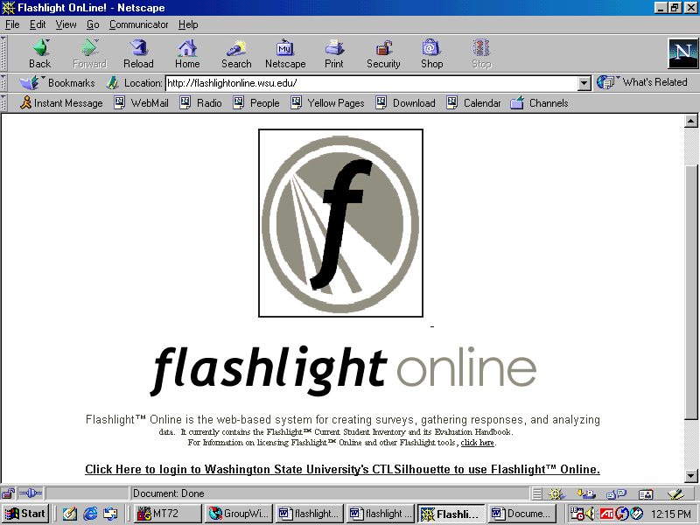
Type address here
http://flashlightonline.wsu.edu and hit the Enter key on your keyboard.
Click here to log on to Flashlight.

Enter your Login ID and Password. For new users, your Login ID is your first initial followed by your last name. Your password is your full first name. For example, Jane Doe would have a Login ID of jdoe and the password jane. Then click on “login.”

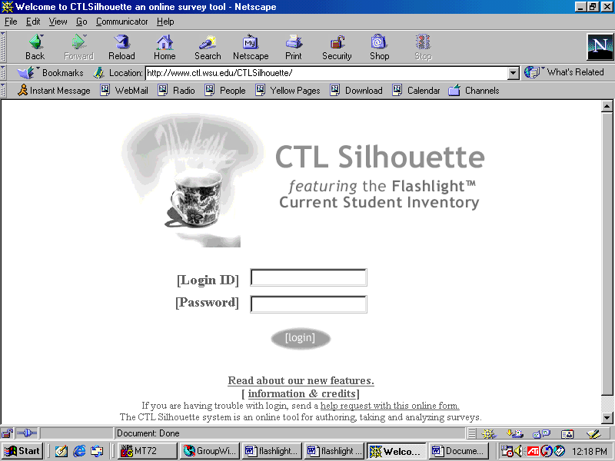
Enter your Login ID and Password here. Then click on “login.”
After logging in, you will be on the home screen. On this screen you can access all surveys you have created as well as any “public” surveys created by other faculty. You cannot alter surveys created by other faculty, but you can copy them as your own and make edits at that time. To create a new survey, click on New Survey at the top of the screen.

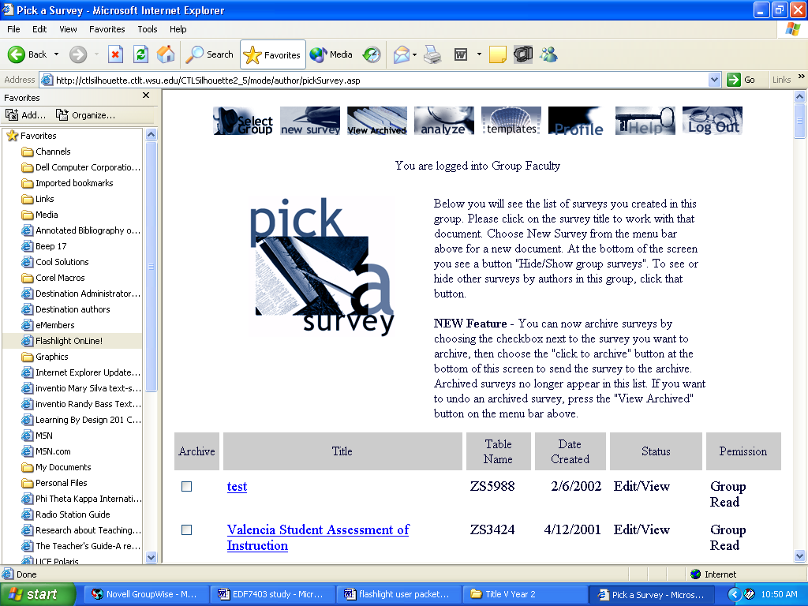
Click on New Survey to start a survey. Scroll down the page to see surveys created by other faculty.

Scroll down the Survey Properties Information screen and answer the questions. All questions must be answered to proceed. When you have finished answering the questions, click OK at the bottom. HINT: Make survey titles as specific as possible. Try to avoid general titles as you may not be able to distinguish the survey from others of the same name. Survey titles will appear on the actual survey.

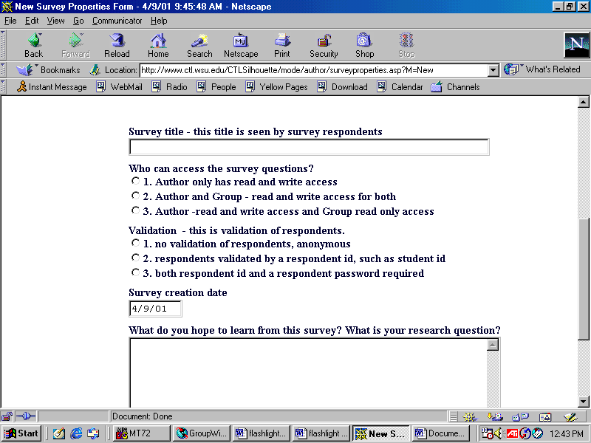
You must respond to all questions to proceed. Click OK at the bottom of the screen when you are finished.

On the next screen, you may add general instructions for the respondents. Any instructions you add here will appear at the top of the survey below the title. You can leave this field blank. When you are finished, click OK at the bottom of the screen.

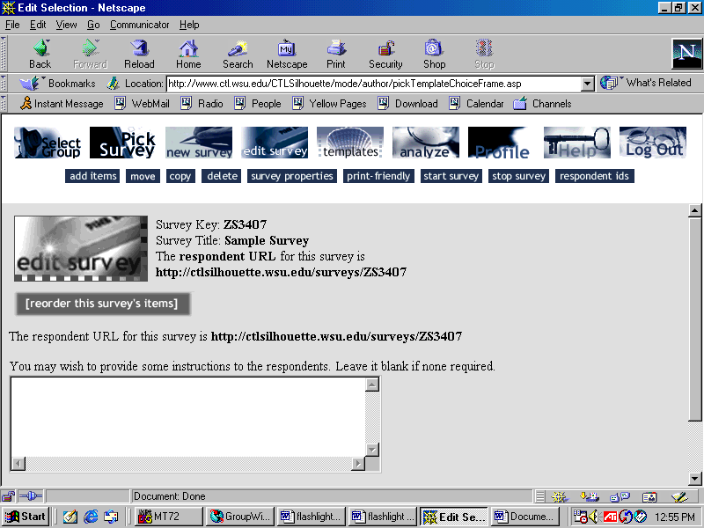
Type any general survey instructions here. Click OK at the bottom when you are through.

Once you click OK, you will return to the same screen. You are now ready to add questions to your survey. Click on Add Items at the top of the screen.

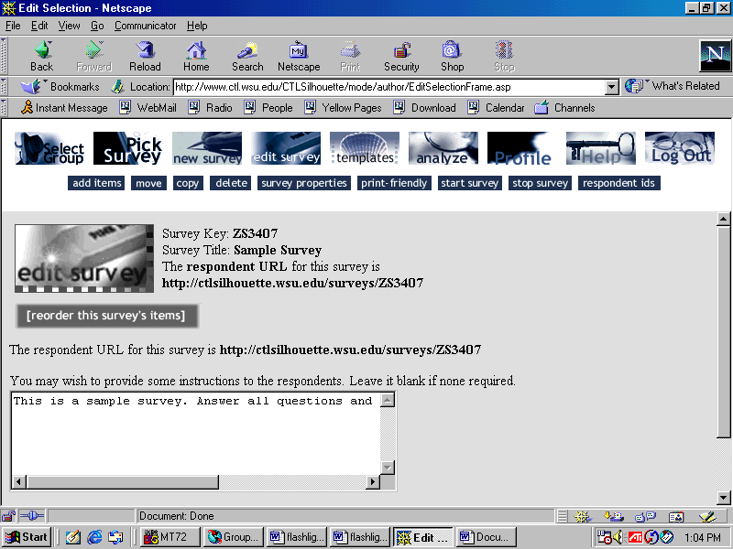
Click on Add Items to begin to add questions to your survey.

You may select questions from the item bank or create your own. We have examples of both below.

To select questions from the item bank, use the various ways of sorting questions at the top of the screen. We recommend starting with Table of Contents which sorts items by category. If you find a question that you like, click in the box to the left of the question(s) you want to add to your survey and click Submit at the bottom of the screen. Note: You cannot edit questions from the question bank.

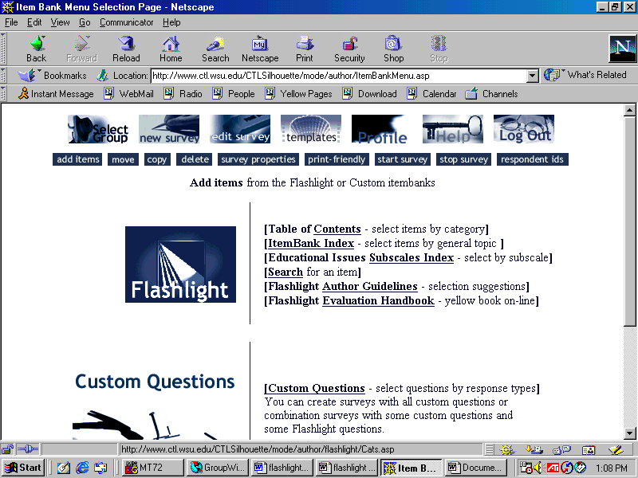
Use the sorting techniques listed at the top of the page to find questions in the bank to add to your survey. Click in the box to the left of any questions you want to add and then click “Submit.”

To create your own custom questions, click on Custom Questions on the bottom half of the screen.

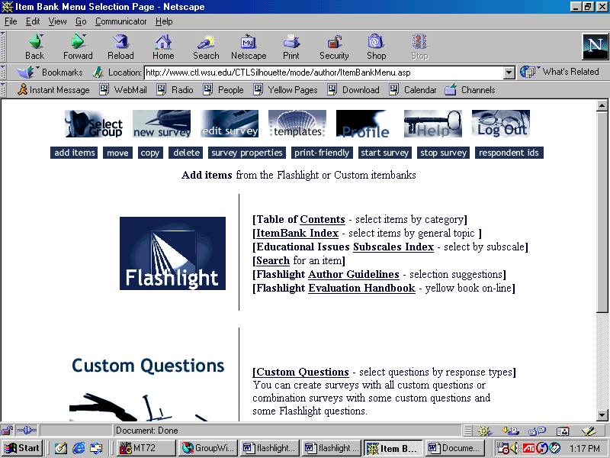
Click on Custom Questions to create your own survey questions.
You will have to select the type of questions you want to create. You can put multiple styles of questions on the same survey. However, you can only create one style of question at a time. For examples of the different styles, look at the sample questions on pages 3 and 4 of this packet. Questions 1-8 are all Block Format Radio Button Questions of various scales. Question 9 is an Open Format question with Radio Buttons and questions 12 and 13 are Text Area Open-Ended Questions. Radio buttons allow only one response per question while Check Boxes allow for questions such as “check all that apply.” Select a number in the Number of Questions box. The smallest choice is 10, but you DO NOT have to make 10 questions. The number of questions is a maximum not minimum number.

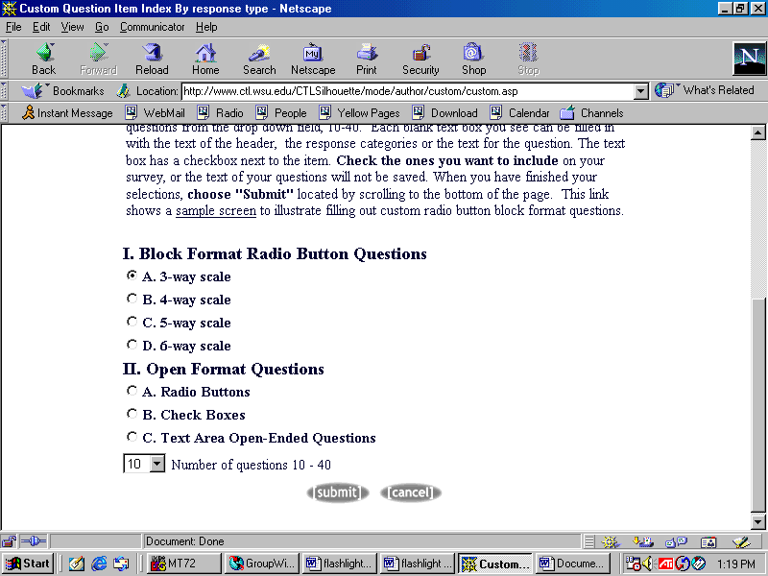
Select the type of question you want to create. You can only create one type of question at a time. See the sample questions in this packet for examples.
This number is the maximum number of questions you want to create. You can create as few as one of any type. Then click Submit.
Once you click Submit, you may begin to enter the questions. Type the information into the appropriate text box. There are spaces for additional instructions. Any boxes left blank will not appear on the final survey. IMPORTANT: BE SURE TO CLICK IN THE BOX TO THE LEFT OF ANY QUESTIONS YOU CREATE TO “SELECT” THE QUESTION OR IT WILL NOT BE SAVED.

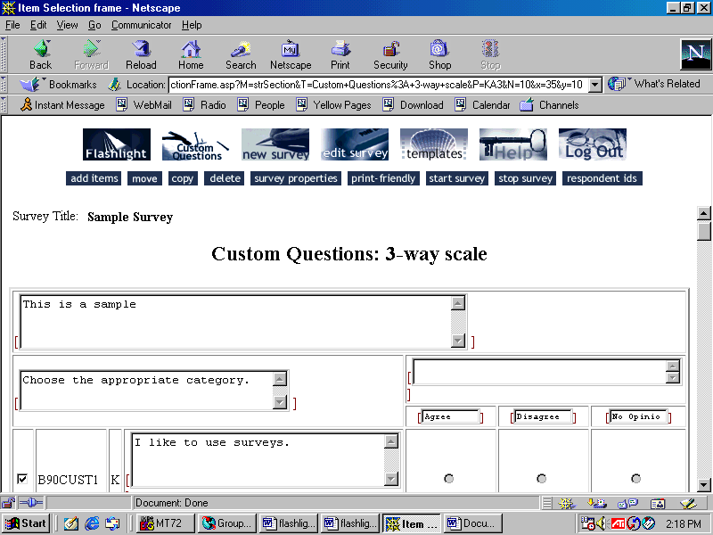
Fill in the text boxes. Be sure to click in the box to the left of the questions or they will not be saved. Click Submit at the bottom of the screen.

After clicking submit, you will return to the custom question screen. You may add additional questions, change the type of questions, or finish. To finish, click on Edit Survey at the top of the screen.

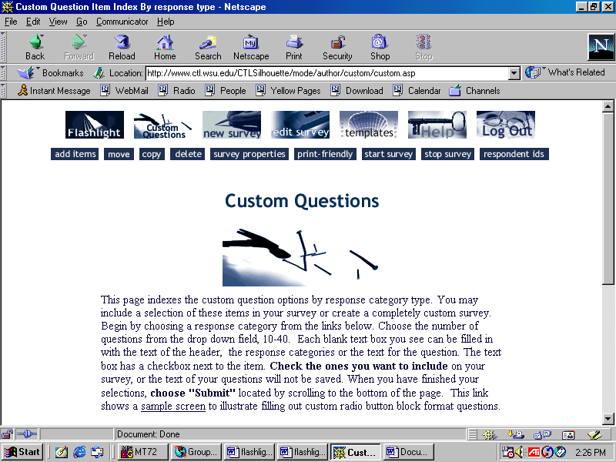
Once you have finished adding your questions, click on Edit Survey at the top of the screen.

Carefully check the survey over for spelling errors, typos, etc. When you are happy with the survey, click OK at the bottom of the screen. You will return to the same screen. To view or print the survey as it will appear, click on Print-Friendly at the top of the screen. Use the Back button in the upper left corner of the screen to return.

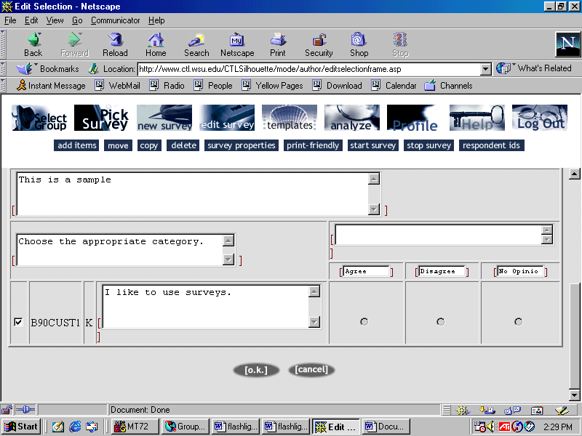
Proof your survey and make any corrections on this screen. Click OK when you are done.
Click on Print-Friendly to see the survey as it will appear to others or print.

The print-friendly version is below. Click on Back to return to last screen.

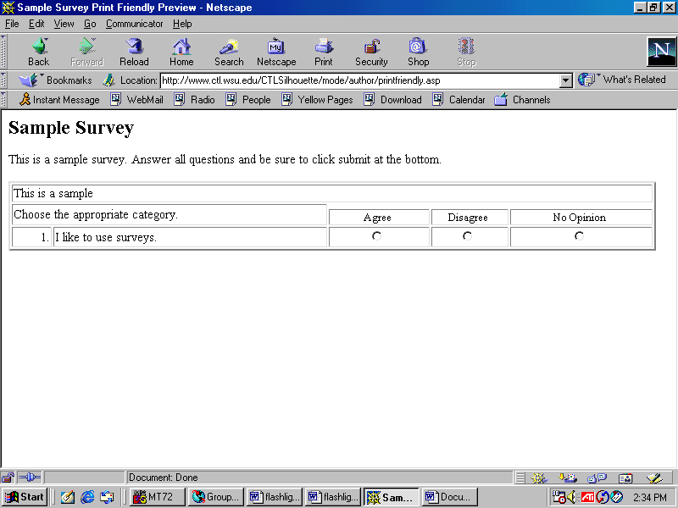
Click on the Back button to return to the previous screen.

If you are happy with your survey, you are ready to start it. IMPORTANT: ONCE YOU START THE SURVEY YOU CANNOT MAKE ANY CHANGES TO IT. Click on Start Survey at the top of the screen.

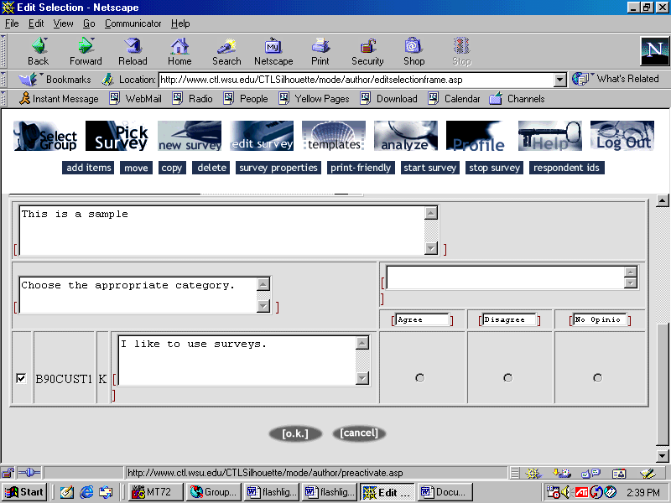
Click on Start Survey to allow people to respond. Once you start your survey you cannot edit it anymore.

You will be given a URL (web address) for respondents to access the survey. This is the link you will provide for your students/others to take the survey. Write the URL down (or copy and paste it) and click OK.

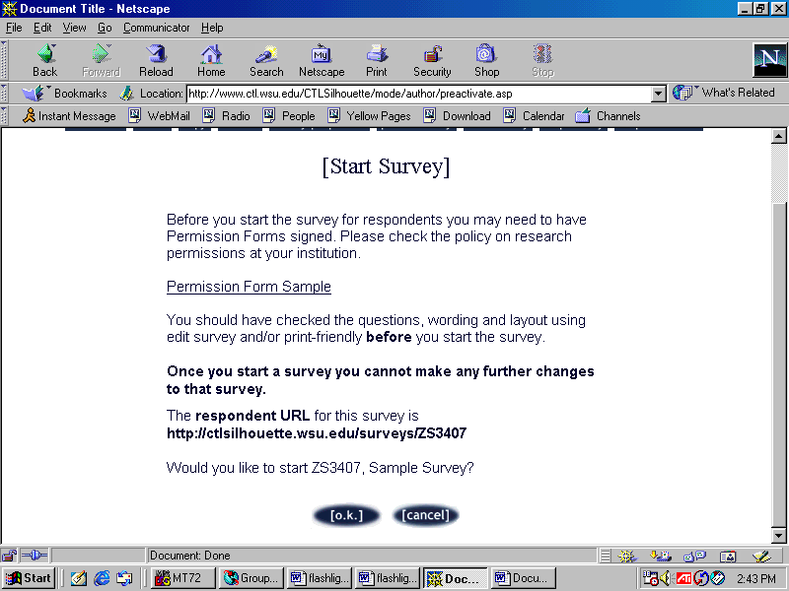
Note the URL provided to access your survey. This is the link you will provide to respondents. (You can copy and paste this link.) Click OK at the bottom of the screen to activate.

The final version of the survey will appear. NOTE: THIS IS NOT THE LOCATION TO RESPOND TO THE SURVEY. If you want an “active” survey that someone could actually respond to, you must type in the URL from the previous screen.

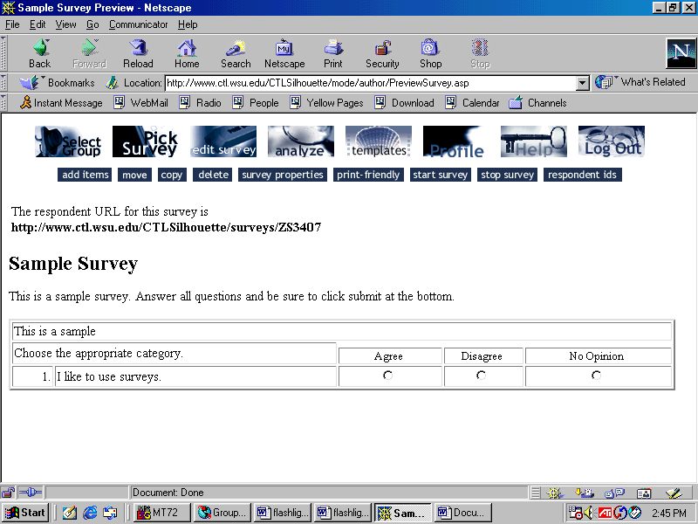
This is the final version of your survey. You CANNOT respond to the survey on this screen. You must go to the actual active link for the survey (provided on the left where the arrow is pointing ) to access an active survey.

CONGRATULATIONS! You have created a Flashlight survey. To analyze your responses, click on the Analyze at the top of the screen. Note: You cannot analyze survey results until the survey has been officially started and some responses have been collected. You can analyze results anytime after the first response.

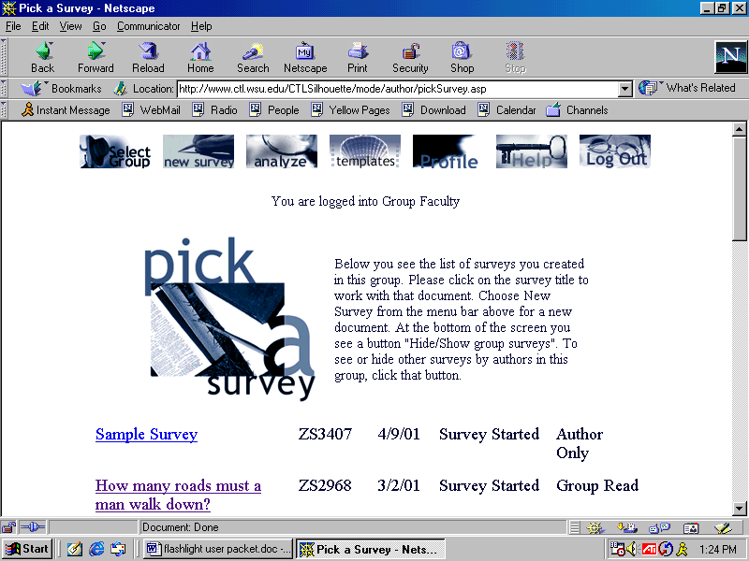
Click on Analyze to see the responses to your survey.
FLASHLIGHT ON-LINE SURVEY

How to Copy A Survey

It is often useful to copy either one of your own surveys (to use it with a different class) or a survey from another faculty member. These instructions will help you copy and customize a Flashlight survey.

A survey many faculty may like to have available is the Valencia Community College Student Assessment of Instruction. Flashlight would make the collection and analysis of student responses much more efficient. These instructions will help you copy this survey and make it your own.

After you sign on to Flashlight (see previous instructions for login information), scroll down the screen to locate surveys created by other faculty. Find the survey you would like to copy (we are doing Valencia Student Assessment of Instruction) and click on the title.

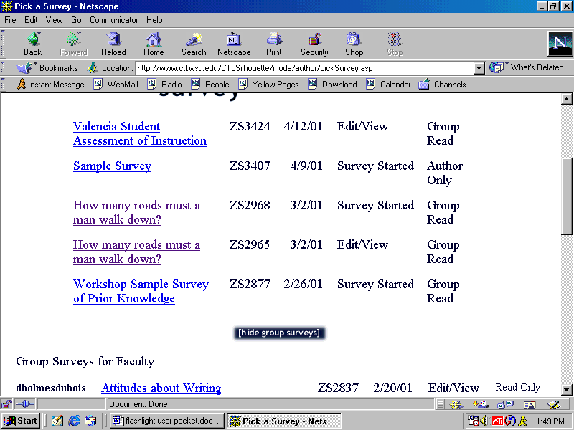
Find the survey you would like to copy and click on the title. Here we are copying Valencia Student Assessment of Instruction.

Click on Copy at the top of the screen.

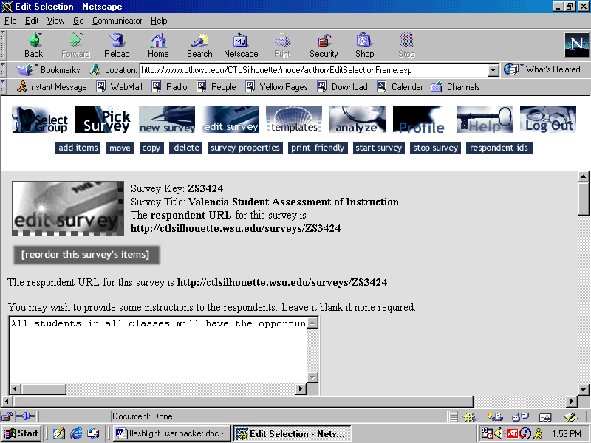
Click on Copy.

You will be asked whether you want a single copy or multiple copies. We recommend you start with just a single copy.

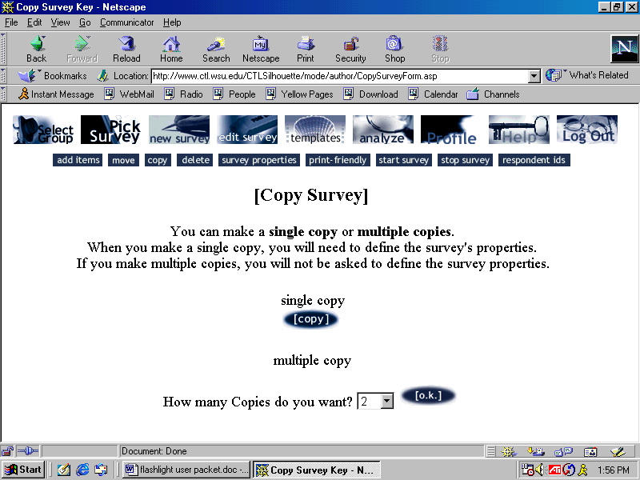
Select single copy.

Complete the Survey Properties as if this were a new survey you were creating. IMPORTANT: Make the survey title as specific as possible. For example, you may call this Student Assessment for STA2023 C301 Spring 2001. This way you will not get this survey confused with others you start at a later time.

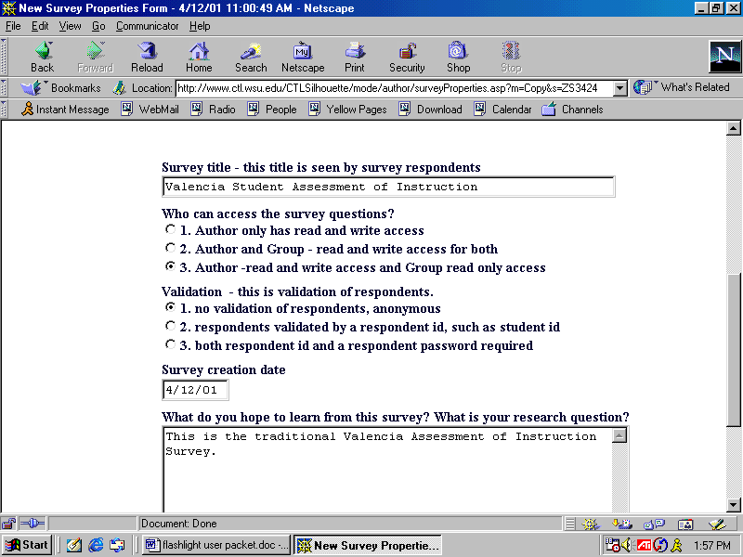
Complete the survey properties. Make the title as specific as possible. The respondents will see the title as you enter it here.

At this point you may make any changes you would like to customize the survey. You may also add new questions or delete existing ones. When you have completed any changes, click OK at the bottom of the screen to save those changes.

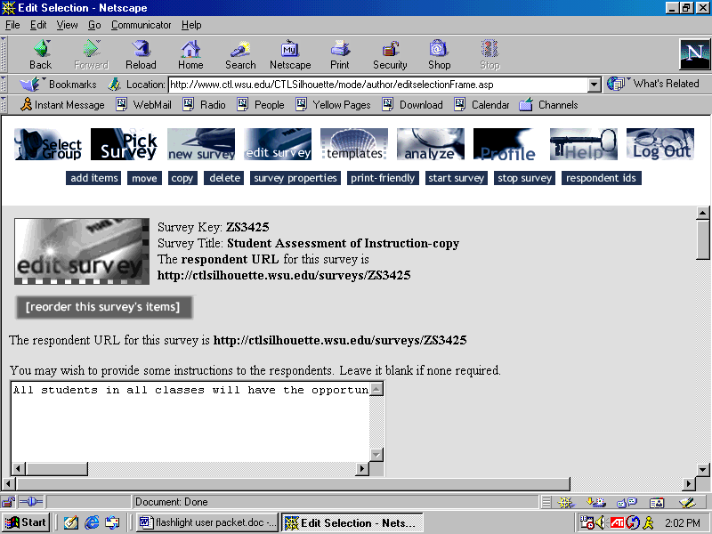
Make any changes to customize the survey on this screen. Use the menu at the top to add any new questions or see a print-friendly version of the survey. Be sure to click OK at the bottom of the screen when you are done.

You are now ready to start the survey. See the previous set of instructions on survey creation for the steps to start and analyze this survey.

