# III. Faculty Learning Outcome #1

Action Research Project

## Faculty Learning Outcome #1

Create a two-part case study assignment designed to increase students’ homework completion rates in order to improve their abilities to demonstrate proficiency in the Chapter 4 and 5 course learning objectives.

## Essential Competencies and Indicators Addressed

1. LifeMap

* Help students develop academic behaviors for student success (e.g., time management, study, test and note taking strategies, etc.)
* Employ electronic tools to aid student contact (e.g., Atlas, MyPortfolio, Blackboard, Ask-A-Librarian, email, etc.)

1. Scholarship of Teaching and Learning
   * Produce professional work (action research or traditional research) that meets the Valencia Standards of Scholarship
   * Build upon the work of others (consult experts, peers, self, students)
   * Be open to constructive critique (by both peers and students)
   * Make work public to college and broader audiences
   * Demonstrate relationship of SoTL to improved teaching and learning processes
   * Demonstrate current teaching and learning theory & practice

## Clear Goals

### A. Abstract

Completing math homework is a vital part of the learning process. While some college-enrolled mathematics students understand and share this point of view, many need to learn the importance of homework and its effect on student learning. Since I observed a positive correlation between homework averages and course averages in my College Algebra classes, I wanted to determine if sharing that relationship with my students using a case-study assignment would result in increased homework averages/completion and test scores. I used two College Algebra classes for my action research, scheduled back-to-back on the same days in the same room. Both classes completed their homework/tests as normal for Chapters 1 and 2. Then during Chapter 3, one class completed the case-study assignment, while the other completed an unrelated task requiring similar student effort. Finally, both classes completed their homework/tests for Chapters 4 and 5. I compared the change in homework averages/completion and test scores for both classes using a student-to-same-student comparison.

The control group exhibited an average change in their homework averages of $-2.91\%$, while the experimental group exhibited an average change in their homework averages of $+0.20\%$. Therefore, the observed gain in homework averages due to the intervention was an average of $+3.11\%$. The control group exhibited an average change in their homework completion rates of $-1.67\%$, while the experimental group exhibited an average change in their homework completion rates of $-1.08\%$. Therefore, the observed gain in homework completion rates due to the intervention was an average of $+0.59\%$. The control group exhibited an average change in their Chapter 4/5 Test scores of $-0.84\%$, while the experimental group exhibited an average change in their Chapter 4/5 Test scores of $-3.55\%$. Therefore, the observed gain in Chapter 4/5 Test scores due to the intervention was an average of $-2.71\%$. However, this test data was compromised by a large confounding variable, an effective Supplemental Learning leader improving the learning of the control group. (The experimental group had no corresponding support.)

It is worth noting that the metric for statistical significance in the field of education is a *p*-value of 0.10 or less. Calculated *p*-values ranged from 0.12 to 0.48, and therefore this research is not statistically significant. Nonetheless, the observations may be of value from a practitioner’s standpoint, and are presented from that point of view.

### B. Research Question

Will completing a two-part case study assignment designed to increase students’ homework completion rates improve students’ abilities to demonstrate proficiency in the Chapter 4 and 5 course learning objectives?

## Adequate Preparation

### Background from Multiple Perspectives

#### Student Perspective

During the Spring 2014 semester, I asked 25 College Algebra students this question: “Is completing math homework a vital part of the learning process? If so, why?” All 25 students answered “Yes” for a variety of reasons. One student responded, “I strongly agree that completing math homework is a vital part of the learning process because you have to actually work out the problems yourself and that triggers learning.” Another responded, “Actually completing math problems is the only way to learn how to do different types of math problems and equations. For me personally it is the best way to learn and remember.” Looking at all of the data, the responses generally included three reasons. Their first reason (14 comments) was homework allows them to practice, and through practice, to develop math skills. Their second reason (4 comments) was homework allows them to solidify their conceptual understanding. And their third reason (4 comments) was completing homework ensures retention of math learning. Looking at this qualitative data in aggregate, it appears that most College Algebra students understand the importance of homework. Yet, many still fail to complete assignments. Perhaps they are missing the connection between homework and course averages, and thus, learning.

To get a preview of the effectiveness of my proposed research, I ran a small version of my action research project during the Spring 2015 semester (one semester before the “official” version). One student remarked that the assignment “shot him straight through the heart. Twice.” When I asked what he meant by that, he explained that the assignment had identified his greatest weakness (a lack of motivation to complete homework), and illustrated empirical evidence which provided that motivation. At that moment, I was hopeful that the student’s reaction would be representative of all students, and that my proposed action plan would result in not only increased homework averages/completion rates, but increased learning as well.

#### Colleague Perspective

I have also explored this issue through conversations with Joel Berman (Valencia College East Campus Professor of Mathematics) and other colleagues through the years. Generally speaking, these faculty members agreed that getting students to complete their homework in a way that results in learning can be challenging. Specifically, our students often take on too much, striking a poor balance between school, work, family and fun time. Hence, their goal when completing homework assignments is finishing instead of learning. Convincing students to establish a better life balance so that they can emphasize learning is quite difficult.

When I shared my intended intervention with my colleagues, all of them felt my investigation was worth doing, and most expressed an interest in “hearing how things turn out.” One of the conversations was particularly memorable. It included a short story from Joshua Guillemette (Valencia College East Campus Professor of Mathematics), who had asked his students (one-on-one) how they would prepare for a dance recital. Nearly all students responded that they would practice their routine until it was ready. When I share this story with my students, I remind them that “getting good at math” is a lot like preparing for a dance recital. You can’t merely watch an expert do it; you have to practice. Which reminds me of one of my favorite quotes:

“Perfect practice makes perfect.” – Derric Johnson

#### Expert Perspective

In the Self Perspective section that follows, I present data that shows a strong positive correlation between algebra student homework averages and course averages. Thus, it is reasonable to conclude that encouraging students to complete their homework, and equipping them with effective strategies in so doing, should result in improved learning (Tuckman, 1996). Of these two components, the more challenging for me as an educator is the motivation aspect. Thus, much of my research centered on this issue. A common theme that emerged was providing students incentives, defined as the goal objects that students desire (Tuckman, 1996). By extension, incentive motivation gives students the desire to attain those incentives, which in an education setting, are course grades (Petri, 1991). Regarding these, Zimmerman, Bandura, and Martinez-Pons (1992) found that students were motivated by both the grades they set out to achieve and the lowest grade they deemed satisfying. Putting this all together, the takeaway is simple: teach students that completing their homework assignments the “right” way correlates to attainment of their desired course grades.

To determine this “right” way for students to learn, I relied heavily on my own experiences. But I focused my thoughts through discussions with colleagues. The most influential of these was with my mentor, Joshua Guillemette (Fall 2011). We discussed five overarching strategies. The first was resources that students should have access to while completing their homework. These included high-speed Internet access and a math expert to answer their questions. The second was goals for accuracy and completeness. I felt that students should aim for a 90%-100% score on every assignment. The third was advice for helping students manage their time and avoid procrastination. I believed that students should start their homework assignments the same day they learn the associated content in class, and try to complete them within 24 hours. The fourth was formatting standards. While this had many components, the essential tack was to pretend each homework problem was a free-response test question and write accordingly. And the fifth was direction in using (not abusing) “helps.” We noted it is essential for a student to (eventually) be able to complete a problem with no help since none is provided during a test.

Anliker, R., Aydt, M., Kellams, M., & Rothlisberger, J. (1997). Improving student achievement through encouragement of homework completion. Retrieved from ERIC database. (ED415022)

Cooper, H. (2002). Recommended homework policies. CQ Researcher 12(42), 1004-1007.

Guillemette, J. (Fall 2011). Developing students’ mathematical skills. As discussed during the faculty mentor/mentee program. Valencia College, East Campus, Orlando, FL.

Hanson, O. (2013). Homework that works: Professional development for teachers. Retrieved from http://scholarworks.calstate.edu:9000/bitstream/handle/10211.2/3218/RevisedHansonGraduateProject.pdf?sequence=1

Petri, H. L. (1991). Motivation: Theory, research and applications (3rd ed.). Belmont, CA: Wadsworth.

Sommers, J. (2011). Self-designed points: Turning responsibility for learning over to the students. Teaching English in the Two-Year College, 38(4), 403-413.

Tuckman, B. W. (1996). The relative effectiveness of incentive motivation and prescribed learning strategy in improving college students’ course performance. The Journal of Experimental Education, 64(3), 197-210.

Zimmerman, B. J., Bandura, A., & Martinez-Pons, M. (1992). Self-motivation for academic attainment: The role of self-efficacy beliefs and personal goal setting. American Educational Research Journal, 29, 663-676.

#### Self Perspective

As a mathematics instructor, I understand the importance of practicing math skills to develop mastery and solidify conceptual understanding. Stated simply, completing math homework is a vital part of the learning process. While some college-enrolled mathematics students understand and share this point of view, many need to learn the importance of homework and its effect on student learning. Too often, math students assume that as long as they understood everything they did when they observed/practiced it in class, they have mastered the concepts and can reliably reproduce the skills needed to solve similar problems at a later time. Those same students often find out (the “hard way,” during an assessment) that their conceptual understanding was not fully formed, and that their skills needed improving.

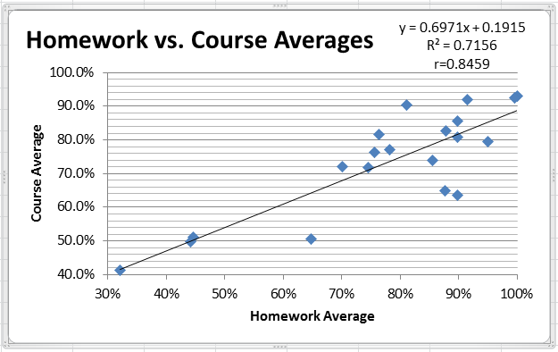

The most compelling evidence supporting my perspective comes from homework data. (See the preceding figure.) During the Summer 2012 semester, I taught a Developmental Mathematics II class of 24 students. Of these, 20 students completed the course. Each student had 38 homework assignments to complete using the computer software MyMathLab. Of these 760 assignments, 138 of them (18.2%) had a score less than 50% at the end of the semester. In my opinion, this figure (18.2%) should be much lower. When examining the relationship between homework and course averages for these same students, I found a strong positive correlation (r≈0.85).

## Appropriate Methods – Methods & Assessment Plan

### Methods

#### Student Learning Outcome 1

Students will explore the correlation between College Algebra homework and course averages.

#### Performance Indicators of Student Learning Outcome 1

• Students will complete a two-part case study assignment

• Students will answer questions #5 and #6 of the two-part case study assignment correctly (or learn the correct answers after-the-fact)

• Students will complete the three-step formative assessment

• Students will complete their assigned homework with a minimum score of 50% on each assignment

• Students will complete their assigned homework with an average score that meets or exceeds their goal average score

#### Student Learning Outcome 2

Students will demonstrate mastery in the Chapter 4 and 5 course learning objectives.

#### Performance Indicators of Student Learning Outcome 2

Students will demonstrate mastery in…

• … graphing linear functions

• … using average rate of change to identify linear functions

• … determining whether a linear function is increasing, decreasing, or constant

• … building linear models from verbal descriptions

• … identifying the vertex and axis of symmetry of a quadratic function

• … graphing a quadratic function using its vertex, axis of symmetry, and intercepts

• … finding a quadratic function given its vertex and one other point

• … finding the maximum or minimum value of a quadratic function

• … building quadratic models from verbal descriptions

• … identifying polynomial functions and their degrees

• … identifying the real zeros of a polynomial function and their multiplicities

• … finding the domain of a rational function

• … finding the vertical asymptotes of a rational function

• … finding the horizontal or oblique asymptote of a rational function

#### Teaching Strategies of Student Learning Outcomes

*The Case Study*

I wanted to improve my students’ understanding of the importance of homework as a tool for learning math. So, I created a two-part case study assignment (See Artifact #1).

The first part (pp. 1-5) is a self-assessment accompanied by a reading assignment; it is intended to provide students with a measure of how effective their current homework strategies are, and direction on how to improve them. The self-assessment consists of a number of multiple choice questions, and each lists various strategies with associated point values. The total score indicates the effectiveness of the strategies employed. The reading assignment has five components: (1) Where students should complete their homework, (2) Goals for accuracy and completeness, (3) When students should start/finish their homework, (4) How students should format their homework, and (5) How students should use (not abuse) help resources. Students are asked to use the information in the reading assignment to identify ways they can improve their homework habits.

The second part (pp. 6-10) is intended to encourage students to complete homework assignments effectively and therefore succeed in the course. It is a series of math problems that collectively demonstrate the correlation between course homework averages and overall course averages. The assignment presents data from my Fall 2014 College Algebra class and a “best fit” line relating these two quantities. In completing this part, students perform various tasks, including: (1) Given a homework average, predict the associated course average, (2) Given a course average, predict the associated homework average, (3) State the lowest course grade they would find satisfying and predict the homework average they must earn to attain it, (4) State the course grade they wish to achieve in the course and predict the homework average they must earn to attain it, and (5) Determine their current homework average and predict their final course average. Finally, students are asked if they feel they need to improve the effectiveness of their homework habits to reach their goals.

*Research Steps*

For my Action Research Project, I used two College Algebra classes — scheduled back-to-back on the same days — one of which experienced the treatment described above and the other of which experienced an unrelated task requiring similar student effort[1]. I sought to determine the effect of the treatment on student understanding of the importance of completing homework, and doing so effectively, as tools for mathematical learning.

For the benefit of anyone wishing to recreate this research, the steps I performed are as follows:

* I had both classes of students complete some course content prior to the intervention to establish a baseline performance. In my case, both classes of students completed Chapters 1 and 2 of the course as normal.
* Once the baseline work was completed, I calculated/documented the homework average for each student, and determined/documented the percent of homework assignments completed with a score of 50% or higher for each student. I also documented student exam scores on the baseline content.
* I identified the chapter that includes the student learning objective “Students will be able to determine the output of a two-variable equation when provided an input, and vice versa.” In my case, that was Chapter 3.
* At the beginning of that chapter, I assigned the experimental group Part 1 of their Case Study (See Artifact #1, pp. 1-5). At the end of the section that includes the student learning objective stated above, I assigned the experimental group Part 2 of their Case Study (See Artifact #1, pp. 6-10) and assigned the control group their Case Study (See Artifact #2). During this chapter, I also showed my students how to use the free online tutoring software Smarthinking and the “Ask My Instructor” button in their MyMathLab homework.
* To assess student learning from that chapter, I created two different versions of the assessment: one for the experimental group, and one for the control group. On the experimental group exam, I included a question exploring the relationship between homework averages and course averages (See Artifact #3). On the control group exam, I included a question exploring the (fictional) relationship between placement exam scores and course averages (See Artifact #4).
* Over three consecutive weeks, I administered the three-step formative assessment to the experimental group (See Artifact #5).
* I had both classes of students complete some course content following the intervention to establish a means of comparison. In my case, both classes of students completed Chapters 4 and 5 of the course. Following this content, I calculated/documented the homework average for each student, and determined/documented the percent of homework assignments completed with a score of 50% or higher for each student. I also documented student exam scores on this post-intervention content.
* I assembled and formatted the data for homework average scores (See Artifact #6), homework completion percentages (See Artifact #7), and test scores (See Artifact #8). I computed the difference value (post minus pre) for each variable for each student, and determined an average difference value for each variable. I ran a t-Test: Paired Two Sample for Means analysis for each variable in each group. I would have run a Mean Difference analysis as well had the results of the t-Tests been statistically significant.
* I had the experimental group respond to survey prompts (on paper and in person, though either is acceptable) regarding their experiences (See Artifact #10) and analyzed the results.

### Assessment Strategies

To demonstrate Student Learning Outcome 1, students explored the correlation between College Algebra homework and course averages. I measured the performance indicators for this SLO in several ways. For indicators 1 and 2, the students completed Part 2 of the case study assignment (See Artifact #1, pp. 6-10). This most directly addressed the intended Student Learning Outcome. For indicator 3, the students completed the three-step formative assessment (See Artifact #5). This helped the students to determine if they were on target to meet the homework goals established when they completed the case study. For indicators 4 and 5, the students completed their homework using software called MyMathLab, which grades their work and logs their scores in an electronic gradebook. From this data, I was able to determine homework average scores and homework completion percentages.

For Student Learning Outcome 2, students demonstrated mastery in the Chapter 4 and 5 course learning objectives. I measured the 14 performance indicators for this SLO with the Chapter 4/5 Test (not included). This test assessed a representative subset of the 14 performance indicators, and therefore the students’ mastery of the intended course learning objectives. This approach is typical in the field of education.

### Action Research Methodological Design

Following my research efforts, I had data from the 30 students in the control group and 22 students in the experimental group. These data included pre- and post-intervention homework average scores (See Artifact #6), pre- and post-intervention homework completion percentages (See Artifact #7), and pre- and post-intervention test scores (See Artifact #8). For each of these metrics, I measured the change[2] using a student-to-same-student comparison, then computed the average of these change values. I also measured the statistical significance of all data using t-Test: Paired Two Sample for Means analyses (See the bottom of Artifacts #6, #7, and #8). For additional details, see the Significant Results section that follows.

## Significant Results

*Analysis in Relation to the FLO and Research Question*

The purpose of this research effort was to determine if a two-part case study assignment designed to increase students’ homework completion rates would improve their abilities to demonstrate proficiency in the Chapter 4 and 5 course learning objectives. The research was done at Valencia College during the Summer 2015 semester, and included two College Algebra classes. The control group consisted of 30 students whose classes met Tuesdays and Thursdays from 1:15 – 2:50 pm in room 9-123. The experimental group consisted of 22 students whose classes met Tuesdays and Thursdays from 3:00 – 4:35 pm in the same room. The students experienced the sequence of events described previously in the Teaching Strategies of Student Learning Outcomes, and the results were as follows.

Homework Average Scores

I computed the average homework scores for each student in the control group at two different times: at the end of Chapters 1/2 and at the end of Chapters 4/5. I also computed the average homework scores for each student in the experimental group at the same two times (See Artifact #6). Since the data consists of pre- and post-scores in a student-to-same-student comparison, statistical significance was determined in two steps. The first step was a *t-Test: Paired Two Sample for Means* analysis, and (pending its statistical significance) the second step was a *Mean Difference* analysis.

The results of the *t-Test: Paired Two Sample for Means* analysis for both the control group and the experimental group are shown at the bottom of Artifact #6. Since these analyses were done using a “post minus pre” calculation, the post-homework mean score is listed first, and the pre-homework mean score is listed second. For the control group, the mean of the post-homework scores was 84.76 and the mean of the pre-homework scores was 87.67. For the experimental group, the mean of the post-homework scores was 81.52 and the mean of the pre-homework scores was 81.33. Since the analyses used a student-to-same-student comparison, the hypothesized mean difference between all population pairs was 0. The results of the *t-Test: Paired Two Sample for Means* analyses showed a *p*-value of approximately 0.15 for the control group and approximately 0.48 for the experimental group. The threshold for statistical significance in the field of education is “0.10 or less.” Hence, the scores analyzed in the *t-Test: Paired Two Sample for Means* analyses did not have statistical significance, and there was no need to conduct a *Mean Difference* analysis. This means that the results of this part of the research were analyzed using observation of patterns and themes, and are only of value from a practitioner’s standpoint. My observations are as follows.

For each student in both groups, I calculated the change in their homework average from the pre- to the post-condition. These ‘change’ values for the control group varied widely (from $-38.89$ to $+45.87$) with an average change of $-2.91$. The ‘change’ values for the experimental group also varied widely (from $-23.62$ to $+59.07$) with an average change of $+0.20$. Therefore, the observed gain in homework averages due to the intervention was an average of $+3.11\%$. See the graph that follows.

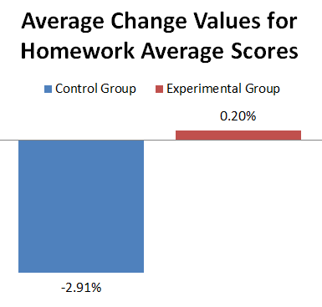

Gain of 3.11%

Generally, I consider this aspect of the research a success. On average, those students that did not experience the intervention saw their homework averages go down, while those students that did experience the intervention saw their homework averages go up (slightly). The intervention had the intended positive effect, increasing homework average scores (by $+3.11\%$), which I would consider modest but meaningful. As a final note, the nature of this research assumes that the students in the control group are comparable to those in the experimental group. However, because the registration system at Valencia College makes clear to students choosing classes which ones are enhanced by Supplemental Learning and which ones are not, it is possible that a “higher caliber” of student was drawn to the control group and not the experimental group, potentially skewing the data. The Supplemental Learning program, and its effect on this research, is discussed in the “Test Scores” subsection of this portfolio.

Homework Completion Percentages

For the purposes of this research, a homework assignment was considered ‘complete’ if a student scored a 50% or higher on the assignment. I computed the homework completion percentages for each student in the control group at two different times: at the end of Chapters 1/2 and at the end of Chapters 4/5. I also computed the homework completion percentages for each student in the experimental group at the same two times (See Artifact #7). Since the data consists of pre- and post-scores in a student-to-same-student comparison, statistical significance was determined in the same manner as above: The first step was a *t-Test: Paired Two Sample for Means* analysis, and (pending its statistical significance) the second step was a *Mean Difference* analysis.

The results of the *t-Test: Paired Two Sample for Means* analyses for both the control group and the experimental group are shown at the bottom of Artifact #7. Since these analyses were done using a “post minus pre” calculation, the post-homework mean score is listed first, and the pre-homework mean score is listed second. For the control group, the mean of the post-homework completion was 88.33% and the mean of the pre-homework completion was 90.00%. For the experimental group, the mean of the post-homework completion was 87.88% and the mean of the pre-homework completion was 88.96%. Since the analyses used a student-to-same-student comparison, the hypothesized mean difference between all population pairs was again 0. The results of the *t-Test: Paired Two Sample for Means* analyses showed a *p*-value of approximately 0.28 for the control group and approximately 0.39 for the experimental group. Using the same threshold stated above (0.10 or less), the scores analyzed in these *t-Test: Paired Two Sample for Means* analyses also had no statistical significance, and there was no need to conduct a *Mean Difference* analysis. This means that the results of this part of the research were analyzed using observation of patterns and themes, and are only of value from a practitioner’s standpoint. My observations are as follows.

For each student in both groups, I calculated the change in their homework completion percentages from the pre- to the post-condition. These ‘change’ values for the control group varied considerably (from $-38.89\%$ to $+49.21$) with an average change of $-1.67\%$. The ‘change’ values for the experimental group also varied considerably (from $-24.60$% to $+66.67$%) with an average change of $-1.08\%$. Therefore, the perceived gain in homework completion percentages due to the intervention was an average of $+0.59\%$. See the graph that follows.

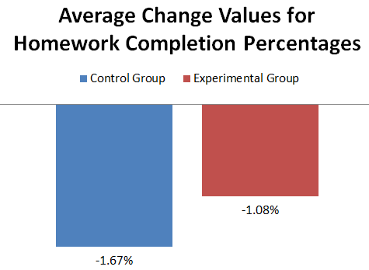

Gain of 0.59%

Looking at the data from a different perspective – one that I did not anticipate during the design phase – it is worth considering the number of students for whom the completion rates increased, decreased, or stayed the same. First off, every student (in both groups) that had no change in homework completion rates had a 100% completion rate at both times they were measured. For these students, increasing completion was not an option, and merely staying the same was the ideal condition. For this reason, I feel it is appropriate to meld the “increased” and “stayed the same” students into one category. With that stated, here are the observed data: In the control group, 12 students (40.0%) saw their completion rates decrease whereas 18 students (60.0%) saw their completion rates increase or stay the same. In the experimental group, 10 students (45.5%) saw their completion rates decrease while 12 students (54.5%) saw their completion rates increase or stay the same. Thus, the control group students outperformed the experimental group students by 5.45%. See the graph that follows.

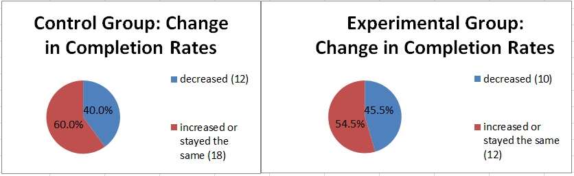

Generally, I do not consider this aspect of the research a success or a failure. Both classes of students experienced a drop in their homework completion percentages; the experimental group simply had less of a drop. It is certainly encouraging that the perceived net effect of the intervention was a positive number ($+0.59\%$), but I don’t believe this is particularly meaningful. In addition, for both classes of students, a majority increased their homework completion rates or kept them at 100%. But the control group had a higher percentage of students that achieved this standard, beating the experimental group by 5.45%. Once again, it is important to note that the nature of this research assumes that the students in the control group are comparable to those in the experimental group. However, because the registration system at Valencia College makes clear to students choosing classes which ones are enhanced by Supplemental Learning and which ones are not, it is possible that a “higher caliber” of student was drawn to the control group and not the experimental group, potentially skewing the data. The Supplemental Learning program, and its effect on this research, is discussed in the “Test Scores” subsection of this portfolio.

Test Scores

I computed the Ch. 1/2 and Chapter 4/5 Test scores for both the control and experimental groups (See Artifact #8). Since the data consists of pre- and post-scores in a student-to-same-student comparison, statistical significance was once again determined in two steps. The first step was a *t-Test: Paired Two Sample for Means* analysis, and (pending its statistical significance) the second step was a *Mean Difference* analysis.

The results of the *t-Test: Paired Two Sample for Means* analyses for both the control group and the experimental group are shown at the bottom of Artifact #8. Since these analyses were done using a “post minus pre” calculation, the post-test (Chapter 4/5) mean score is listed first, and the pre-test (Chapter 1/2) mean score is listed second. For the control group, the mean of the post-test (Chapter 4/5) scores was 72.12 and the mean of the pre-test (Chapter 1/2) scores was 73.03. For the experimental group, the mean of the post-test (Chapter 4/5) scores was 69.57 and the mean of the pre-test (Chapter 1/2) scores was 73.12. Since the analyses used a student-to-same-student comparison, the hypothesized mean difference between all population pairs was 0. The results of the *t-Test: Paired Two Sample for Means* analyses showed a *p*-value of approximately 0.40 for the control group and approximately 0.12 for the experimental group. As stated above, the threshold for statistical significance in the field of education is “0.10 or less.” Hence, the scores analyzed in the *t-Test: Paired Two Sample for Means* analyses had no statistical significance, and there was no need to conduct a *Mean Difference* analysis. This means that the results of this part of the research were analyzed using observation of patterns and themes, and are only of value from a practitioner’s standpoint. My observations are as follows.

For each student in both groups, I calculated the change in their test scores from Ch. 1/2 to Ch. 4/5. These ‘change’ values for the control group varied substantially (from $-32.5$ to $+48$) with an average change of $-0.84$%. The ‘change’ values for the experimental group also varied substantially (from $-43$ to $+20$) with an average change of $-3.55\%$. Therefore, the perceived gain in test scores due to the intervention was an average of $-2.71\%$.

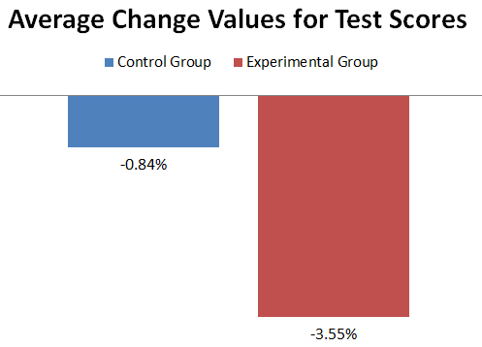

Gain of -2.71%

Generally, I consider this aspect of the research a failure. I went to great lengths to avoid confounding variables, but a rather significant one beyond my control had a powerful effect on this work, effectively negating my ability to correlate homework gains with learning gains. Specifically, my control group had a truly fantastic Supplemental Learning leader[3] while my experimental group had none. I requested data from this leader, showing the number of student visits each week for the whole semester, to attempt to illustrate her impact (See Artifact #9). With a total of 73 student visits during the research period (64 visits in the first seven weeks plus nine students on 6/29), and 176 student visits during the entire semester, this leader’s impact on student learning was far-reaching and positive. I showed her supervisor the data in Artifact #9 and asked him, “How would you rate the level of attendance at this SL leader’s sessions?” He replied, “I would rate it as exemplary. This is someone that has done a good job getting people to come.”

Looking at these three categories of research holistically, it appears the intervention was modestly successful in increasing the homework scores of the students overall, but had no significant impact on homework completion rates. As for test scores, it is impossible to tell whether the intervention had the intended effect or not.

*Student Feedback*

I obtained in-person student feedback regarding this project in two modes: a conversation with the students and a paper survey. In both modes, I obtained information from the students using the same prompts. The results are as follows.

Prompt: “Recall the five-topic reading assignment with suggestions for improving your homework habits, then respond to the following statement: ‘The five-topic reading assignment helped me improve my homework effectiveness.”’

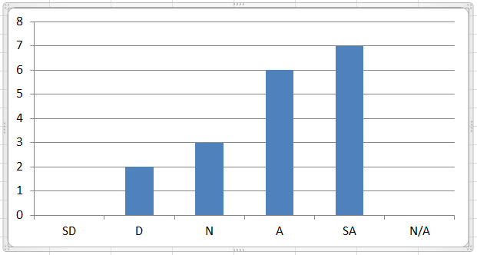

This chart is also shown in Artifact #10, Page 1, top half.

SD=Strongly Disagree, D=Disagree, N=Neither Agree Nor Disagree, A=Agree, SA=Strongly Agree, and N/A=Not Applicable

A large majority (72.2%) of students selected “Agree” or “Strongly Agree” in response to this prompt. Clearly, the reading assignment helped students improve their homework effectiveness. One student who selected Strongly Agree said “…it taught me not to wait until all of my homework was due a day before to start it.” Another said “The reading assignments where [sic] very clear and organized the student to be successful in class.” One student who selected Agree said “It made me realize the importance of doing my homework in a quiet location & how helpful it is to do homework in the tutor center.” One student who selected Disagree said “it did not motivate me at all.” During the conversation with the students, they said much the same things written above. For example, one student said, “I used to do homework at home and get distracted by the TV and food and whatever, but then I started doing all my work in the library.”

Prompt: “Recall the chart that presented homework and course averages, as well as a best-fit line showing a positive correlation between those two quantities, then respond to the following statement: ‘I understood what this chart was trying to show me.”’

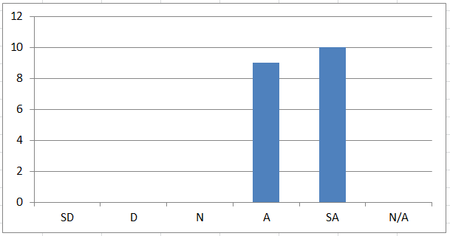

This chart is also shown in Artifact #10, Page 1, bottom half.

SD=Strongly Disagree, D=Disagree, N=Neither Agree Nor Disagree, A=Agree, SA=Strongly Agree, and N/A=Not Applicable

100% of the students selected “Agree” or “Strongly Agree” in response to this prompt. (The split was 47% and 53%, respectively). Clearly, the students felt that they ‘got the message’ being conveyed by the graph. One student who selected Strongly Agree said “Great tool to persuade students that homework is important to your overall grade”. Another said “It's nice to see real-life models demonstrating how homework & course average correlate to the sucess [sic] of a student.” One student who selected Agree noted that doing well at a single aspect of homework completion isn’t necessarily enough, stating, “It just goes to show that even though homework can be done in a timely manner, but do miserably on tests thereby changing a students [sic] course average”. During the conversation with the students, I asked one student, “What is this chart trying to show you?” He responded, “What the average person got on their homework grades and what their total grade was in the class.” In response, I asked, “Is it only for the average person?” The student replied, “No, it’s for everybody.” One thing worth noting on this topic is that the experimental group did not do particularly well on the math part of the case study. The average score was a 61.8% and the median score was an 80%. So while many students may have understood the intent of the assignment, a notable number may have missed the personal correlation between *their* homework averages and *their* projected course averages.

Prompt: “Recall the chart that presented homework and course averages, as well as a best-fit line showing a positive correlation between those two quantities, then respond to the following statement: ‘I believed the chart would accurately predict my course average using my homework average.”’

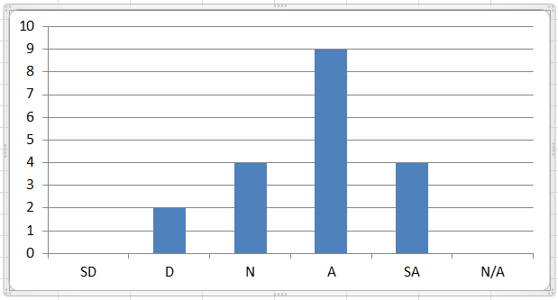

This chart is also shown in Artifact #10, Page 2, top half.

SD=Strongly Disagree, D=Disagree, N=Neither Agree Nor Disagree, A=Agree, SA=Strongly Agree, and N/A=Not Applicable

Approximately a two-thirds majority (68.4%) of students selected “Agree” or “Strongly Agree” in response to this prompt, though it is worth noting that the Agrees outweighed the Strongly Agrees 9 to 4. Here, it appears the students generally believed the chart could predict their course averages, but acknowledged that it would be an estimate and therefore could be wrong. One student who selected Strongly Agree said, “Yes the correlation was very consistent and I believed it reflected my overall grade.” One student who selected Agree said, “I know it gave a ballpark area of where our grade would be but I knew it was heavily dependent on how well we studied”. A student who selected Neither Agree Nor Disagree said, “Usually it may but I believe it is better used as an example. Not real world prediction”. And finally, one student who selected Disagree simply wrote, “Statistical outliers.” This final sentiment was mentioned during the conversation with the students. One student (probably the same student) said “Statistical outliers exist.” When I asked this student, “Did you believe that this data applied to you?” he laughed and said “No.” He went on to clarify, “It’s kind of like, if you do your homework, you’ll be successful on the tests. In my case, necessarily, I don’t think I have to do the homework. I mean, I did it because it’s better for me just to, like, get a better grade overall in the class, but like, it’s kind of like if you put more time into homework, you’ll get a better grade, and I never really put too much time into it.” In response, I asked, “And yet you were successful anyway?” and the student replied, “Yes.” This exchange illustrates an important facet of this research. Even when presented with actual real-world data, some students remain unconvinced that it applies to them. They view themselves as the exception to the rule. Certainly, this is true sometimes, but in my experience, “the rule” is right more often than it is not.

Prompt: “Recall the ‘Are You On Target to Get the Grade You Want?’ form, where you tracked your homework average over time, then respond to the following statement: ‘This document motivated me to improve my homework scores.”’

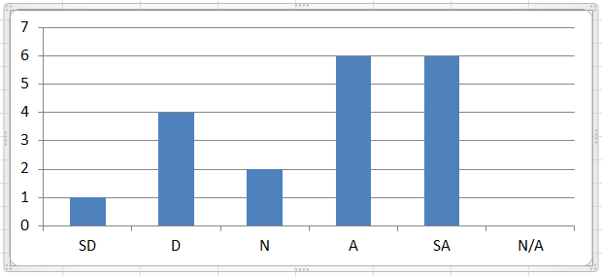

This chart is also shown in Artifact #10, Page 2, bottom half.

SD=Strongly Disagree, D=Disagree, N=Neither Agree Nor Disagree, A=Agree, SA=Strongly Agree, and N/A=Not Applicable

A majority (63.2%) of students selected “Agree” or “Strongly Agree” in response to this prompt. So, for most students, the form had the intended effect. Still, this was not the case for seven students, and the diversity of written responses reflected this. One student who selected Strongly Disagree wrote, “With access to checking my own grade, likewise in respect to the professor having the capability as well, I felt the process was reduntant [sic].” In contrast, one student who selected Strongly Agree said, “This honestly helped me stay on track of things. I never looked at my grade after we stopped doing that worksheet so I wish we would've continued it for longer.” One (high-achieving) student who selected Agree said “It did not motivate me to improve my homework scores but it motivates me to maintain the homework average at 100%. As I couldn't go beyond it”. One student who selected Disagree offered, “I answered this way b/c I always tried to get very good grades on my homework with or without the gray paper.” As a final thought, I think it is worth noting that the reason why only 63.2% of students selected Agree or Disagree in response to this prompt is not that they weren’t motivated. When I discussed this with them in person, nearly everyone said that they were motivated to improve their homework scores. The objection was simply that the form itself was not the motivator. Their ability to see their homework averages in MyMathLab had the effect that the form was intended to provide.

Prompt: “Recall the ‘Are You On Target to Get the Grade You Want?’ form, where you tracked your homework average over time, then respond to the following statement: ‘Because of this document, I actively improved my homework scores.”’

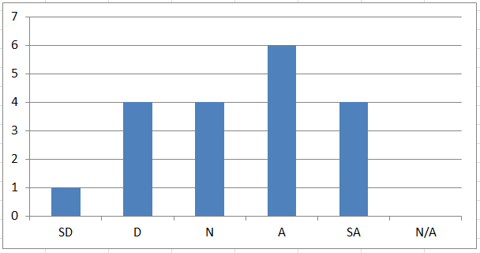

This chart is also shown in Artifact #10, Page 3, top half.

SD=Strongly Disagree, D=Disagree, N=Neither Agree Nor Disagree, A=Agree, SA=Strongly Agree, and N/A=Not Applicable

A simple majority (52.6%) of students selected “Agree” or “Strongly Agree” in response to this prompt. Of all the survey response graphs, this had the “flattest” overall shape with a significant number of respondents selecting each of “D,” “N,” “A,” and “SA.” In keeping with the previous prompt’s results, this was (for some students) because the document itself was not the reason they improved their scores; it was seeing their homework scores inside MyMathLab. In addition, some students noted that even though they were motivated to improve, they were not able to do so. For example, one student who selected Disagree said, “I wouldn't say it helped me improve but it did snap me to reality.” To the previous point, one student who selected Strongly Disagree said, “The document wasn't a motivation.” Thankfully, some students not only identified a need to improve, but were able to do so. One student who selected Strongly Agree said, “It absolutely helped me realize that I needed to work harder and as a result my grades improved.” Another said, “I made sure I had 100% on all my Homework assignments because of this.” One student who selected Agree stated simply, “I improved”. During the class discussion of this prompt, the students were hesitant to speak individually. Some did not respond in any way. Some simply nodded their heads ‘yes’ to indicate that they were able to improve their scores. As a result, I picked a random row of the class (with seven students in it) and asked, “Did your homework scores actually go up as a result of completing this form?” Five students said “Yes” and two students said “No.” Although 71.4% of the students in that row said “Yes” as their response, there are two things which cast some doubt on the relevance of that datum. The first is that students may not be willing to say in front of their peers that their scores went down. The second is that those seven students are likely not representative of the entire class.

Prompt: “Recall the question on the grey paper where you listed the lowest grade you would be happy with in this class, then respond to the following statement: ‘At some point, I lowered the grade I would be happy with in this class.”’

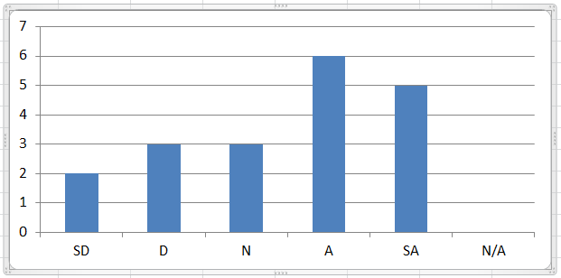

This chart is also shown in Artifact #10, Page 3, bottom half.

SD=Strongly Disagree, D=Disagree, N=Neither Agree Nor Disagree, A=Agree, SA=Strongly Agree, and N/A=Not Applicable

A majority (57.9%) of students selected “Agree” or “Strongly Agree” in response to this prompt. I asked this question because I suspected this might be the case. For the students who answered this way, there were two major reasons: they were either unable to achieve their goal grade (eight respondents), or unwilling to put in the time needed to do so given the other demands on their time (two respondents). One student who selected Agree said, “Yes, as the class became tougher my grade expectation lowered by one letter grade.” Another said, “I figured out it was a - lot [sic] more work than I was willing to put in to get the grade I wanted. (Job, family, friends were more important to me)”. Still another said, “Because, after I realized it was unrealistic I had to lower my standards.” When I discussed this prompt with the students, two of them volunteered that they had lowered their goal grades, and both of them cited their test scores as the reasons they did so.

To put this all together, I believe it is illustrative to conduct a *most probable path* analysis. The following paragraph describes the most likely outcome that a student in the experimental group experienced during the intervention, expressed as a response to each survey prompt:

The student used the five-topic reading assignment to improve their homework effectiveness, understood the correlation between homework averages and course averages, believed the associated equation would predict their homework/course average relationship (with a modest degree of error), and was motivated to improve their homework scores.

Then a split occurs:

The student had about a 50% chance of actually improving their homework scores, and about a 50% chance of lowering their expectations for their performance.

*How project results will inform my practice and impact student learning*

Of the three categories of research performed, the only one that was (modestly) successful was the increase in homework averages. The increase in average homework completion rates was negligible at best, and the analysis of the test scores was compromised. Nonetheless, I believe the intervention is worth repeating in future semesters. (In fact, I’ve already given my Fall 2015 and Spring 2016 College Algebra students the same case-study assignment.) It was quite encouraging, for example, to observe evidence that the students learned not only that they needed to be more effective at completing their homework, but learned how to increase their effectiveness using the suggestions contained in their reading assignment. I also believe that the students understood the correlation between homework and course averages, and sought to increase their homework averages accordingly. It could be argued that even the students who lowered their expectations for their performance increased their knowledge of what it takes to learn mathematics.

If I were to attempt to view this research objectively, there are a few assumptions that I would challenge. Without a doubt, the first would be the equity of the students in the control and experimental groups. As mentioned above, the students’ potential knowledge of which one of those classes was enhanced by Supplemental Learning and which one was not may have impacted the quality of the students in each group. This could easily have skewed the ‘homework’ portion of the research data, and I absolutely believe the Supplemental Learning sessions skewed the ‘test scores’ portion of the research data. The second would be the somewhat arbitrary criterion of 50% used to indicate that a homework assignment was “completed” by the student. It could certainly be argued that this number should be different. The third would be the scale of 90-100 indicating a homework effectiveness rating of “expert” in the survey portion of the experimental group’s case-study assignment. Having administered this same survey instrument three times now (Summer 2015, Fall 2015, Spring 2016), the results have led me to scrutinize question #8 of that survey, which asks students to identify which “helps” they have used to improve their understanding of the math concepts/skills taught in the class. Since each help is worth 2 points, a perfect score on the survey instrument would require the student to have used all five helps during the semester. I believe it is more reasonable to expect an “expert”-level student to use just two or three of those helps, earning 4 to 6 points from that question instead of 10. Since this is an average of 5 fewer points, I believe it justifies changing the “expert” scale from 90-100 to 85-100 and the “competent” scale from 64-89 to 64-84.

## Reflective Critique

### General Reflection

*How Do You Intend to Use the Results of This Project?*

Based on the results of this project, I believe the intervention is worth repeating, as I did in the Fall 2015 and Spring 2016 semesters. I believe that the case-study assignment is well-designed, needing only a few tweaks here and there. One way I might improve it is to change the grading of the assignment. I stated above that the experimental group did not do a stellar job on the case study assignment (average 61.8%; median 80.0%). One way to use this result is to require the students to submit the case-study work twice before determining the final assignment grade. The first submission would be a formative assessment, allowing the student to explore the case-study in a low-stakes environment and receive feedback on their work. The second submission would be the summative assessment, wherein I determine their actual grade on the assignment. I believe this approach would improve student learning significantly because the students would use my comments on the first submission to improve their work on the second submission, strengthening their understanding of the correlation between homework and course averages.

*What Would I Do Differently Next Time?*

If I were to repeat this research, there are certainly things I would change and/or explore further. On the topic of preserving the integrity of the research, I would certainly insist that both the experimental group and control group had the same Supplemental Learning leader experience – either the same leader or no leader at all in both groups. On the topic of variables, it would be interesting to explore the correlation between the homework effectiveness rank values and the homework averages. It would also be interesting to explore the correlation between the homework effectiveness rank values and the course averages. Taking this even further, it would be fascinating (and a new mathematical experience for me) to explore the correlation among homework effectiveness rank values (variable 1), homework averages (variable 2), and course averages (variable 3) using a *plane* of best fit and a three-variable equation. (A plane of best fit would be beyond the curriculum of College Algebra, but the skillset needed to use a two-variable equation is very similar to the skillset needed to use a three-variable equation.) Finally, on the topic of procedural changes, I would consider not using the “Are You On Target…” document (Artifact #5) and instead “nudge” the students from time to time (perhaps via email or group chat) to look at their homework averages in the MyMathLab gradebook and compare them to their goal averages. Also, while administering the end-of-research survey questions (Artifact #10), I would display the documents referenced in the questions in addition to describing them in words in the prompts. I would also reword the portions of the prompt which reference the “Are You On Target…” document (Artifact #5). For example, instead of “This document motivated me to improve my homework scores,” I might write “Comparing my current homework average to my target homework average motivated me to improve my homework scores” instead.

### Critical Evaluation of Each Essential Competency in this FLO

### LifeMap

* Help students develop academic behaviors for student success (e.g., time management, study, test and note taking strategies, etc.)
* Employ electronic tools to aid student contact (e.g., Atlas, MyPortfolio, Blackboard, Ask-A-Librarian, email, etc.)

### Reflection

My project for FLO1 was undoubtedly a LifeMap project. At the core of the project was the two-part case study assignment, and all elements of that assignment were designed to improve student academic behaviors. The first part was a self-assessment and reading assignment where students identified academic behaviors performed while completing their homework, and learned how to change/improve those behaviors. These included topics such as the location where the student completes the homework, the resources available to the student at that time/place, goals for accuracy and completeness, goals for time management (avoiding procrastination), advice for formatting assignments, and suggestions on how to use (not abuse) help resources. The second part was a series of math questions that collectively demonstrated a correlation between student homework and course averages, allowing the student to predict their final grade in the class. Its intent was to convince the students that completing homework in a way that results in learning leads to higher test scores and therefore higher course grades. A subset of the above activities included employing electronic tools to aid student contact. Specifically, during the research period, all students (whether in the control group or the experimental group) experienced a demonstration of how to use the free online tutoring service Smarthinking. They also received advice on how to use the Ask My Instructor button, which is built into all questions in their MyMathLab homework.

I believe the elements of FLO1 described above demonstrate my understanding of the LifeMap competency and the selected indicators. A notable majority of students (72.2%) self reported that the reading assignment helped them improve their homework effectiveness, and a bit less than that (63.2%) indicated that they were motivated to improve their homework scores. And while Smarthinking was not universally used by the students (other forms of help are usually more convenient and therefore greater utilized), it was essential in helping some students. For example, following the Smarthinking demonstration, I was approached by a student who works Mondays/Wednesdays/Fridays 8 am – 6 pm and Tuesdays/Thursdays 8 am – 2 pm, and attends classes Tuesdays/Thursdays after work. For her, places like the Tutoring Center were not open when she was available. She said to me, “Thank you for showing us Smarthinking. I’m definitely going to use it.” I found that quite gratifying. As for the Ask My Instructor tool, it was heavily used. I received 27 Ask My Instructor emails from 15 different students over the course of the semester. Surprisingly, 14 of those 15 students (93.3%) were female! (The roster for the two classes was 38% male, 62% female, so this statistic is notable.[4]) It would be interesting to study whether various forms of math helps are preferred consistently by male students versus female students.

As for possible improvements, I have previously discussed the changes I would make to the case-study assignment. So I will address here the changes I would make in employing electronic tools to aid student contact. For the past two semesters now, I have been using an app with my classes called LINE. This app is a group text-messaging program that allows the students in my classes to talk to each other and to three math experts: myself, a supplemental learning leader, and the coordinator of a math tutoring area. This has been an excellent supplement to Ask My Instructor. With three math experts, there is someone on LINE most of the time to answer students’ questions. Plus, the app allows students to not only send text communication (Ask My Instructor is limited to text communication), but pictures and video as well. In fact, most communication from students asking for help starts with a picture of what they are looking at, then is followed by a question on how to proceed. This tool has been wildly successful in helping aid student contact with math experts and other students.

### 2. Scholarship of Teaching and Learning

* + Produce professional work (action research or traditional research) that meets the Valencia Standards of Scholarship
  + Build upon the work of others (consult experts, peers, self, students)
  + Demonstrate current teaching and learning theory & practice
  + Be open to constructive critique (by both peers and students)
  + Make work public to college and broader audiences
  + Demonstrate relationship of SoTL to improved teaching and learning processes

### Reflection

Since my master’s degree did not include a thesis, my work on this portfolio is the most robust research effort I have ever undertaken. There is no doubt that I have made great strides in the scholarship of teaching and learning. To begin, I believe this portfolio demonstrates my ability to produce professional work. I believe I have a strong writing ability and a talent for proofreading and editing. In addition, I have adhered to the Valencia Standards of Scholarship; my work includes Clear Goals, Adequate Preparation, Appropriate Methods, Significant Results, Reflective Critique, and Effective Presentation. Not surprisingly, my portfolio builds upon the work of others. Three works of particular influence were *The Relative Effectiveness of Incentive Motivation and Prescribed Learning Strategy in Improving College Students’ Course Performance* (Tuckman, 1996), *Motivation: Theory, Research and Applications (3rd Ed.)* (Petri, 1991), and *Self-Motivation for Academic Attainment: The Role of Self-Efficacy Beliefs and Personal Goal Setting* (Zimmerman, Bandura, and Martinez-Ponz, 1992). I credit these works for ensuring my research was grounded in current teaching and learning theory and practice. Of course, I also relied on the work of my peers[5], the work of my students, and my own instincts/gathered data.

Naturally, during the production of this portfolio, I received a lot of constructive critique from peers and students. It most likely goes without saying that my tenure-track panel offered wonderful suggestions for improvement, and I have tried to adhere to those suggestions precisely. Even before my panel was assembled, my Teaching/Learning Academy advisors were instrumental in providing edits and ideas to consider. I have made every effort to embrace their wisdom and incorporate their suggestions; I believe my portfolio is all the stronger for having done so. Near the end of my research effort with my students, I had a discussion with them regarding their experiences. Interestingly, their only criticism was that I should simply *require* them to complete their homework (to some minimum standard) instead of trying to convince them to do so by way of the case-study assignment. One student indicated that he “would rather be forced … to complete [his] homework in order to pass this class…” because that provided the motivation he needed to actually sit down and do it. Three other students agreed.

Returning briefly to the scholarly works I mentioned previously, I would like to reference one of them as an example of how I applied the scholarship of teaching and learning to utilize improved teaching and learning processes. I wrote in my Analysis of My Practice that I needed to learn ways to motivate my students to exhibit good academic behaviors. Zimmerman, Bandura, and Martinez-Pons (1992) found that students were motivated by both the grades they set out to achieve and the lowest grade they deemed satisfying, which I had not previously considered. This provided an essential element of my case study assignment (See Artifact #1, Page 9, Questions 5 and 6) that I would not have come up with on my own.

Regarding the indicator “Make work public to college and broader audiences,” please see the Plan for Dissemination section that follows.

1. Plan for Dissemination

I have uploaded this action research project into the Action Research Builder in Atlas; I will submit it once it has been reviewed, revised, and approved. I also intend to contact OIT Web Services about adding a new Research section to my Faculty Front Door Web site so that I can publicly post my action research there. Finally, I intend to upload the case-study assignment into at least one of the following Valencia Blackboard courses: GEN ED College Algebra Resources, West Campus Math Division AY 201516-Faculty Development, and West Campus Mathematics Faculty.

## Supporting Artifacts for FLO#1

See next pages.

FLO1 Artifact #1

Experimental Group – Case-Study Assignment

Page 1 of 10

How Effectively Do You Complete Your Homework? A Self-Assessment

Name:____________________________________________________________ Course Days/Times: __________

**MULTIPLE CHOICE. Read each scenario, then choose the one alternative that best describes what you typically do. For the purposes of this survey, "typically" means more than 70% of the time.**

1) Which of the following best describes the place where you typically complete your homework?

A) It has reliable high-speed Internet access AND a math expert who can answer my questions.

B) It has a math expert who can answer my questions.

C) It has reliable high-speed Internet access.

D) None of the Above

2) When you do your homework, which of the following best describes how much of each assignment you typically attempt?

A) I attempt all of the problems.

B) I attempt more than half of the problems.

C) I attempt about half of the problems.

D) I attempt less than half of the problems.

E) I attempt none of the problems.

3) When you do your homework, which of the following best describes how much of each assignment you typically complete correctly?

A) I complete all of the problems correctly.

B) I complete more than half of the problems correctly.

C) I complete about half of the problems correctly.

D) I complete less than half of the problems correctly.

4) Which of the following best describes when you typically begin each of your homework assignments?

A) I begin each homework assignment before I learn about it in class.

B) I begin each homework assignment after I learn about it in class, on the same day.

C) I begin each homework assignment a day or two before it is due.

D) I begin each homework assignment about twelve hours before it is due.

E) I begin each homework assignment a few hours before it is due.

F) I attempt to begin each homework assignment after it is due, but it is locked.

5) Which of the following best describes when you typically finish each of your homework assignments?

A) I finish each homework assignment before I learn about it in class.

B) I finish each homework assignment after I learn about it in class, on the same day.

C) I finish each homework assignment a day or two before it is due.

D) I finish each homework assignment about six hours before it is due.

E) I finish each homework assignment about an hour before it is due.

F) I don't finish each homework assignment because I run out of time.

FLO1 Artifact #1

Experimental Group – Case-Study Assignment

Page 2 of 10

6) How many homework assignments from this class have you missed completely and are now "Past Due" (worth 0%) in the gradebook?

A) None

B) One

C) Two

D) Three

E) Four or more

7) Homework is practice for taking the test. There are many things you should do when writing your homework. Which of the following do you typically do? (Circle ALL that apply.)

A) Write your name and the homework section at the top of the first page.

B) Number each problem you complete so that you can refer to it later as needed.

C) Write your solutions neatly, showing all steps, and circling your final answer.

D) Write your calculations in pencil, using an eraser when you make small mistakes.

8) There are many ways to improve your understanding of the math concepts/skills taught in this class. Which of the following "helps" have you used this semester to improve your understanding of the math concepts/skills taught in this class? (Circle ALL that apply.)

A) Smarthinking free online tutoring service

B) Supplemental Learning sessions

C) Tutoring from the Tutoring Center

D) Visiting Prof. Lacoste during his office hours

E) MyMathLab "help" buttons (Help Me Solve This, View an Example, Ask My Instructor...)

9) Imagine you use a "help" like the ones listed above in order to solve a homework problem. Because your instructor has asked you to, you put a "star" next to that problem to indicate that you needed help completing it. After using the "help" to solve the problem correctly, which of the following best describes what you would typically do next?

A) I would move on to the next problem. However, when I finish all of the problems, I would return to the "starred" problem and click the Similar Exercise button until I can complete that kind of problem correctly with no help.

B) I would immediately click the Similar Exercise button until I can complete that kind of problem correctly with no help. Then I would move on to the next problem.

C) I would move on to the next problem and never return to the "starred" problem.

10) Imagine you complete a homework problem, but it takes you longer than seven minutes. Because your instructor has asked you to, you put a "star" next to that problem to indicate that you need to improve your speed when completing a problem of that type. Which of the following best describes what you would typically do next?

A) I would move on to the next problem. However, when I finish all of the problems, I would return to the "starred" problem and click the Similar Exercise button until I can complete that kind of problem in seven minutes or less.

B) I would immediately click the Similar Exercise button until I can complete that kind of problem in seven minutes or less. Then I would move on to the next problem.

C) I would move on to the next problem and never return to the "starred" problem.

FLO1 Artifact #1

Experimental Group – Case-Study Assignment

Page 3 of 10

**SCORING. Now follow the directions below to calculate your score.**

Each answer choice in the questions above is worth a certain number of points. Circle the letter or letters you selected for each question, then write the number of points in the blank. Add all of the points together to get your total score.

1) A (6 pts) B (4 pts) C (2 pts) D (0 pts) ______

2) A (12 pts) B (8 pts) C (4 pts) D (0 pts) E (0 pts) ______

3) A (12 pts) B (8 pts) C (4 pts) D (0 pts) ______

4) A (10 pts) B (8 pts) C (6 pts) D (4 pts) E (2 pts) F (0 pts) ______

5) A (10 pts) B (8 pts) C (6 pts) D (4 pts) E (2 pts) F (0 pts) ______

6) A (12 pts) B (9 pts) C (6 pts) D (3 pts) E (0 pts) ______

7) A B C D Each option circled is worth 2 pts. ______

8) A B C D E Each option circled is worth 2 pts. ______

9) A (10 pts) B (10 pts) C (0 pts) ______

10) A (10 pts) B (10 pts) C (0 pts) **______**

TOTAL SCORE: ______

**If your total score is between 0 and 63, your homework effectiveness rank is "novice" and you need to make some serious changes in order to improve it.**

**If your total score is between 64 and 89, your homework effectiveness rank is "competent" but you should work to improve it.**

**If your total score is between 90 and 100, your homework effectiveness rank is "expert." You might be able to make a few small improvements, but generally speaking, keep up the good work!**

FLO1 Artifact #1

Experimental Group – Case-Study Assignment

Page 4 of 10

**How to Effectively Complete Your Homework**

**Location, Location, Location**

Even though we call it homework, you should almost never do your homework at home. You need to complete your homework in a place with a math expert, someone who can interact with you in real time and answer your questions. Such places include the Tutoring Center and Supplemental Learning (SL) sessions. In addition, you should complete your homework in a place with reliable, high-speed Internet access. That way, you can use the Smarthinking free online tutoring service, or take advantage of other help services like videos and pencasts. In other words, come to Valencia’s campus to do your homework!

**Accuracy and Completeness**

You cannot develop math mastery just by watching an expert. You must practice problems on your own. This will allow you to make mistakes and learn from them. More importantly, this will allow you to learn math skills, develop conceptual understanding, and retain both of these far into the future. To achieve these goals, you must complete all of your homework. And you must complete it accurately, with learning as the goal. Aim for a 90% to 100% score on every homework assignment.

**Time Management and Procrastination**

To succeed in any college class, you must learn good time management skills and avoid procrastination. When it comes to completing math homework assignments, start them the same day you learn about them in class, and try to finish them within 24 hours. That way, if you have any difficulty, you have plenty of time to take advantage of help resources. Plus, you can focus on learning from your homework instead of just rushing to complete it before the deadline.

**Formatting**

What comes next after you complete your homework? The test! So treat each homework problem like it was a free-response test question. You need to practice writing math neatly and completely. Do all of your homework on the same type of paper, and keep them all together. Write your name and the homework section at the top of the first page of every assignment. Number each problem you complete so that you can refer to it later as needed. Write your solutions neatly, show all steps, and circle your final answer. Write your calculations in pencil, using an eraser when you make small mistakes. When you make big mistakes, don’t erase; instead, put a big “X” through your work and start over. That way, when you get the question right later, you can look back, find your mistakes, and learn from them.

**“Helps”**

All of that formatting will come in handy when it’s time to get help. Bring all of your work to a math expert so they can see what you have done so far. These include your professor (during his office hours), your Supplemental Learning (SL) leader (during her SL sessions), and tutors. Other helps include the Smarthinking free online tutoring service and the MyMathLab help buttons (Help Me Solve This, View an Example, Ask My Instructor…). But be warned! If you use any help on a problem, put a “star”

FLO1 Artifact #1

Experimental Group – Case-Study Assignment

Page 5 of 10

next to it and return to it later. You must try a Similar Exercise with no help so that you are certain you have learned that material. And if a problem takes you a long time to do (more than seven minutes), try using Similar Exercises to increase your speed. It is probably best to complete your homework assignments first, then go back to the “starred” problems at the end.

**Now Answer These Questions**

What was your homework effectiveness rank on the self-assessment? (Circle one.)

Novice Competent Expert

Based on the above reading, identify some strategies that you can use in the future to more effectively complete your homework, then write them below. Use the table to determine how many strategies you must write.

|  |  |
| --- | --- |
| Novice | 4 Strategies |
| Competent | 3 Strategies |
| Expert | 2 Strategies |

Strategy 1: ___________________________________________________________________________

_____________________________________________________________________________________

Strategy 2: ___________________________________________________________________________

_____________________________________________________________________________________

Strategy 3: ___________________________________________________________________________

_____________________________________________________________________________________

Strategy 4: ___________________________________________________________________________

_____________________________________________________________________________________

Which of the strategies above will be the hardest to follow? (Circle one.) 1 2 3 4

How will you have to change your behaviors to successfully follow that strategy? __________________

_____________________________________________________________________________________

_____________________________________________________________________________________

_____________________________________________________________________________________

_____________________________________________________________________________________

FLO1 Artifact #1

Experimental Group – Case-Study Assignment

Page 6 of 10

**Exploring the Relationship between Homework Averages and Course Averages**

Before completing this part of the assignment, be sure to complete the self-assessment “How Effectively Do You Complete Your Homework?” because you will need to know your homework effectiveness rank.

**Introduction**

During the Fall 2014 semester, I taught three College Algebra classes. I found a positive correlation between their homework averages and their course averages. The chart below shows the data from the 77 students who completed the course, and the line of best fit represents the relationship between the two averages.

The equation of the line can be written in function notation as

$$f\left(x\right)=0.7146x+13.254$$

and as a two-variable equation as

$$y=0.7146x+13.254$$

where $y$ and $f(x)$ represent the course average (a percent between 50 and 100) and $x$ represents the homework average (a percent between 50 and 100). These

FLO1 Artifact #1

Experimental Group – Case-Study Assignment

Page 7 of 10

equations allow us to predict a homework average if we know the course average, and to predict a course average if we know the homework average. Let’s practice these skills.

**Problem 1**

A College Algebra student has a homework average of 72. Using the equation of the graphed line, predict that student’s course average. Show all work below, and round your answer to one decimal place.

**Problem 2**

A College Algebra student wishes to have a course average of 90 or higher. Using the equation of the graphed line, what is the minimum homework average score that student should try to earn? Show all work below, and round your answer to one decimal place.

FLO1 Artifact #1

Experimental Group – Case-Study Assignment

Page 8 of 10

Your answer for Problem 1 should be 64.7. If it isn’t, go back and find your mistake. Your answer for Problem 2 should be 107.4. If it isn’t, go back and find your mistake. You might have noticed that 107.4 is an impossible homework score for a student to earn. This implies that it is impossible to earn an “A” in College Algebra. Since that’s not true, let’s explore this idea further.

**Problem 3**

Looking at the data points (diamonds) on the chart, you can see that many students had a homework average of 100. Considering only those students, what was the highest course average and the lowest course average earned? Estimate your answers to the nearest whole number.

Highest: _____________ Lowest: _____________

**Problem 4**

Using the equation of the graphed line, predict the course average of a student whose homework average is 100%. Show all work below, and round your answer to one decimal place.

I have a theory about the data found in Problems 3 and 4. I believe that when a student completes their homework effectively, it improves how much they learn, and therefore their course average at the end of the semester. Perhaps a student who earns a 100% homework average but only an 85% course average has a homework effectiveness rank of “competent.” Maybe a student who earns a 100% homework average but only a 68% course average has a homework effectiveness rank of “novice.” I believe that, if you want to earn a course grade that is higher than the one predicted by the equation, you need to improve your learning by improving your homework effectiveness to the rank of “expert.”

FLO1 Artifact #1

Experimental Group – Case-Study Assignment

Page 9 of 10

**Problem 5**

What is the lowest College Algebra course grade you would be happy with? (Circle one.)

1. An “A” (course average of 90 or higher)
2. A “B” (course average of 80 or higher)
3. A “C” (course average of 70 or higher)

Using the equation of the graphed line, what is the minimum homework average you should try to earn to get that grade? Show all work below, and round your answer to one decimal place.

**Problem 6**

What is the College Algebra course grade you hope to receive? (Circle one.)

An “A” (course average of 90 or higher)

A “B” (course average of 80 or higher)

A “C” (course average of 70 or higher)

Using the equation of the graphed line, what is the minimum homework average you should try to earn to get that grade? Show all work below, and round your answer to one decimal place.

FLO1 Artifact #1

Experimental Group – Case-Study Assignment

Page 10 of 10

**Problem 7**

What is your current homework average? (Log into MyMathLab, select our class, click Gradebook, and click Show Overall Score. Look in the table to find your average homework score.)

__________

Using this homework average and the equation of the graphed line, predict the course average you will receive at the end of the class. Show all work below, and round your answer to one decimal place.

**Problem 8**

Do you need to improve your homework average to earn the grade you hope to receive in this class? If so, why? If not, why not?

___________________________________________________________________

___________________________________________________________________

What was your homework effectiveness rank on the self-assessment? (Circle one.)

Novice Competent Expert

Do you need to improve your homework effectiveness to earn the grade you hope to receive in this class? If so, why? If not, why not?

___________________________________________________________________

___________________________________________________________________

FLO1 Artifact #2

Control Group – Case-Study Assignment

Page 1 of 6

**Importance of a College Placement Test**

*By Van Thompson, Demand Media; Supplemented by Darren Lacoste, Valencia College*

Although college students begin school with hopes and dreams, they frequently enter with vastly different abilities. While a student might have good grades on paper, the actual meaning of those grades is affected by the quality of her high school, the rigor of her classes and the assistance she received from teachers. Consequently, many colleges use placement exams -- particularly for core classes in math and English -- to assess what a student has already learned and place her in a class that will help her further develop her skills.

Many schools advise students to study basic math and reading skills prior to taking a placement test. Studying doesn't just help students raise their scores, though. It also gets them to focus on the skills they'll be working on when they begin classes. Summer breaks tend to cause students to lose focus on learning and forget some of the information they've learned in the previous year. But when college students are encouraged to study for placement exams, they may re-learn forgotten information and be better prepared for beginning college.

If students eventually forget material they have learned, then how long are placement exam scores valid? Most schools’ placement exam scores (particularly math exams) have an expiration date of one or two years. This is another way to counteract the effect of students forgetting. When a college student is encouraged to take her placement exam shortly before she enrolls in related classes, she is better prepared to succeed in those classes.

Students whose classes are properly tailored to their academic needs may learn more. A student in a class that moves too slowly is missing out on learning opportunities and may become bored while a student in a class that's way over her head could become frustrated and overwhelmed. Placement exams ensure that students enroll in classes that meet their academic needs and educational skills.

Source: <http://education.seattlepi.com/importance-college-placement-test-1159.html>

FLO1 Artifact #2

Control Group – Case-Study Assignment

Page 2 of 6

**Exploring the Relationship between Placement Exam Scores and Course Averages: A Fictional Case-Study**

**Introduction**

During the Fall 2014 semester, I taught three College Algebra classes. Those students previously took a placement exam consisting of Intermediate Algebra questions. (Intermediate Algebra is a pre-requisite of College Algebra). I found a positive correlation between their placement exam scores and their course averages. The chart below shows the data from the 77 students who completed the course, and the line of best fit represents the relationship between the placement exam scores and the course averages.

The equation of the line can be written in function notation as

$$f\left(x\right)=0.7146x+13.254$$

and as a two-variable equation as

$$y=0.7146x+13.254$$

where $y$ and $f(x)$ represent the course average (a percent between 50 and 100) and $x$ represents the placement exam score (a percent between 50 and 100). These equations allow us to predict a placement exam score if we know the

FLO1 Artifact #2

Control Group – Case-Study Assignment

Page 3 of 6

course average, and to predict a course average if we know the placement exam score. Let’s practice these skills.

**Problem 1**

A College Algebra student has a placement exam score of 72. Using the equation of the graphed line, predict that student’s course average. Show all work below, and round your answer to one decimal place.

**Problem 2**

A College Algebra student wishes to have a course average of 90 or higher. Using the equation of the graphed line, what is the minimum placement exam score that student should try to earn? Show all work below, and round your answer to one decimal place.

FLO1 Artifact #2

Control Group – Case-Study Assignment

Page 4 of 6

Your answer for Problem 1 should be 64.7. If it isn’t, go back and find your mistake. Your answer for Problem 2 should be 107.4. If it isn’t, go back and find your mistake. You might have noticed that 107.4 is an impossible placement exam score for a student to earn. This implies that it is impossible to earn an “A” in College Algebra. Since that’s not true, let’s explore this idea further.

**Problem 3**

Looking at the data points (diamonds) on the chart, you can see that many students had a placement exam score of 100%. Considering only those students, what was the highest course average and the lowest course average earned? Estimate your answers to the nearest whole number.

Highest: _____________ Lowest: _____________

**Problem 4**

Using the equation of the graphed line, predict the course average of a student whose placement exam score is 100%. Show all work below, and round your answer to one decimal place.

I have a theory about the relationship between placement exam scores and College Algebra course averages. I believe that, for a variety of reasons, many students do not study for placement exams. As a result, they score lower on the placement exams than they should. Therefore, the placement exam underestimates their predicted College Algebra course average. I also believe that, sometimes, there is too much time between the placement exam and when the student takes College Algebra. During that time, the student forgets course material. Therefore the placement exam overestimates their predicted College Algebra course average.

FLO1 Artifact #2

Control Group – Case-Study Assignment

Page 5 of 6

**Problem 5**

I asked a College Algebra student, “What is the lowest College Algebra course grade you would be happy with?”

The student responded, “The lowest grade I would be happy with is a ‘C’.”

(A grade of ‘C’ represents a course average of 70 or higher)

Using the equation of the graphed line, what is the minimum placement exam score the student should try to earn to get that grade? Show all work below, and round your answer to one decimal place.

**Problem 6**

I asked the same College Algebra student, “What is the College Algebra course grade you hope to receive?”

The student responded, “I hope to receive a ‘B’ in College Algebra.”

(A grade of ‘B’ represents a course average of 80 or higher)

Using the equation of the graphed line, what is the minimum placement exam score the student should try to earn to get that grade? Show all work below, and round your answer to one decimal place.

FLO1 Artifact #2

Control Group – Case-Study Assignment

Page 6 of 6

**Problem 7**

Imagine you are an academic adviser. The student in your office scored a 76% on the placement exam. Using this score and the equation of the graphed line, predict the course average the student will earn in College Algebra. Show all work below, and round your answer to one decimal place.

**Problem 8**

Despite the data above, the student insists he can be successful in College Algebra. He needs an “override” from you. You are doubtful he will be successful, but want to give him the benefit of the doubt. What questions should you ask the student to help you make your decision? Be sure you consider the “theory” presented between Problem 4 and Problem 5 when creating your questions.

Question 1:

___________________________________________________________________

___________________________________________________________________

Question 2:

___________________________________________________________________

___________________________________________________________________

FLO1 Artifact #3

Experimental Group – Chapter 3 Test Question

Page 1 of 1

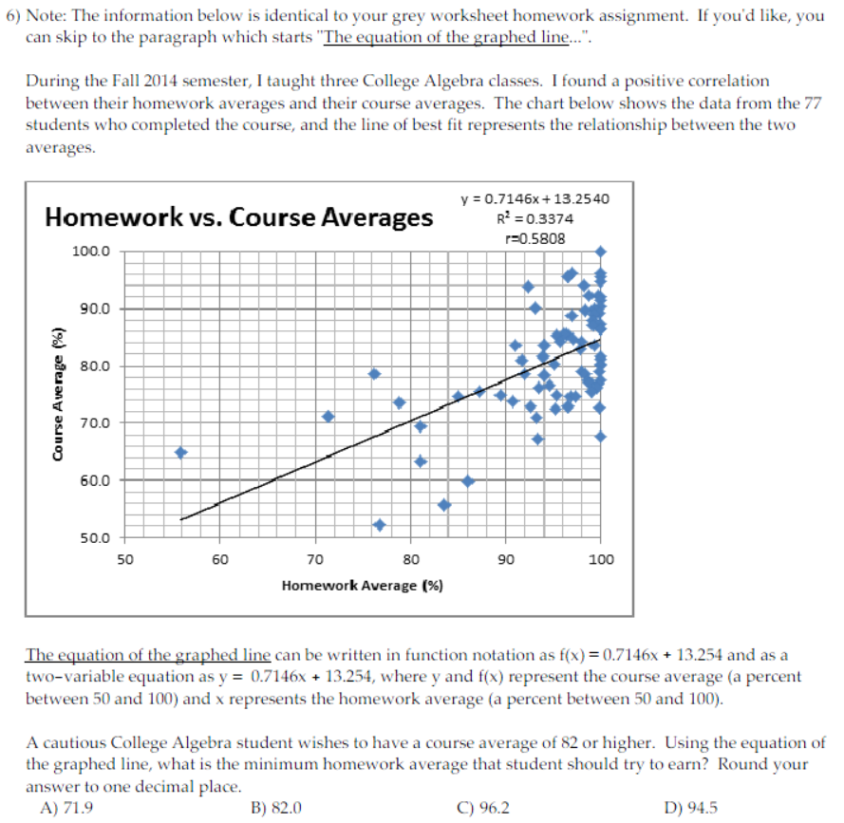

FLO1 Artifact #4

Control Group – Chapter 3 Test Question

Page 1 of 1

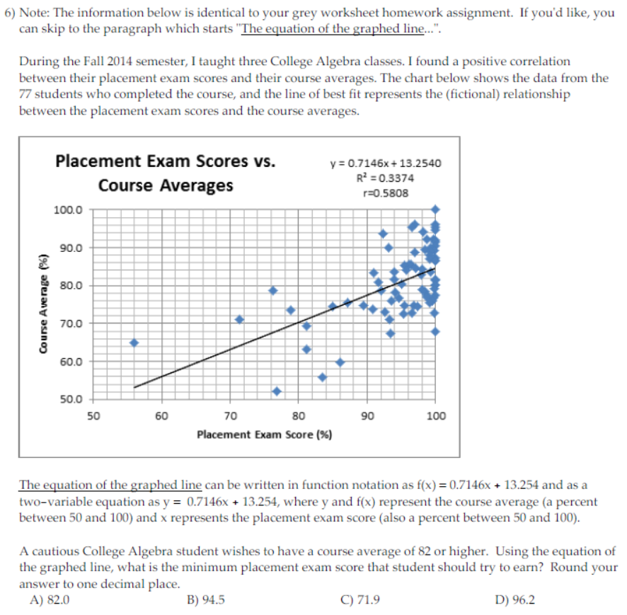

FLO1 Artifact #5

Experimental Group – Three-Step Formative Assessment

Page 1 of 1

Name: _____________________________________________ Course Days/Times: ________________

**Are You On-Target to Get the Grade You Want?**

Please refer to page 9 of the assignment “Exploring the Relationship between Homework Averages and Course Averages” and complete the following:

What were your answers for Questions 5 and 6? Please fill in the blanks below.

The lowest College Algebra course grade I would be happy with is __________ and I need a homework score of __________ to get it.

The College Algebra course grade I hope to get is __________ and I need a homework score of __________ to get it.

Now fill in the next blank line below.

Date: __________ Current Homework Average: __________

Date: __________ Current Homework Average: __________

Date: __________ Current Homework Average: __________

FLO1 Artifact #6

Control and Experimental Group – Homework Average Scores

Page 1 of 1

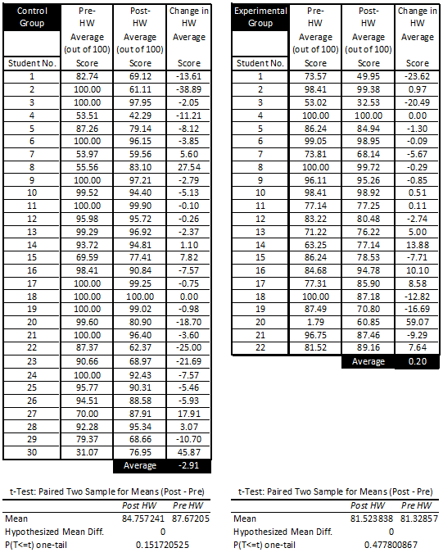

FLO1 Artifact #7

Control and Experimental Group – Homework Completion Percentages

Page 1 of 1

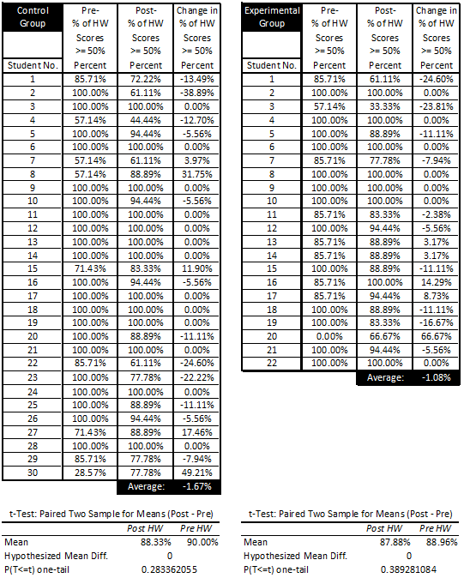

FLO1 Artifact #8

Control and Experimental Group – Test Scores

Page 1 of 1

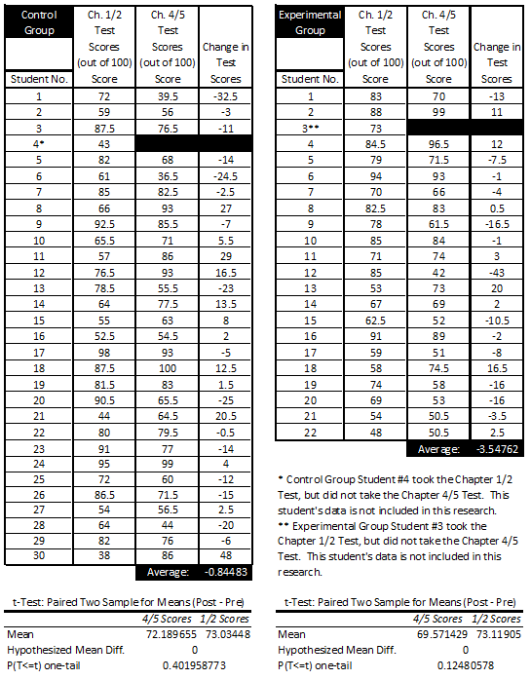

FLO1 Artifact #9

Control Group – Number of Students Attending Supplemental Learning Sessions

Page 1 of 1

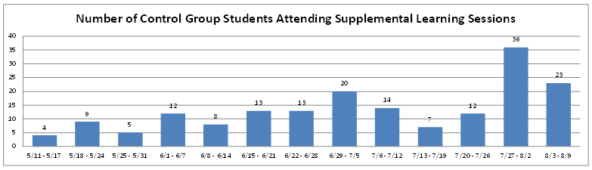

Exam days were 5/26 (Ch. 1/2), 6/16 (Ch. 3), 6/30 (Ch. 4/5), 7/9 (Ch. 8/6), 7/28 (Ch. 6), and 8/4 (final exam)

FLO1 Artifact #10

Experimental Group – Post-Intervention Survey

Page 1 of 3

I asked the students to: “Recall the five-topic reading assignment with suggestions for improving your homework habits, then respond to the following statement: The five-topic reading assignment helped me improve my homework effectiveness.” Their responses were as follows*:



I asked the students to: “Recall the chart that presented homework and course averages, as well as a best-fit line showing a positive correlation between those two quantities, then respond to the following statement: I understood what this chart was trying to show me.” Their responses were as follows*:



* SD=Strongly Disagree, D=Disagree, N=Neither Agree Nor Disagree, A=Agree, SA=Strongly Agree, and N/A=Not Applicable

FLO1 Artifact #10

Experimental Group – Post-Intervention Survey

Page 2 of 3

I asked the students to: “Recall the chart that presented homework and course averages, as well as a best-fit line showing a positive correlation between those two quantities, then respond to the following statement: I believed the chart would accurately predict my course average using my homework average.” Their responses were as follows*:



I asked the students to: “Recall the Are You On Target to Get the Grade You Want? Form, where you tracked your homework average over time, then respond to the following statement: This document motivated me to improve my homework scores.” Their responses were as follows*:



* SD=Strongly Disagree, D=Disagree, N=Neither Agree Nor Disagree, A=Agree, SA=Strongly Agree, and N/A=Not Applicable

FLO1 Artifact #10

Experimental Group – Post-Intervention Survey

Page 3 of 3

I asked the students to: “Recall the Are You On Target to Get the Grade You Want? Form, where you tracked your homework average over time, then respond to the following statement: Because of this document, I actively improved my homework scores.” Their responses were as follows*:



I asked the students to: “Recall the question on the grey paper where you listed the lowest grade you would be happy with in this class, then respond to the following statement: At some point, I lowered the grade I would be happy with in this class.” Their responses were as follows*:



* SD=Strongly Disagree, D=Disagree, N=Neither Agree Nor Disagree, A=Agree, SA=Strongly Agree, and N/A=Not Applicable

1. The problems they solved were identical to those of the experimental group, just with different theming. The control group investigated a (fictional) correlation between placement exam scores and final course averages.
2. The change was computed using the post-intervention value minus the pre-intervention value.
3. A Supplemental Learning leader is a student hired by Valencia College to act as a model student in class and assist other students in their learning outside of class.
4. In a class with 38% male and 62% female students, if I were to select 15 of them at random, I would predict 6 male students and 9 female students. So when 15 students used Smarthinking, and 14 of them were female, I found that disproportionate and quite surprising.
5. In chronological order: Joshua Guillemette, Joel Berman, Russell Takashima, Donna Colwell, Julie Kloft, Wendi Bush, Julia Nudel, Aaron Powell, and Roberta Carew.