USA Funds Life Skills Student Guide
Valencia College, Life Skills Student Success

Through your school, you now have access to USA Funds® Life Skills®, a free online learning program that offers you advice for managing your time and money wisely while on campus and after graduation. This Student Guide provides basic information about the tool and outlines the steps necessary to access and complete the lesson(s) that your school has assigned to you.
Log in.
New users are required to complete a simple, one-time registration process. Once you complete the initial registration process, only your username and password are required for future visits.
- Open your browser and go to www.lifeskills.org.
  - Helpful hint: Save this address as a favorite to simplify access for future visits.
- Click “Request a new account” in the Login box to create your account.
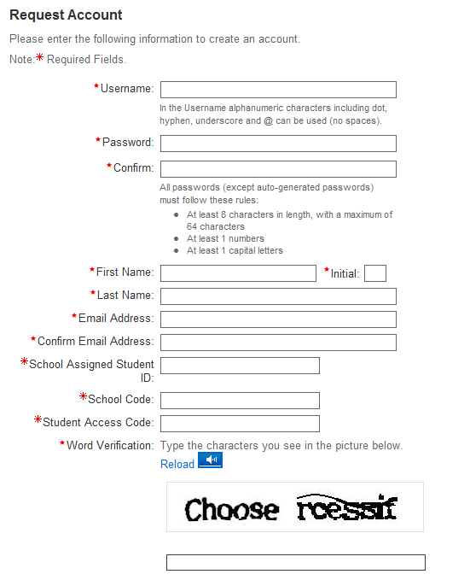
- Complete all of the information on the Request Account page. Some fields require the school defined information listed below.
  - Enter your school e-mail address as your username.
  - Enter the student ID number assigned to you by your institution as your school-assigned student ID.
  - Enter 00675000 as your School Code. Note: This code must be entered exactly as shown here.
  - Enter 00675000-01 as your Student Access Code. Note: This code must be entered exactly as shown here.
- Click “Create Account” in the lower right corner to create your account.
  - Note: If you forget your password on future visits, click “Forgot your password?” in the Login box to receive an email containing your password to the email address you provided when you created your account.

Get started.
To access and complete the lessons, follow these steps:
- Select “My Catalog” from the left navigation menu or select the “My Catalog” tab at the top of the page.
- Click on the name of a lesson and click “Enroll” on the right side of the screen.
  - Lessons can be completed in any order. If you are unable to complete a lesson in one visit, you can return to it at any time and continue where you left off. Click the name of the lesson under “My Learning” on your Home page to return to the in-progress lesson.
- Click on the name of the lesson again under “OLT Lessons” to begin the lesson.
  - Note: Your computer settings must be set to allow pop-ups to access the lesson. The lessons also contain sound so you may want to use headphones.
- Click “Next” to advance through the lesson.
- Complete the Lesson Challenge quiz at the end of the lesson. You must achieve 70 percent or higher to pass the lesson. Once achieved, your score will be recorded on your transcript as well as your school’s weekly report. (See next section for transcript information.)
  - Scroll to the bottom of the Lesson Challenge results and click “Print” to print your quiz results.
- Click “Ok” to close your quiz results and click “Close Window” to exit the lesson.
- Click USA Funds Life Skills Survey under “Course Activities” to complete a brief survey about the lesson.
- Click the “Home” tab to return to the Home page.
- Repeat the previous steps until you have completed all of the lessons assigned to you.
You can review the lessons and retake the Lesson Challenges to improve your score at any time by navigating to the lesson through the course catalog.
Your school has assigned the following lesson(s) to you:
- 101 How Will I Pay for My Higher Education?
- 102 How Do I Apply for Financial Aid?
- 103 What Do I Need to Know About Repaying My Student Loans?
- 104 What If I Have Trouble Repaying My Student Loans?
- 105 How Do I Manage My Student Loans While I’m in School?
- 201 How Do I Achieve My Goals?
- 202 What Do I Need to Know Before I Select a Program of Study?
- 203 How Do I Live on a Budget While I'm in School?
- 204 How Do I Manage My School Life?
- 205 How Do I Manage My Personal Life While I Am in School?
- 301 Now That I am About to Graduate, How Do I Find A Job?
- 302 How Do I Prepare For a Job Interview?
- 303 How Do I Establish Career Goals?
- 304 Where Does My Paycheck Go?
- 305 How Do I Live On A Budget After I Have Completed School?
- 306 What Do I Need to Know when Deciding to Pursue a Graduate Degree?
- 401 How Do I Manage My Credit Card Debt?
- 402 What Do Credit Scores Mean to Me?
- 403 What Do Credit Reports Mean to Me?
- 404 How Can I Protect Myself From Identity Theft?
- 405 How Do I Manage My Debt?
- 406 How Do I Set Savings Goals?
- 407 How Can I Make the Most of My Savings?
- 701 Couple Talk: How Do We Cope With School and Our Relationship?
- 702 Couple Talk: How Do We Manage Our Money While In School?
- 703 Couple Talk: How Can We Have a Life With So Little Money?

See your results.
A printable transcript of your lesson activity is available at any time.
- Click “My Transcripts” in the left navigation menu.
  - Your transcript will provide details about any lesson in which you have enrolled, including completion status, registration date, completion date and final assessment score.
- You have the option to print or export your transcript.
  - Click “Print” in the upper right corner to print your transcript.
  - Click “Export” in the upper right corner, choose an export format and click “Export” to create an electronic version of your transcript.

Complete multiple assignments.
If you are assigned multiple lessons from different staff (for example, one group of lessons from the financial aid office and another group of lessons from a professor), you will need to enter additional access codes to your account. This is required for your lesson completion results to be accurately reported to those who assigned the USA Funds Life Skills lessons to you.
- Click “My Account” in the left navigation menu.
- Enter the additional code(s) in the available Student Access Code fields.
  - Note: If you override an existing code with a new code, your completion results no longer will be reported to the person who provided the existing code.
- Click “Update.”
Get help.
For assistance, use the “Contact Us” link or call USA Funds Customer Support, Monday through Friday, between 8 a.m. and 8 p.m. Eastern time at (800) 766-0084. After these hours, support is available at (866) 722-1470.

