Minutes from 9/24/2015

Attending: Julie Abbarno, Denise Bourne, Yolanda Gonzalez, Erich Heintzelman, Becky Hopkins, Rob McCaffrey

Awarding: Julie Abbarno, Denise Bourne, Yolanda Gonzalez, Erich Heintzelman, Becky Hopkins

Occupied: Linda Anthon, Aaron Babcock, Roger Corriveau, Melissa Schreiber

* Following up from a discussion in April, the Committee agreed to fund multiple trips per year as long as an applicant has not reached the annual cap. (Figure 1).
* Rob McCaffrey will establish a way to remind supervisors that they can recommend a priority order when multiple people apply for the same event.
* Rob will look into getting the current online form to be electronically signed and converted to a form that can be used as the Per Diem form upon a traveler’s return.
* The committee agree to begin Cycle 1, 2016 – 2017 with a cap bump to $1100. This will be followed by an annual increase of 3% per year in an effort to keep up with the cost of traveling expenses.

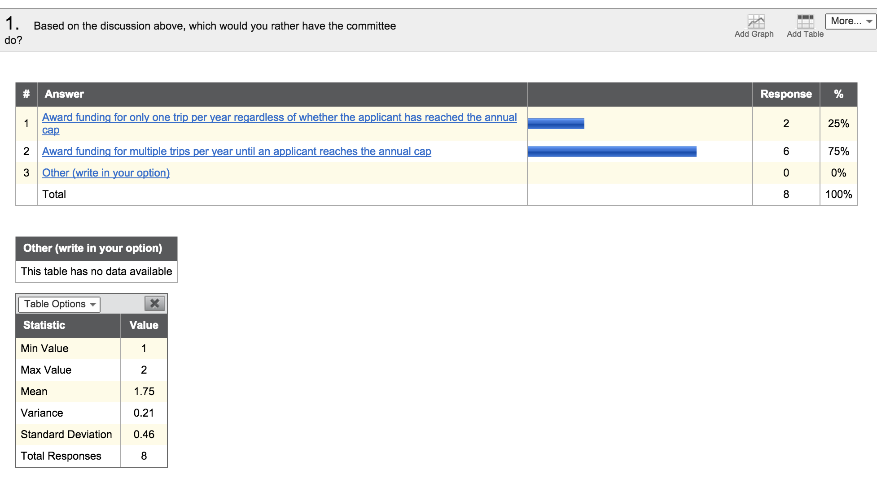

Fig. 1

The following requests were funded:

|  |  |  |  |  |  |  |
| --- | --- | --- | --- | --- | --- | --- |
| **Applicant** | **New Request?** | **Speaker Chair or Presenter?** | **High Impact?** | **In-state or alternate funds?** | **Total** | **Award Amount** |
| Addelston | 1 | 1 |  |  | 2 | $1,000.00 |
| Bauer | 1 |  | 1 |  | 2 | $1,000.00 |
| Chu | 1 |  | 1 |  | 2 | $1,000.00 |
| Cortes | 1 |  | 1 |  | 2 | $1,000.00 |
| Dalrymple | 1 |  | 1 |  | 2 | $784.20 |
| Gair | 1 |  |  |  | 1 |  |
| Grajeda | 1 |  | 1 | 1 | 3 | $1,000.00 |
| Madison | 1 |  |  | 1 | 2 |  |
| McCaffrey | 1 |  | 1 |  | 2 | $947.00 |
| Obrien | 1 |  |  |  | 1 |  |
| O'Neal | 1 | 1 |  |  | 2 | $1,000.00 |
| Perri | 1 |  | 1 |  | 2 | $893.14 |
| Salto | 1 |  | 1 |  | 2 | $1,000.00 |
| Salto | 1 |  |  |  | 1 | $0.00 |
| Saxman | 1 |  | 1 |  | 2 | $1,000.00 |
| Territo | 1 | 1 | 1 | 1 | 4 | $563.00 |
| Van De Car | 1 |  | 1 |  | 2 | $857.59 |

TOTAL for this cycle: **$12,044.93**