Minutes from 201710 meeting.

The awards for this cycle are listed on the following page.

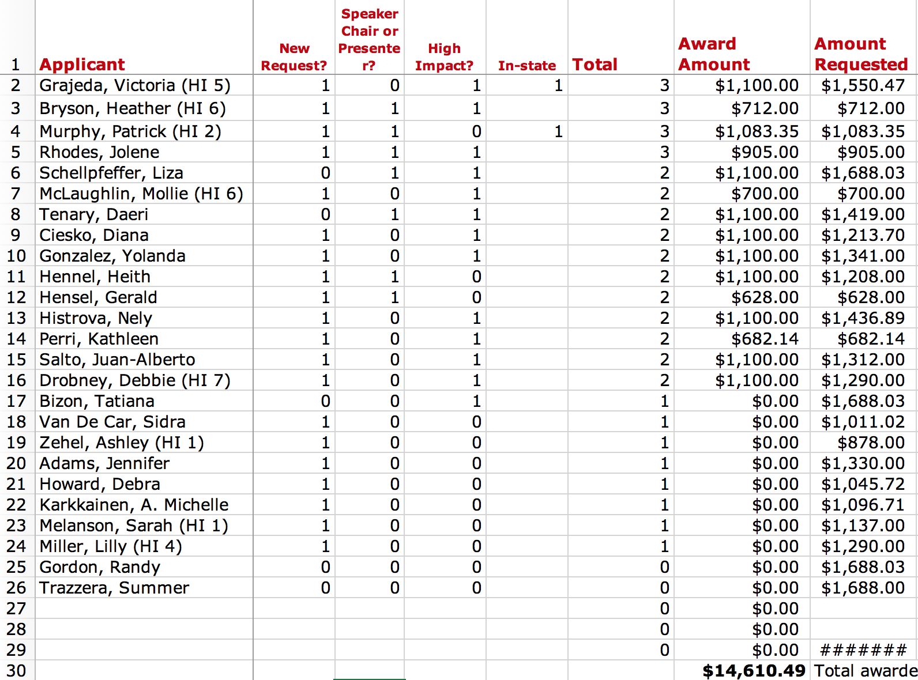

The award for cycle 1 of 2017 – 2018 were as follows:

