# MATH LAB SYLLABUS

1. **ATTENDANCE**

* **FULL TERM *(SPRING and FALL)*** – You must attend the MATH LAB *at least* 50 minutes per week.
* **FLEX START *(SPRING and FALL)*** – You must attend the MATH LAB *at least* 75 minutes per week.
* **FULL TERM *(Summer)*** – You must attend theMATH LAB *at least* 60 minutes per week.
* **TERM A/B *(Summer)*** – You must attend the MATH LAB *at least* 120 minutes per week.

**MATH LAB HOURS OF OPERATION**

|  |  |
| --- | --- |
| **Monday** | **8:00am - 8:00pm** |
| **Tuesday** | **8:00am - 8:00pm** |
| **Wednesday** | **8:00am - 8:00pm** |
| **Thursday** | **8:00am - 8:00pm** |
| **Friday** | **8:00am - 7:00pm* (12 PM DURING SUMMER)** |
| **Saturday** | **11:00am - 4:00pm** |
| **Sunday** | **11:00am - 4:00pm** |

## Location: Bldg 7 Room 240 Questions: Call 407-582-1633

1. **ASSIGNMENTS**

* There are 7 to 9 assignments available through MyMathLab™ in WebCT.
* You MUST complete one **Math Learning Plan** **(MLP)** for each and every assignment. MLP is accessed through the Math Lab website.

* You MUST complete the Lab Mastery for each assignment by its **due date**.
* Follow the due dates located on MyMathLab Calendar.
* Access the following Math Lab website for MLP, Lab Syllabus, Worksheets etc.

<http://www.valenciacc.edu/west/Lss/math/openlab.cfm>

1. **GRADES**

j0397482Lab work = 15%* of class grade(*Please check with your professor for their individual lab grading scheme).

**Weekly Attendance = ¼ of 15%**

**MATH LAB**

**(15% of class grade)** **Assignments = ¾ of 15%**

Your Math Lab grade corresponds to 15%* of your class grade, so it is in your best interest to come and participate in the Math Lab!

1. **HOW TO LOG INTO ACCUTRACK**

**AccuTrack** is the software used to track your attendance in the Open Math Lab. You will need to **SIGN IN** each time you visit the MATH LAB in order to receive credit for your attendance.

* **First time logging into Accutrack**:

1. Type in your VID

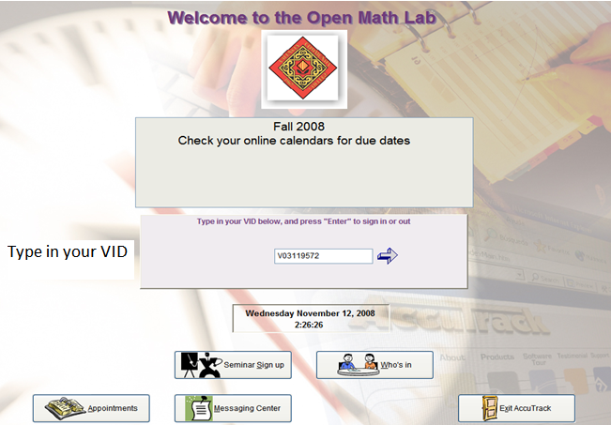

* **First time logging into Accutrack continued…………**

1. Select your Instructor’s name and CRN

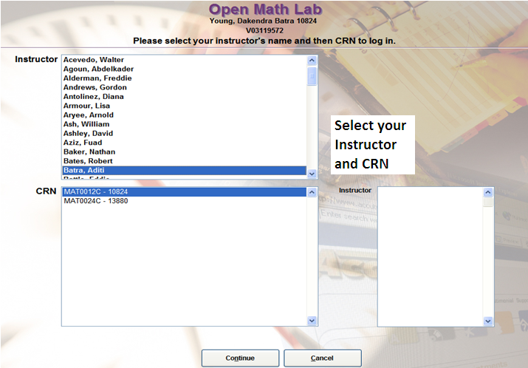

1. Click Continue
2. Click Yes

* **Next time logging into Accutrack**:

1. Type in your VID
2. Click Continue

Accutrack will remember your information. *However, always make sure that you are recording your time for the correct Instructor and CRN.*

* **Accutrack continued…………**

When signed into Accutrack, you will see your name in a box that has a Sign Out button below it. The time you remain signed in will appear below the Sign Out button.

Your Name



Sign Out button

Minutes spent during the visit

* **Accutrack continued…………**

**Sign-out table in Accutrack displays**:

* The number of visits made in the current week and semester
* Time spent in the Lab for current week and semester

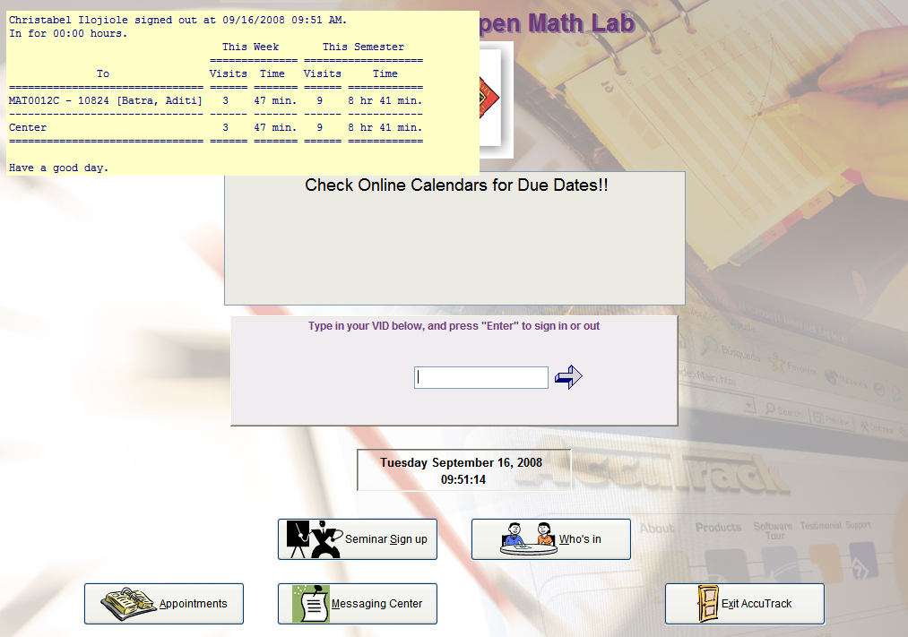

1. **HOW TO LOG INTO WebCT IN THE OPEN MATH LAB**

* **Logging into WebCT in the Open Math Lab**

1. Double Click on **Internet Explorer** after signing into Accutrack.



* **Logging into WebCT in the Open Math Lab continued…………**

1. On Valencia web page, go to **Quick Links** and drop down to Online Courses. Click **Online Courses**.

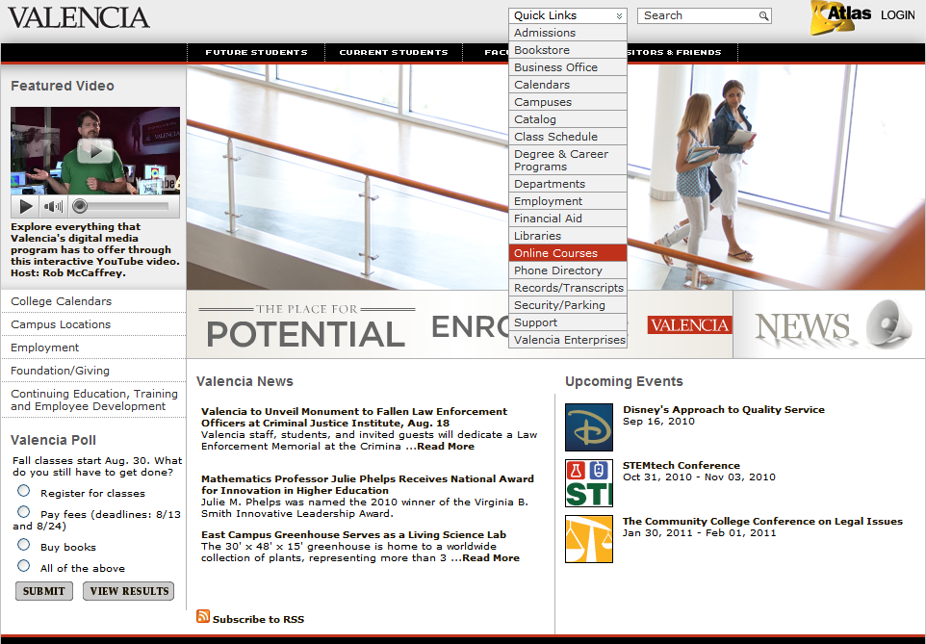

**Go to Quick Links and drop down to Online Courses. Click Online Courses.**

* **Logging into WebCT in the Open Math Lab continued…………**

1. Click on the **WebCT** icon.

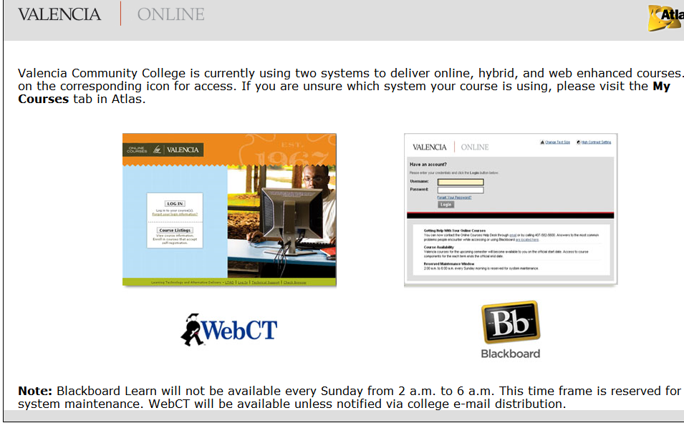

**Click on WebCT**

* **Logging into WebCT in the Open Math Lab continued…………**

1. Click **LOG IN**.



* **Logging into WebCT in the Open Math Lab continued…………**

1. Enter your atlas user name and atlas password to log in.

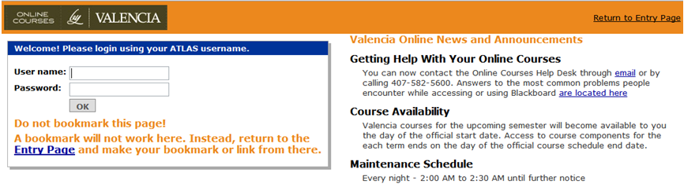

1. Once logged in, **click on your current Math course**. The course home page will be displayed after you click on your course link.

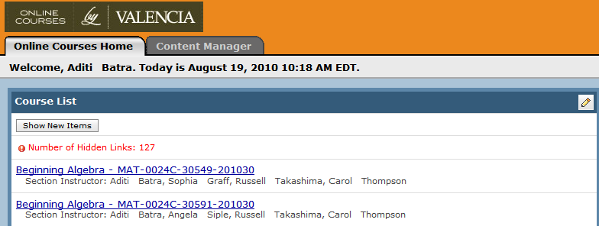

1. **HOW TO COMPLETE AN ASSIGNMENT: MAT0012C, MAT0020C, MAT0024C**

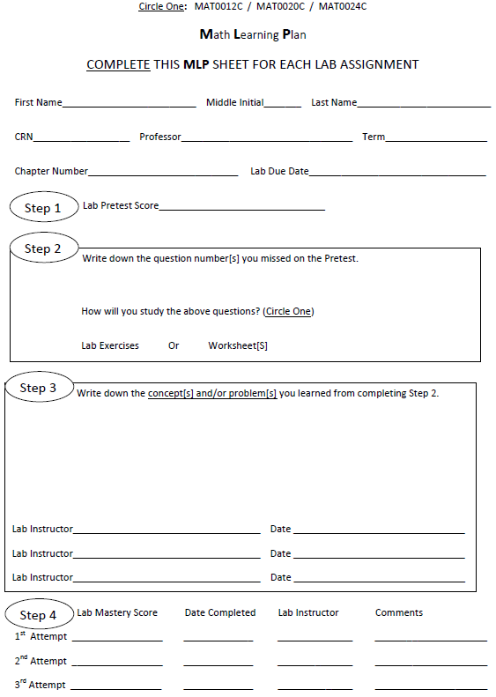

Fill entire **Math Learning Plan (MLP)** as you complete each step. (One MLP per assignment)

Take lab pretest in the Open

Math Lab

Do lab exercises/Worksheet[s]

on missed questions on lab pretest and score 100%

Write down what you learned

and get signed off by a

Lab Instructor

Take lab mastery in the Open

Math Lab and score **at least** **80% on lab mastery**

for MAT0012C/ MAT0020C/

MAT0024C

At

**Raise the red flag and a lab instructor will approach you as soon as possible**

**VII. HOW TO COMPLETE AN ASSIGNMENT: MAT1033C**

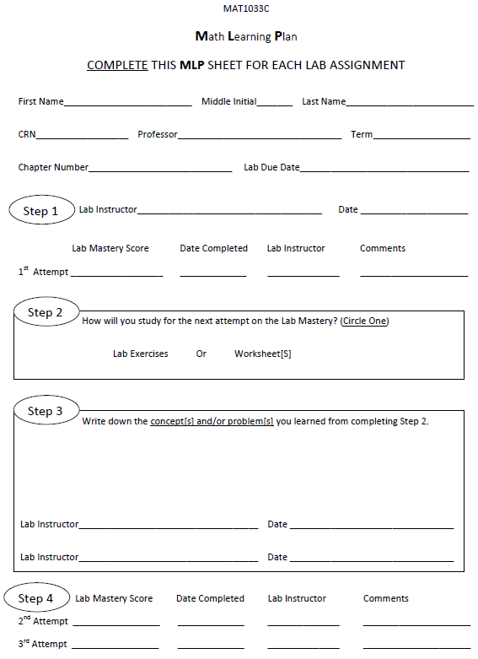

Fill entire **Math Learning Plan (MLP)** as you complete each step. (One MLP per assignment)

Take lab mastery in the Open

Math Lab and score at least 75%

If score is less than 75% in

Step 1 then do lab exercises /

Worksheet[s] and score at least 75% on each section

Write down what you

learned from step 2

and get signed off by

a Lab Instructor

Take next attempt at lab

Lab and score **at least 75% on lab mastery**

for MAT1033C

At

**Raise the red flag and a lab instructor will approach you as soon as possible**

1. **IMPORTANT INFORMATION**

*You need one of the two below within the first fifteen days of your first login on WebCT:*

1. **MyMathLab Student Access Kit (purchase in Valencia bookstore only)**

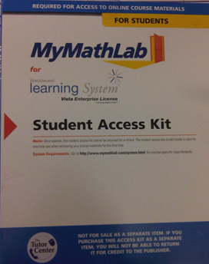

**Enter the access code from the kit within the first fifteen days of your first login on WebCT.**

1. **Unofficial Transcript – Show your unofficial transcript to a lab instructor if repeating course from prior two semesters. (access from Atlas)**

**__________________________________________________________________________________________________________________________________________________________________________**



* **MAT0020/24 – Register for the Competency Test in the Open Math lab**

**and practice for it on WebCT**

* **MAT0012 – Practice for the Final Exit Exam on WebCT**

1. **HOW TO LOG INTO WebCT FROM HOME**

* Logging into WebCT™ from Home

1. Go to [http://www.valenciacc.edu](http://www.valenciacc.edu/west/Lss/)
2. Follow the login procedures of the lab.

* At home you are ONLY allowed to work on your lab exercises.
* Lab Pretest / Lab Mastery MUST BE completed in the Math Lab with the

entire MLP completed, signed by a Math lab instructor to receive credit for

the assignment.

