# MATH LAB SYLLABUS

1. **ATTENDANCE**

* **FULL TERM *(SPRING and FALL)*** – You must attend the MATH LAB *at least* 50 minutes per week.
* **FLEX START *(SPRING and FALL)*** – You must attend the MATH LAB *at least* 75 minutes per week.
* **FULL TERM *(Summer)*** – You must attend theMATH LAB *at least* 60 minutes per week.
* **TERM A/B *(Summer)*** – You must attend the MATH LAB *at least* 120 minutes per week.

**MATH LAB HOURS OF OPERATION**

|  |  |
| --- | --- |
| **Monday** | **8:00am - 8:00pm** |
| **Tuesday** | **8:00am - 8:00pm** |
| **Wednesday** | **8:00am - 8:00pm** |
| **Thursday** | **8:00am - 8:00pm** |
| **Friday** | **8:00am - 7:00pm* (12 PM DURING SUMMER)** |
| **Saturday** | **9:00am - 2:00pm** |
| **Sunday** | **11:00am - 4:00pm** |

## Location: Bldg HSB Room 105 Questions: Call 407-582-1720, 407-582-1780

1. **ASSIGNMENTS**

* There are 7 to 9 assignments available through Online Courses.
* You MUST complete one **Math Learning Plan** **(MLP)** for each and every assignment in your lab manual.
* You MUST complete the Mastery test for each assignment by its **due date**.
* Access the following Math Center website to view the due dates <http://www.valenciacc.edu/west/Lss/math/openlab.cfm>

Click on [](http://www.valenciacc.edu/west/lss/math/OpenLabCalendars.cfm)

________________________________________________________________________________

1. **GRADES**

Lab work = 15% of class grade(check with your class professor)

**j0397482**

**Assignments = 75%**

**MATH LAB**

**(15% of class grade)** **Weekly Attendance = 25%**

Your Math Lab grade corresponds to 15% of your class grade, so it is in your best interest to come and participate in the Math Lab!

1. **HOW TO LOG INTO ACCUTRACK**

**AccuTrack** is the software used to track your attendance. You will need to **SIGN IN** each time you visit the MATH LAB in order to receive credit for your attendance.

* **First time logging into *Accutrack***:

1. Type in your VID

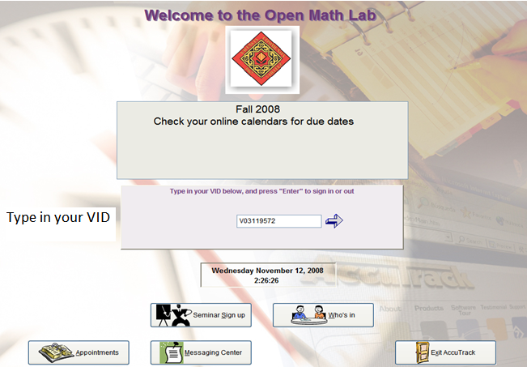

* **First time logging into *Accutrack* continued…………**

1. Select your Instructor’s name and CRN

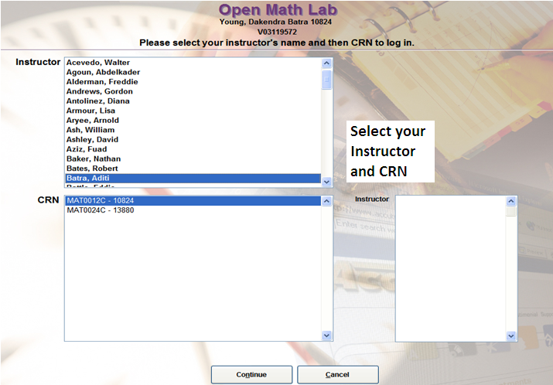

1. Click Continue
2. Click Yes

* **Next time logging into *Accutrack***:

1. Type in your VID
2. Click Continue

Accutrack will remember your information. However, always make sure that you are recording your time for the right Instructor and CRN.

* ***Accutrack* continued…………**

When signed into Accutrack, you will see your name in a box that has a Sign Out button below it. The time you remain signed in will appear below the Sign Out button.

Your Name



Sign Out button

Minutes spent during the visit

* ***Accutrack* continued…………**

**Sign-out table in Accutrack displays**:

* The number of visits made in the semester
* Time spent in the Lab for current week and semester

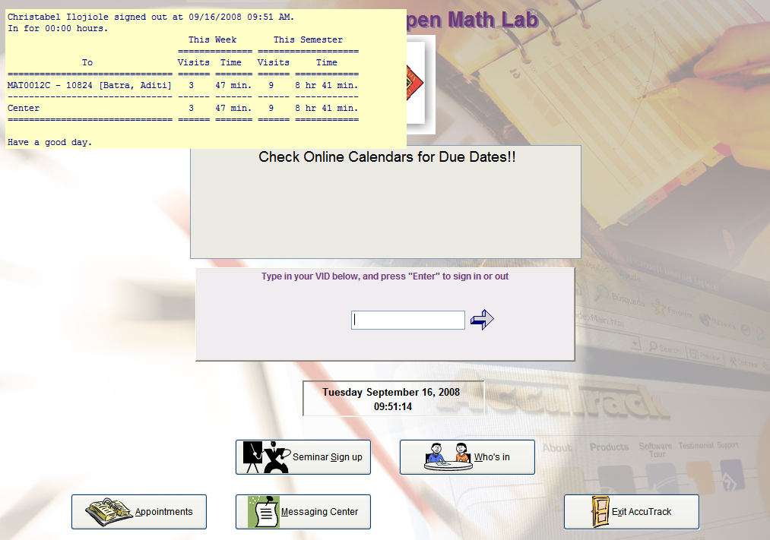

1. **HOW TO LOG IN *ONLINE COURSES* IN THE MATH LAB**

* **Logging into *Online Courses* in the Math Lab**

1. Double Click on Internet Explorer after signing into Accutrack



* **Logging into *Online Courses* in the Math Lab continued…………**

1. Click on **Quick Links** drop down menu to **Online Courses**

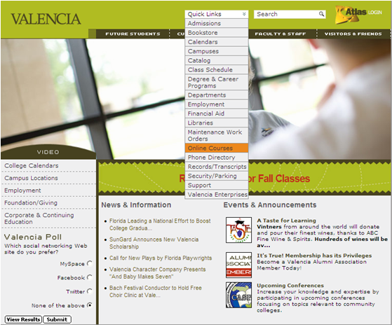

* **Logging into *Online Courses* in the Math Lab continued…………**

1. Click on **LOG IN**



1. Enter your **Atlas User name** and **Atlas Password**

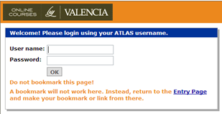

* **Logging into *Online Courses* in the Math Lab continued…………**

1. Once logged in Online Courses, select your current **MAT_ _ _ _C** course link.

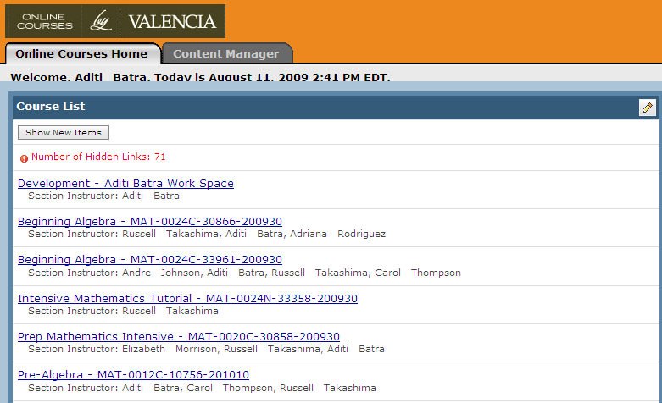

* **Logging into *Online Courses* in the Math Lab continued…………**

1. The home page for your course will be displayed after you click on your course link. *Below is an example of the Online Courses home page for MAT0012C.*

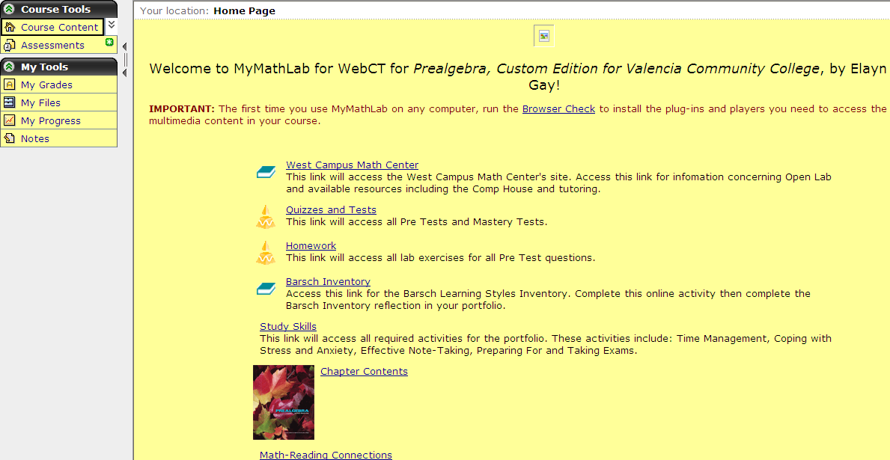

1. **HOW TO COMPLETE AN ASSIGNMENT – MAT 0012C, 0020C, 0024C**

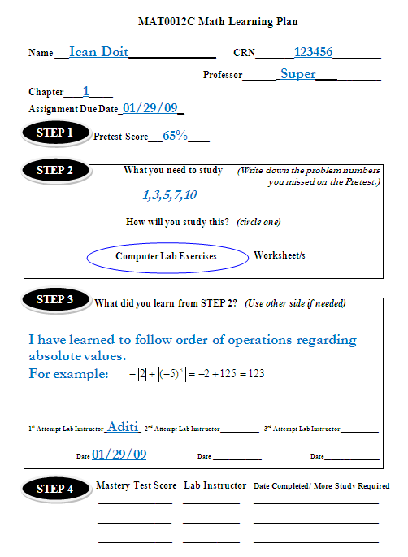

Fill entire **Math Learning Plan (MLP)** in your Lab Manual as you complete each step. (One MLP per assignment)

STEP 1. Take Pre-test in the lab

STEP 2. Do computer lab exercises/

worksheet(s) on missed

questions on pre-test and

score 100%

STEP 3. Write down what you learned

and get signed off by a

Lab Instructor

STEP 4. Take Mastery test in the lab

and score at least

**80%** on Mastery tests

for **MAT0012C/**

**MAT0020C/MAT0024C**

At

**MCj02979350000[1] When assistance is needed, raise your hand and a lab instructor will approach you as soon as possible.**

**VI. HOW TO COMPLETE AN ASSIGNMENT – MAT1033C**

MCj02979350000[1] 

Fill entire **Math Learning Plan (MLP)** in your Lab Manual as you complete each step. (One MLP per assignment)

STEP 1. SKIP STEP 1.

STEP 2. Do all homework and

score 100%

STEP 3. Write down what you learned

and get signed off by a

Lab Instructor

STEP 4. Take Mastery test in the lab

and score at least

At **70%** on Mastery tests

for **MAT1033C**

**When assistance is needed, raise your hand and a lab instructor will approach you as soon as possible.**

1. **MCj03979810000[1] HOW TO LOG INTO *ONLINE COURSES* FROM HOME**

* **Logging into Online Courses from Home**

1. Go to http://www.valenciacc.edu
2. Follow the login procedures of the lab (*Your computer might need a set of plug-ins in order to access the multimedia content in your course. To install these plug-ins, log in to Online Courses**and run the Browser Check.)*

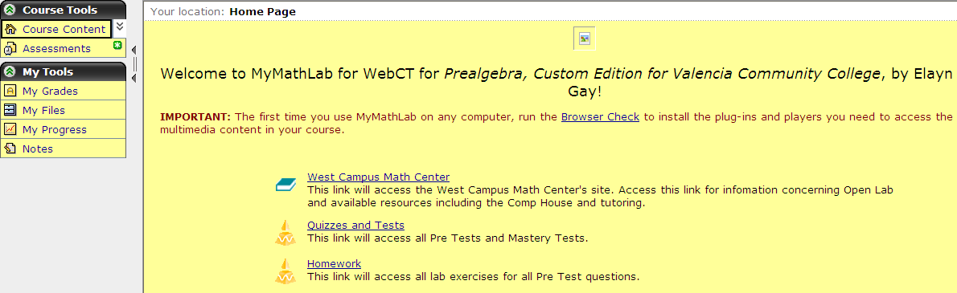

* At home, you are ONLY allowed to work on your ***lab homework which is***

***separate from your class homework***.

* Pre/Mastery Tests MUST BE completed in the Math Lab so you can fill out

your entire MLP, get signed off and receive credit for your assignment.

1. **IMPORTANT INFORMATION**

See Math Lab Calendar <http://www.valenciacc.edu/west/Lss/math/openlab.cfm>

You need one of the two below within the first fifteen days of the term.

1. **Blue MyMathLab Student Access Kit –** Enter the access code within the

first fifteen days of the term.

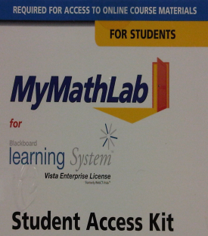

1. **Unofficial Transcript –**

Show your unofficial transcript to a Lab Instructor if you took the course

in the previous semester. *(access from Atlas)*

***Important Information* continued…………**



Go to the following website for ONLINE COURSES: [**http://webct6.valenciacc.edu/webct/entryPageIns.dowebct**](http://webct6.valenciacc.edu/webct/entryPageIns.dowebct)

**OR**

Go to www.valenciacc.edu and then follow the login procedures of the lab.

* **MAT0020/24 – Register for the State Competency Exam in the Math**

**lab and practice for it on** 

* **MAT0012 – Practice for the Final Exit Exam on **

