International Education Week – Virtual Events
MONDAY, NOV 16, 2020
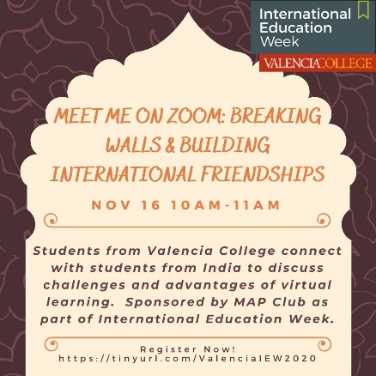
Meet me on Zoom: Breaking Walls & Building International Friendships - Muslim Ambassadors for Peace Officers and students at Valencia College will meet college students in India on Zoom to discuss challenges and advantages of Virtual Learning. The meeting will promote dialogue across cultures and countries Sponsored by MAP Club and Dr. Yasmin Qadri.
10am-11am

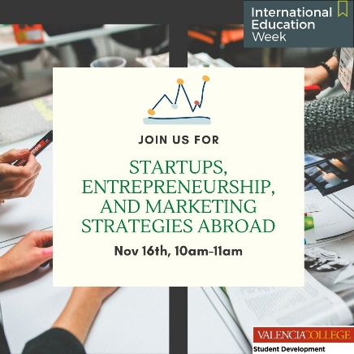
Startups, Entrepreneurship, and Marketing Strategies Abroad - Join special guest speaker, Priscilla Charles, Marketing Communications and Global Events Manager, as she Zooms in from Ireland to discuss marketing and business solutions to accelerate global commercial success. Sponsored by SAGE, WorldStrides, and Student Development. 10am-11am

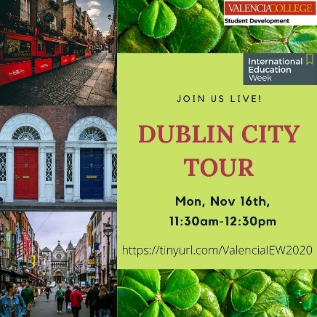
Ireland Study Abroad: Live Dublin Walking Tour * -Experience an Irish city from the comfort of your home! Your guide will take you through Dublin and share knowledge about Dublin Castle, Christchurch, Temple Bar, and the Irish Revolutionary War. Sponsored by SAGE, WorldStrides, and Student Development. *COVID-19 Update: Due to current pandemic-related lockdowns in the UK, some of the elements of this session will be modified. 11:30am-12:30pm

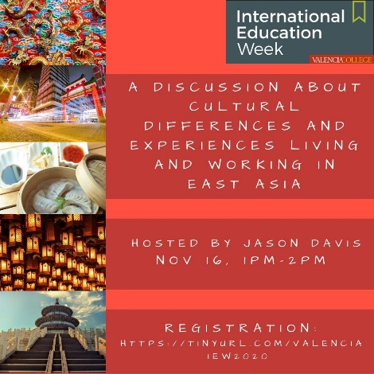
A Discussion about Cultural Differences and Experiences Living and Working in East Asia - Please join Jason Davis, international recruiter for Valencia College, for a frank discussion about cultural differences between the West and Asia. We will discuss sociological research about behaviors and cultural norms while trying to avoid any stereotypes! Open discussion and an open mind, please. Sponsored by International Student Recruitment and Global Engagement (ISRGE). 1pm-2pm

TUESDAY, NOV 17, 2020
Consumer Trends in Spain and Beyond - Eulogi Bordas Casas, CEO and Co-Founder of Photoslurp, will be joining us from Spain for International Education Week! Photoslurp is a software that makes your social media shoppable. The session will highlight entrepreneurship, technology, and consumer trends! Sponsored by SAGE, WorldStrides, and Student Development. 10am-11am

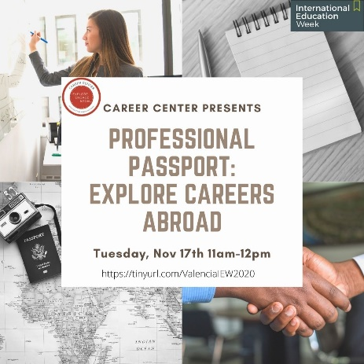
Professional Passport: Explore Careers Abroad - Join us for an interactive workshop about global careers hosted by the Career Center! Students who attend can expect to learn about careers in-demand internationally and skills needed for careers abroad. Sponsored by the Career Center. 11am-12pm

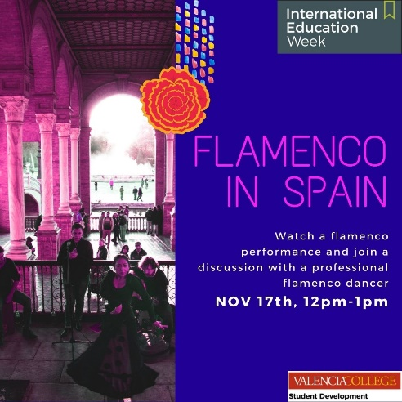
Flamenco Performance from Spain - Join Annette Morcos, a passionate Flamenco performer and instructor, as she joins us from Spain to provide an introduction to Flamenco and to share a performance. Sponsored by SAGE, WorldStrides, and Student Development. 12pm-1pm

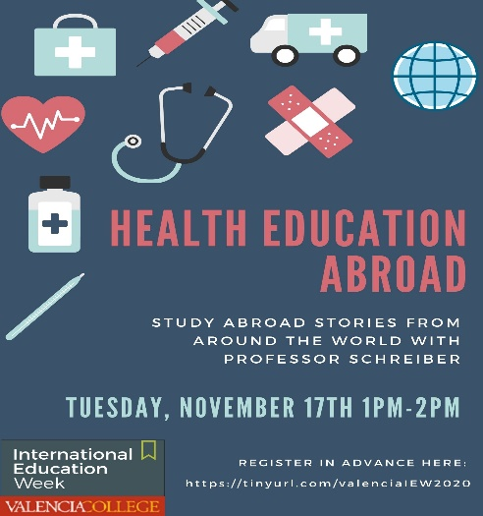
Health Education Abroad - Have you had interest in learning outside of the classroom in a foreign country about a new culture and language? If the answer is yes, you need to study abroad! In this presentation, you will hear what students learn in and out of the classroom in a foreign country through a faculty member's experiences. Join Professor Schreiber as she shares what she learned as a study abroad student and as a study abroad faculty leader. Sponsored by SAGE and Professor Melissa Schreiber. 1pm-2pm

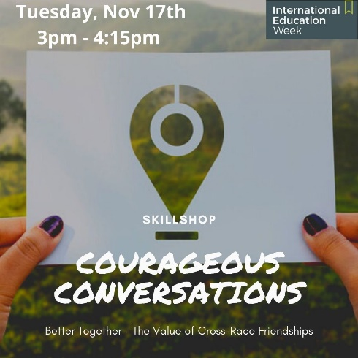
Courageous Conversations: Better Together - The Value of Cross-Race Friendships - Join a culturally diverse panel as they discuss their experiences with cross-race friendships. Participants will also have the opportunity to share their experiences and discuss the benefits and barriers to creating a culturally diverse group of friends. Presented by Counseling Services and sponsored by the Skillshop team. 3pm-4:15pm

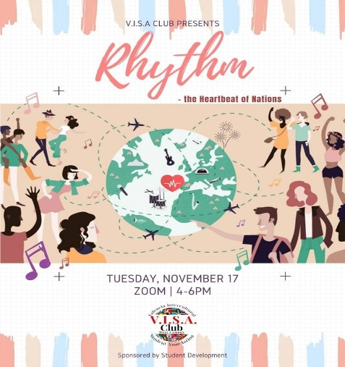
Rhythm: The Heartbeat of Nations - Music connects us, despite language and cultural barriers, so developing an appreciation for music and dances outside your own can deepen your appreciation for other cultures and what they have to offer. This event promotes cultural exchange, which is the goal of VISA! Come join us as we learn about different music and dances from around the world! Sponsored by VISA Club, International Student Services (ISS) and Student Development. 4pm-6pm

WEDNESDAY, NOV 18, 2020
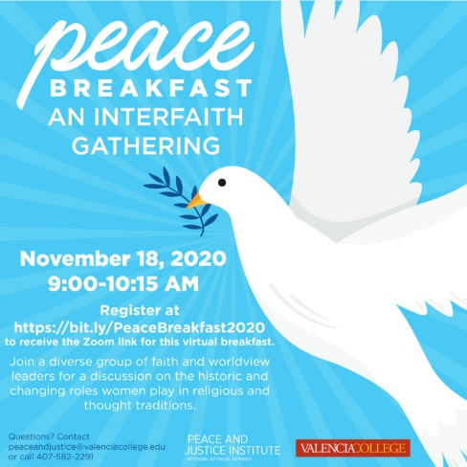
Peace Breakfast: An Interfaith Gathering - Join a diverse group of faith and worldview leaders for a discussion on the historic and changing roles women play in religious and thought traditions. Sponsored by Peace and Justice Institute (PJI). 9am-10:15am

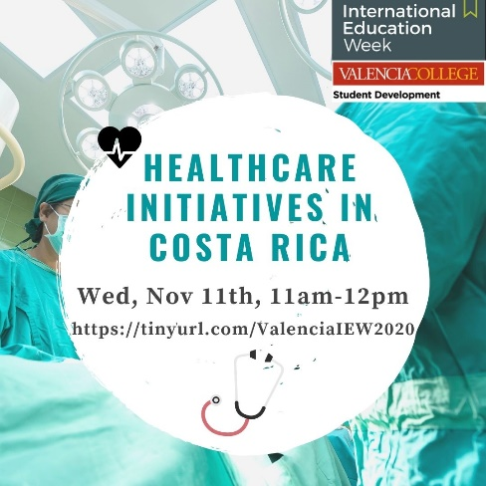
Healthcare Initiatives in Costa Rica - Join special guest speakers Eduardo Viso and Paola Murillo from Royal Phillips, a leading health technology company focused on improving people's health and well-being. This session will feature healthcare initiatives in Costa Rica and will touch on patient monitoring, health informatics, and clinical/consumer insights. Sponsored by SAGE, WorldStrides and Student Development. 11am-12pm

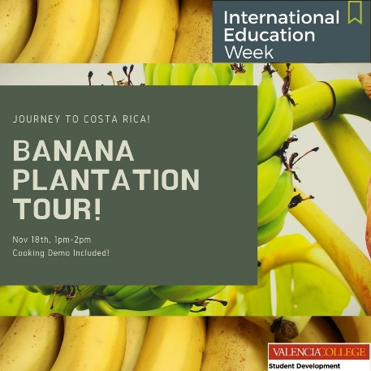
Banana Plantation Tour (Live) & Cooking Class Demo from Costa Rica - Explore a local banana plantation with locals in this highly interactive session. Your guide will explain all of the details surrounding the growth and production of bananas and how it relates to Costa Rica’s history. At the end of your tour, see how bananas are used in local recipes. Sponsored by SAGE, WorldStrides, and Student Development. 1pm-2pm

THURSDAY, NOV 19, 2020
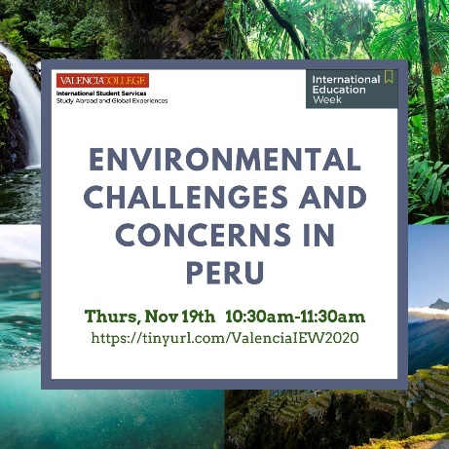
Environmental Challenges and Concerns in Peru - Join Jorge Risi, General Manager of the National Fisheries Society, as he Zooms in from Peru to highlight the environmental challenges and concerns that Peru is currently facing. Emphasis will be placed on sustainability, innovation, and aquaculture. Sponsored by SAGE, WorldStrides, and Student Development. 10:30am-11:30pm

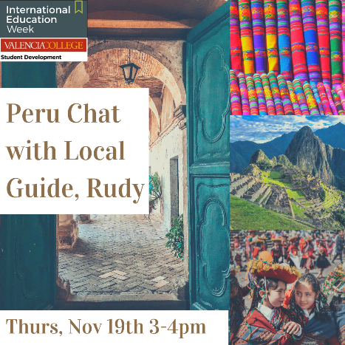
Peru with Local Guide, Rudy - Enjoy a live conversation with Rudy Chalco, an expert guide local to Peru. Learn the history of Peru and the Inka people. Focus on culture and food – learn how the first inhabitants of this country found sources of food and how this has evolved. Rudy will answer all of your questions about this beautiful and unique country! Sponsored by SAGE, WorldStrides, and Student Development. 3pm-4pm

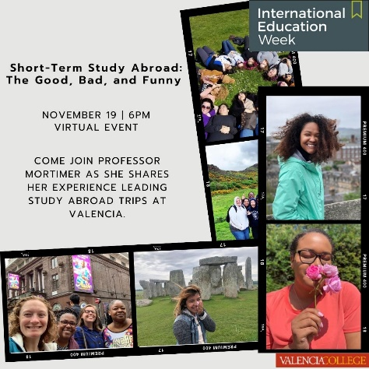
Short-Term Study Abroad: The Good, Bad, and Funny - Hear one faculty member's experience accompanying students abroad. The good: castles, the inside of European Parliament, and more. The bad: a hospital visit, changing hotels, a transportation strike, and more. The funny: crying with joy at the Harry Potter Studio Tour, cage dancers inside a store, falling asleep at a Council of Europe meeting, and more! Sponsored by SAGE and Professor Charlotte Mortimer. 6pm-7pm

FRIDAY, NOV 20, 2020
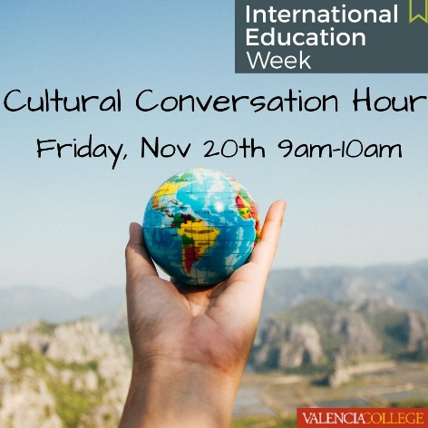
Cultural Conversation Hour - Join EAP students for a virtual Conversation Hour as they practice their English conversation and pronunciation skills. Learn more about EAP students' culture, languages, and backgrounds. Sponsored by EAP, East Campus Learning Support, and SAGE. 9am-10am

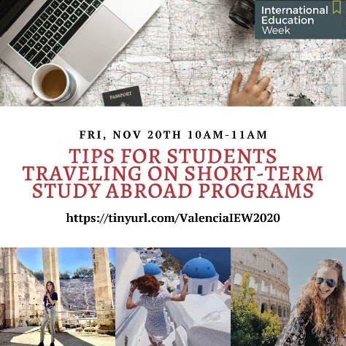
Tips for Students Traveling on Short-Term Study Abroad Programs - Join study abroad professor Hensel and SAGE Manager Lindi Kourtellis as they present tips for students studying abroad on short-term study abroad programs. Hear first-hand stories of their time abroad with students and lessons learned. Sponsored by SAGE and Professor Jerry Hensel. 10am-11am

